**MIT-NSE GEIGER COUNTER ASSEMBLY (REV-10)**

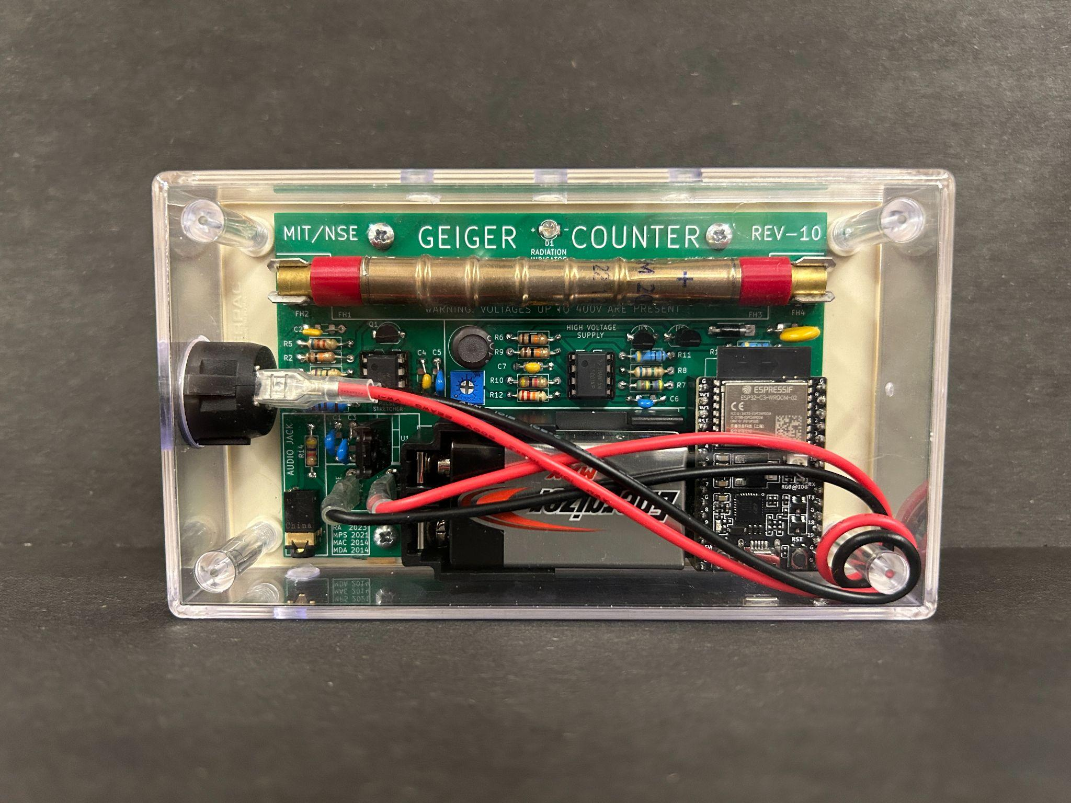

By: Rhett Applestone

**Introduction:**

When opening your MIT-NSE Geiger Counter box you should be greeted with something that looks similar to this.

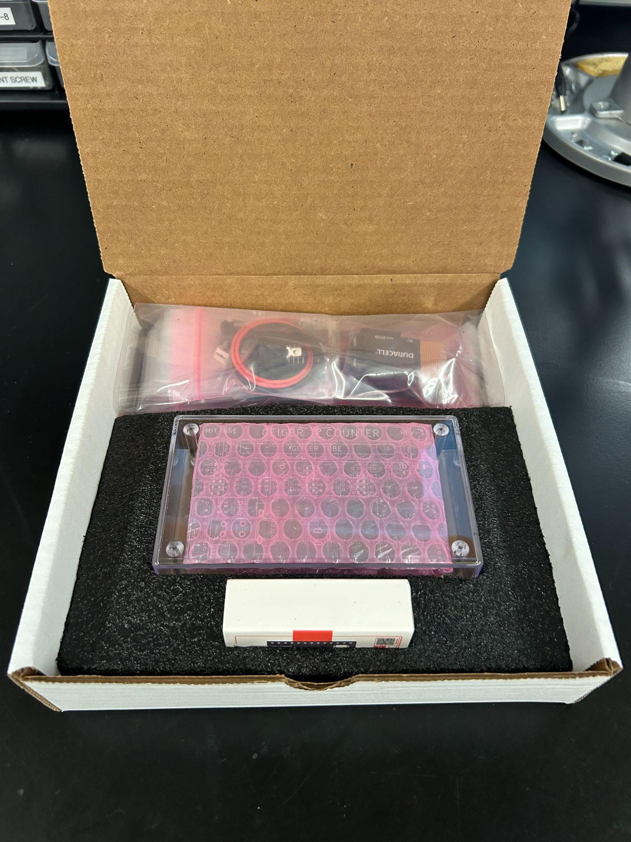

(fig 1)

The top bag contains all the electronic components that are needed to assemble your own working Geiger-Müller counter. The clear case contains both your Rev-10 circuit board and your geiger tube. Below that is a small box containing an ESP32-C3-DEVKITC-02. The ESP32-C3-DEVKITC-02 is a programmable microcontroller that we use to communicate with mobile apps, web apps, and conventional software applications for data logging purposes.

**Note: It’s a good idea to fully read each individual section before soldering to make sure you understand exactly what to do.**

**SUGGESTED TOOLS / MATERIALS:**

* Soldering iron
* Solder
* Solder flux (if you want)
* Something to clean iron tip (brass shavings, sponge)
* Pliers
* Screwdriver (small philips)

**Section 1: The Resistors**

This kit has 14 axial resistors. They do not have polarity and can be installed in **either direction**. I will demonstrate how to properly install one resistor, in this case R5. Once Installed solder them to the board from the bottom. The remaining resistors can be installed in any order. Please reference the labels on the individual bags (or bins) to know which resistor goes where.

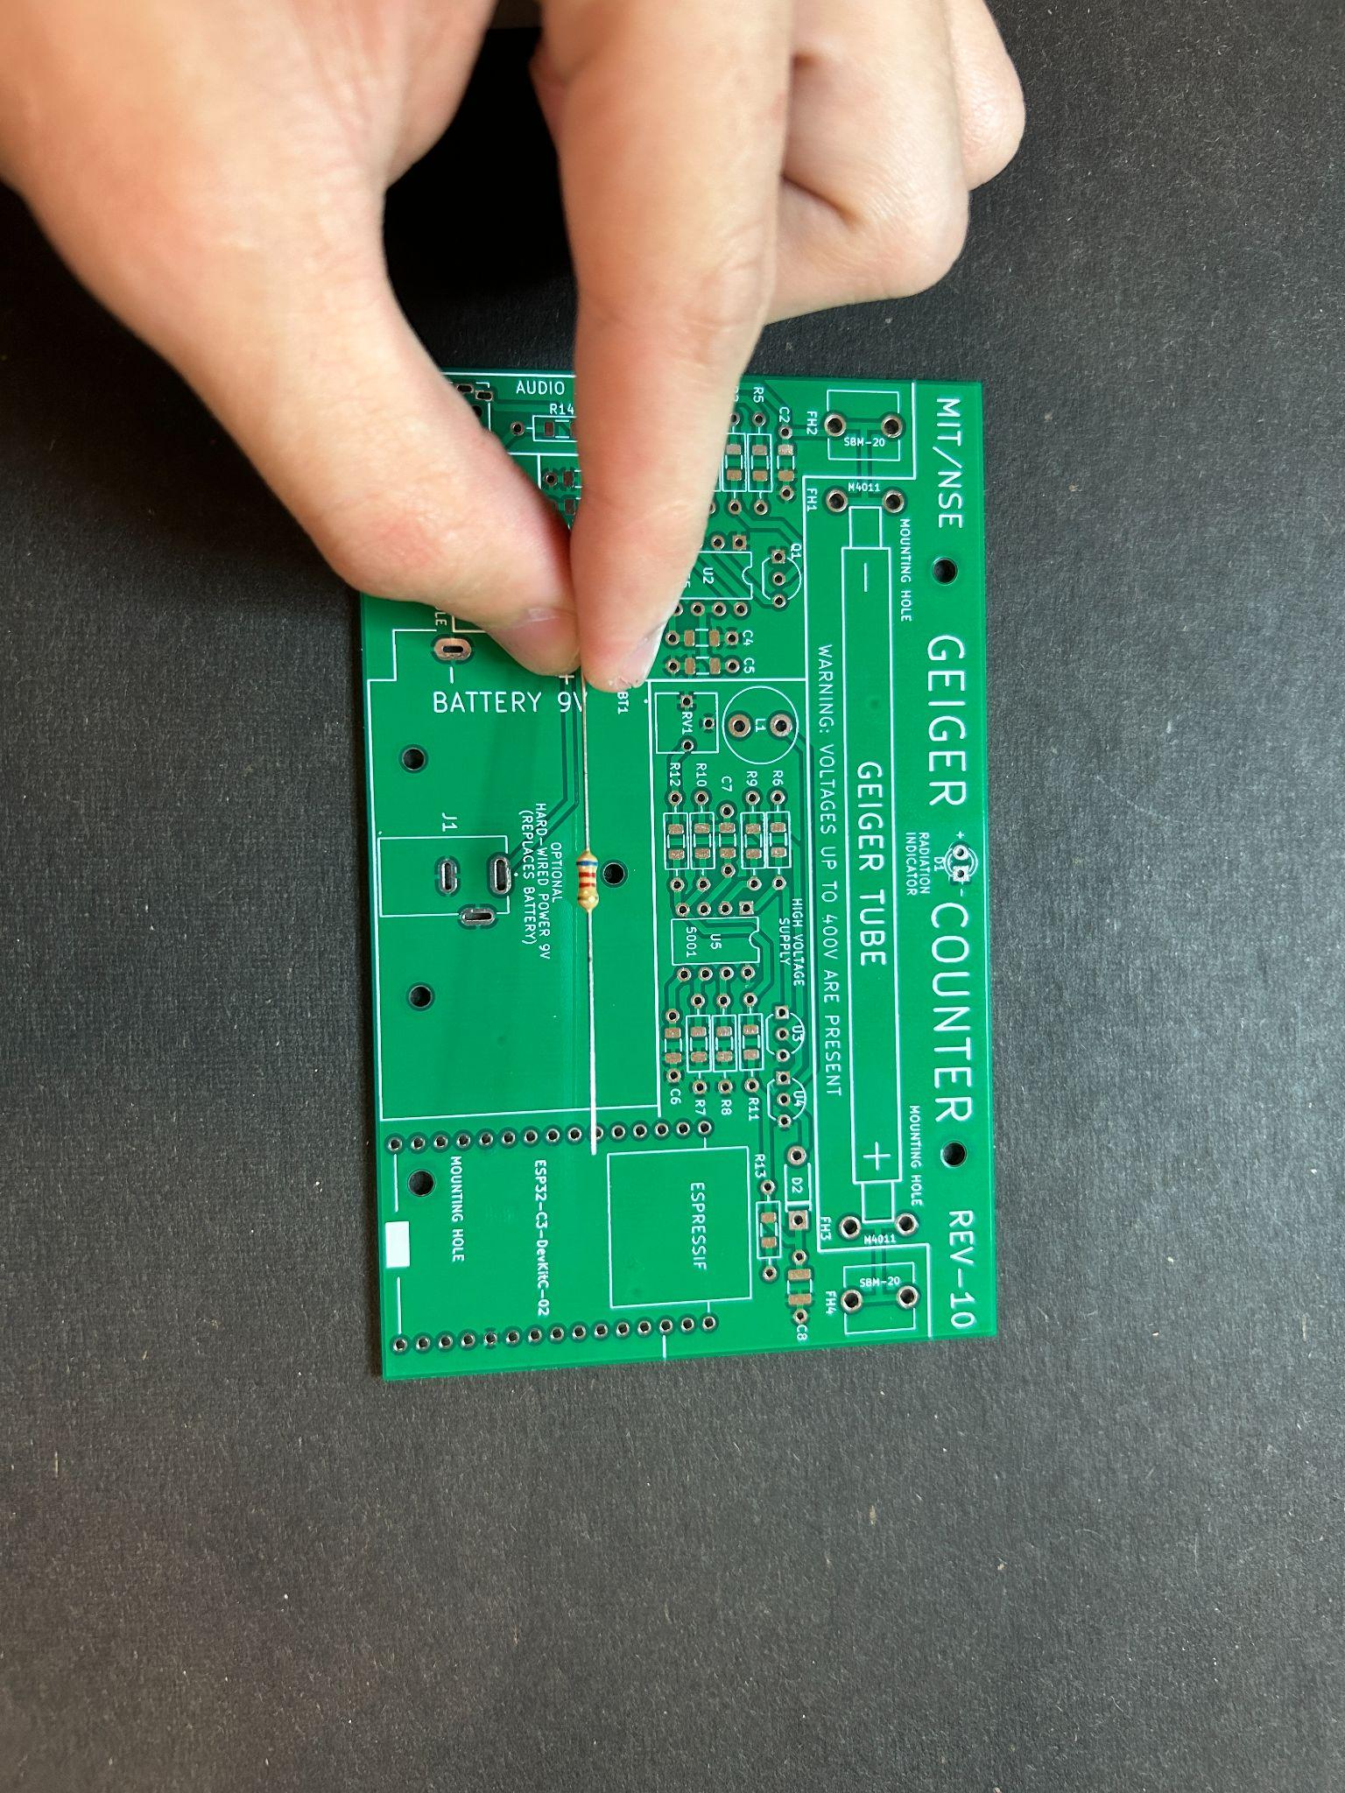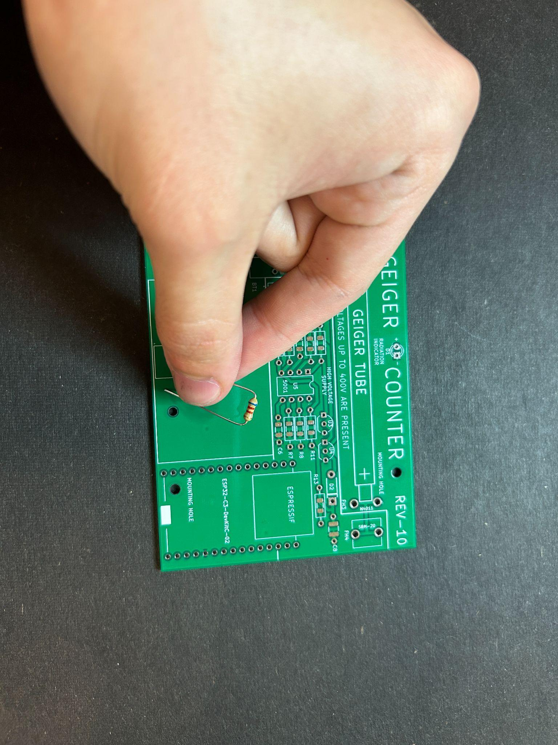

(Fig 2) (Fig 3)

First find the correct resistor, in this case R5, then bend the leads as shown in Fig 3.

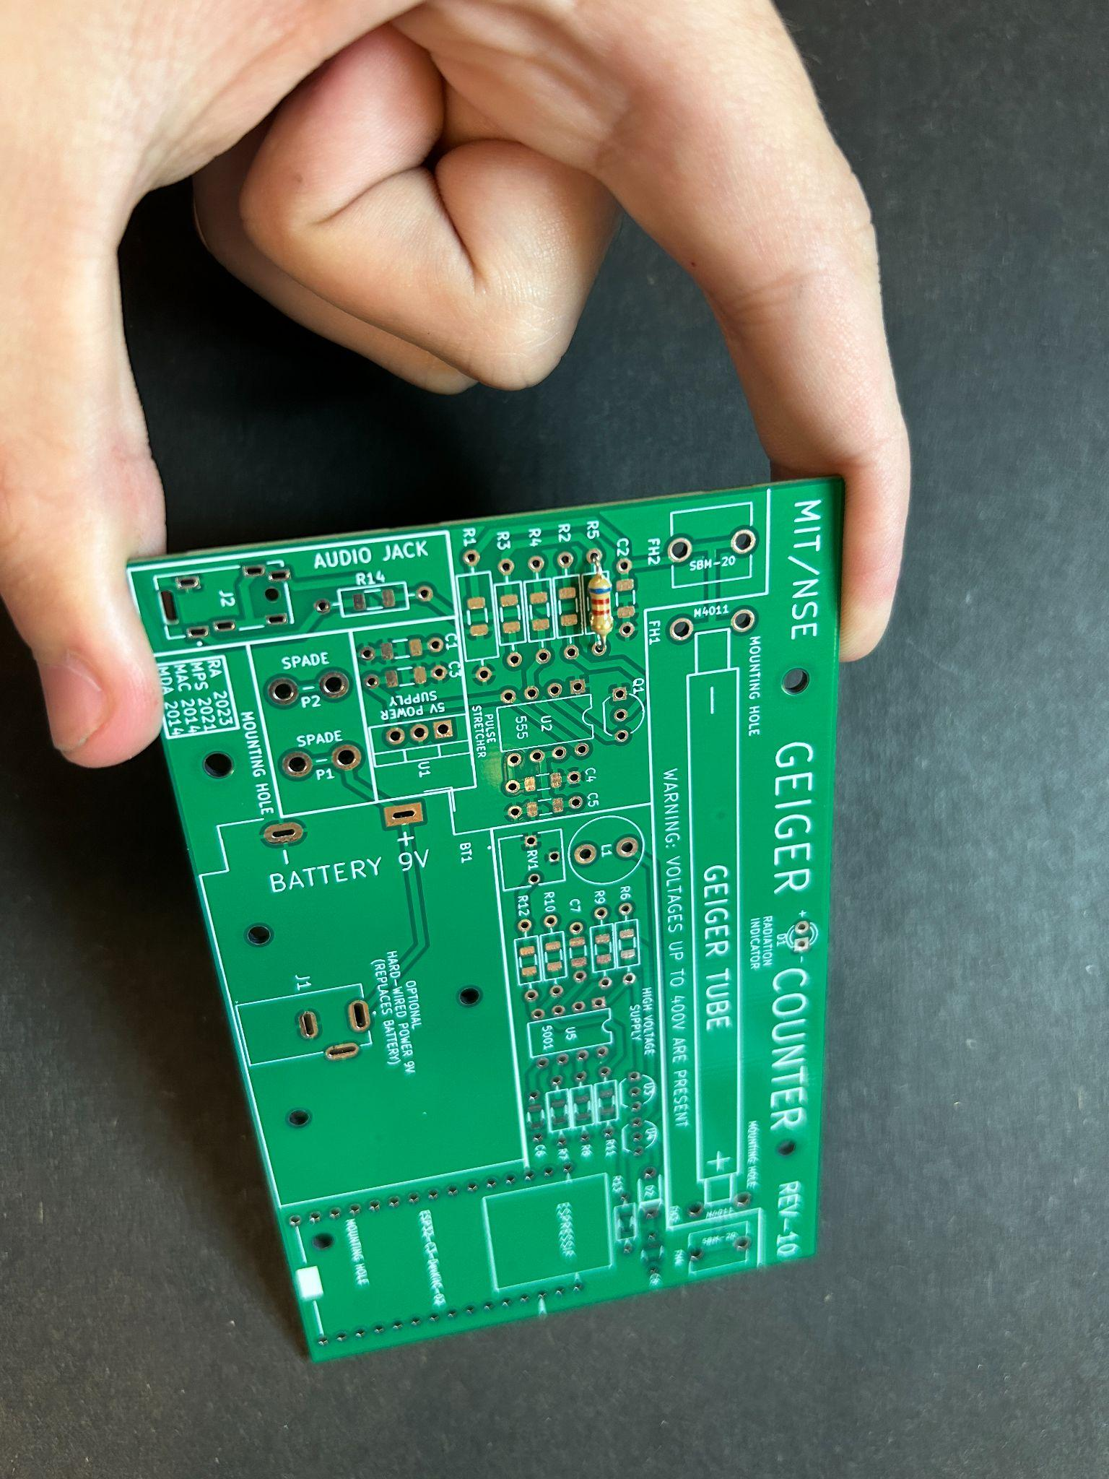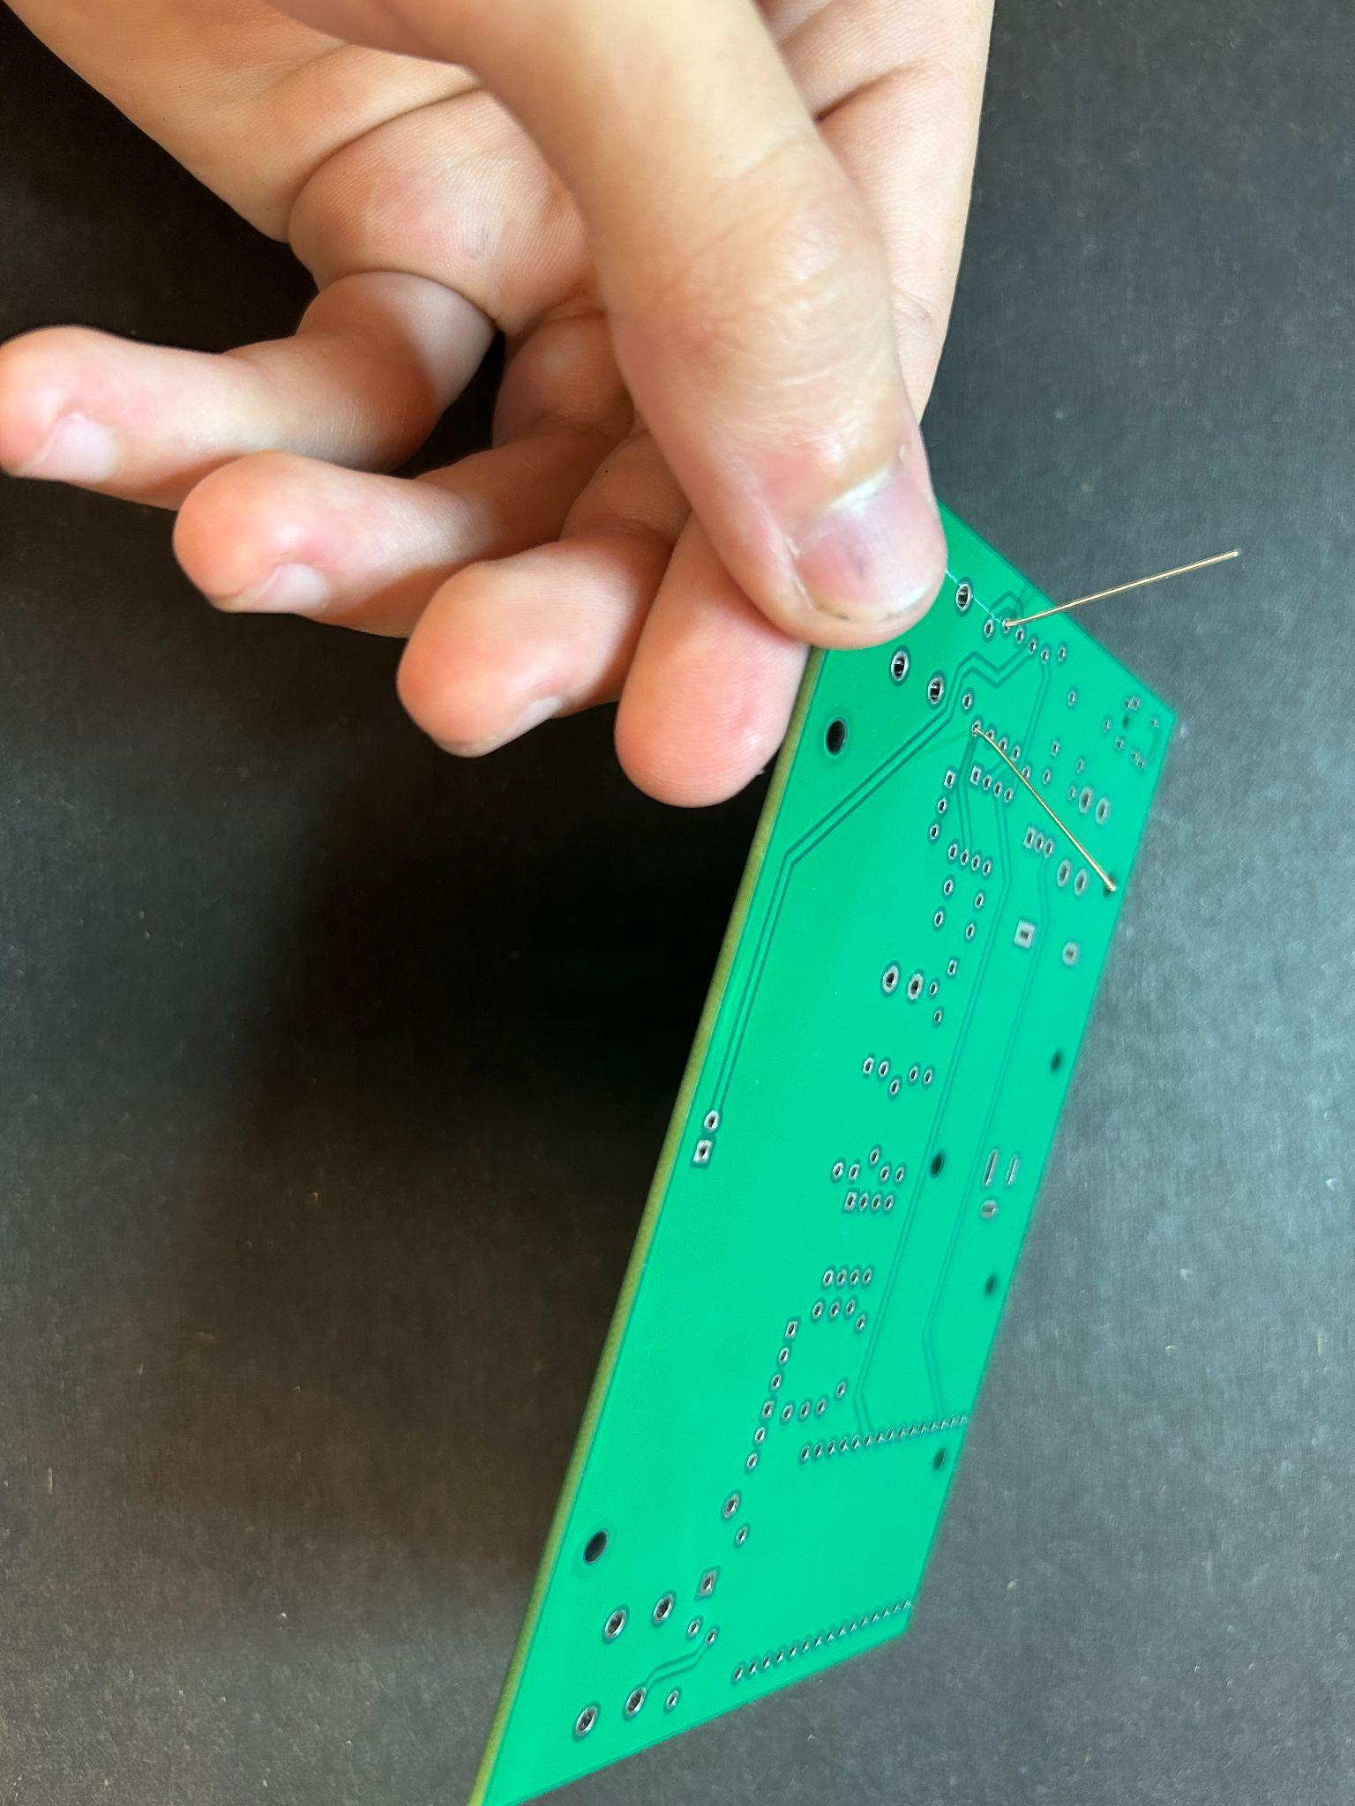

(Fig 4) (Fig 5)

Insert the resistor into its correct holes so that it lies flat and then flip the board and flare out the leads so they don’t not fall out of the board before you solder them. After this, solder the resistor in and clip the excess leads flush (or close to flush) with the bottom of the board to prevent short circuits.

Find the rest of the resistors and solder them in following the same process

**Section 2: Soldering The Capacitors**

Soldering in the capacitors is much like soldering in the resistors. Our capacitors are all ceramic, and have no polarity (although some other electrolytic capacitors do). This means they can be put in **either direction.** I will demonstrate this with C1

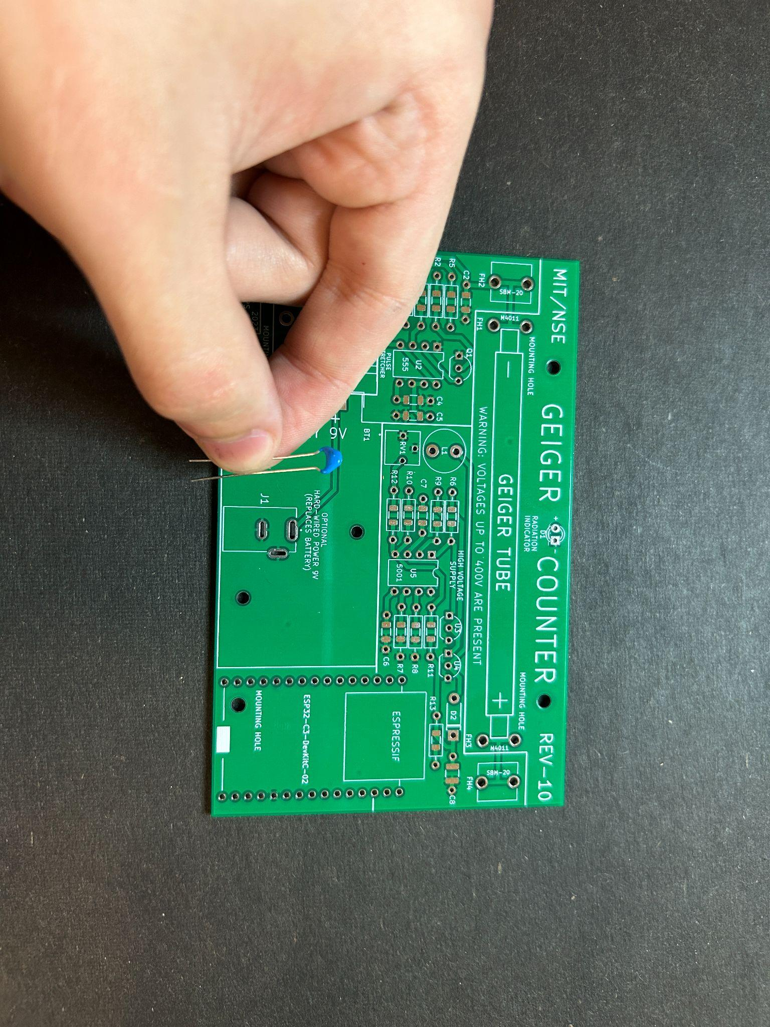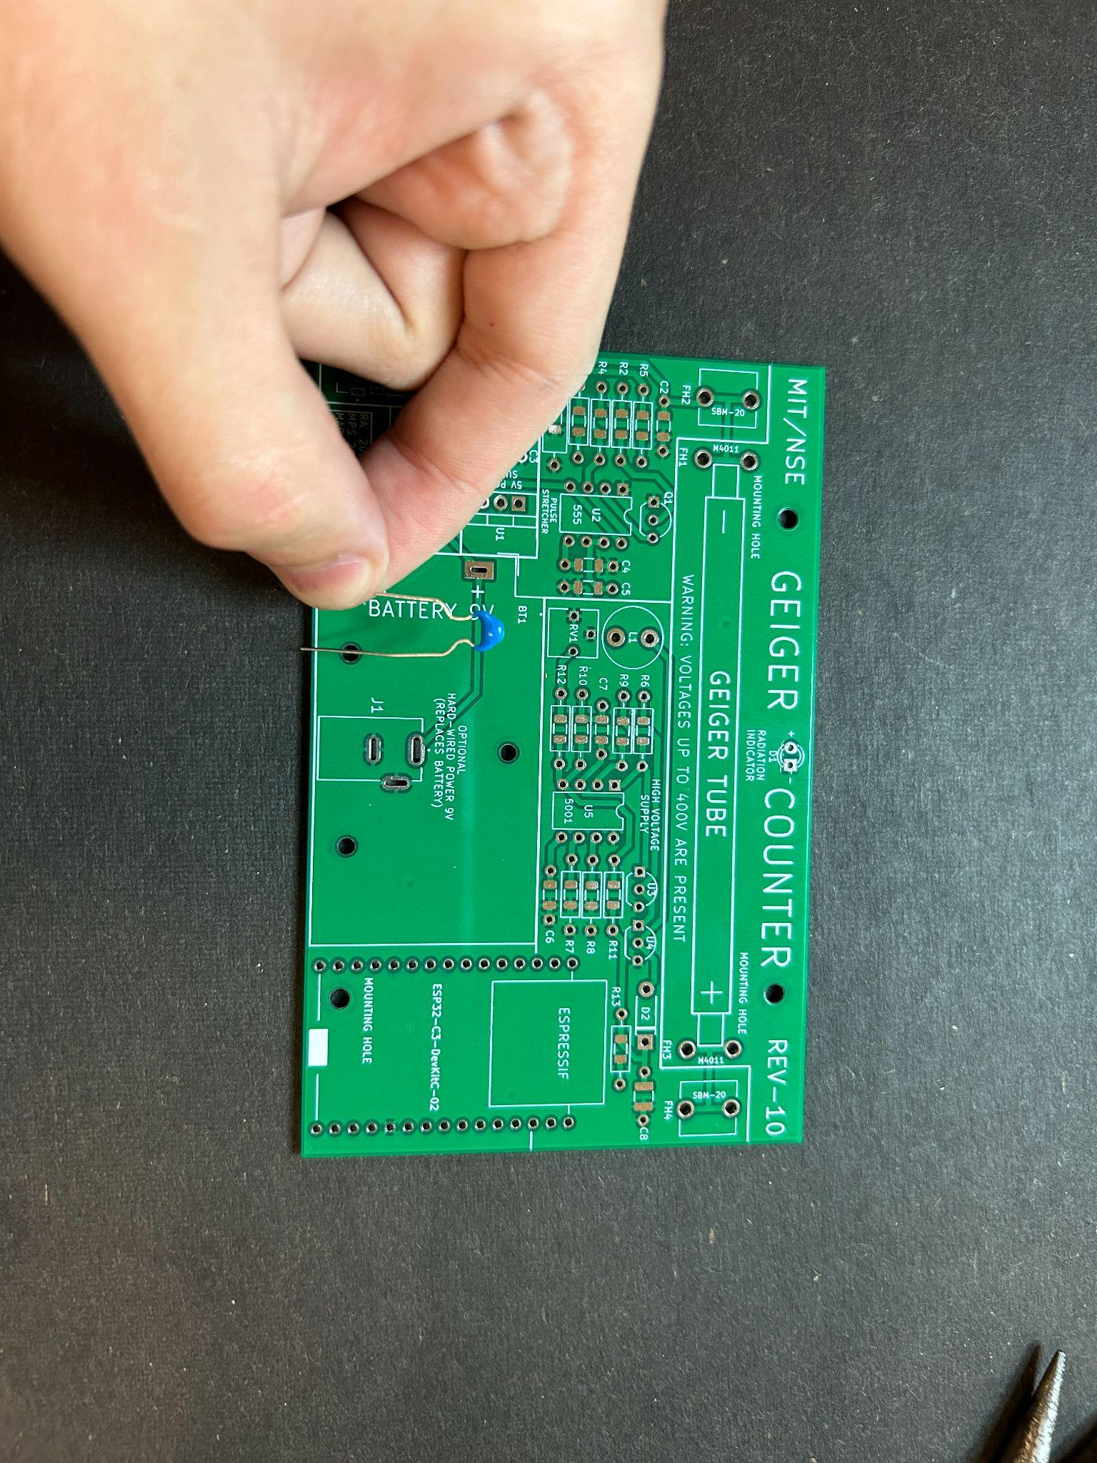

(Fig 6) (Fig 7)

First find the correct capacitor (double check), then flare out the leads slightly if needed to fit comfortably in the holes.

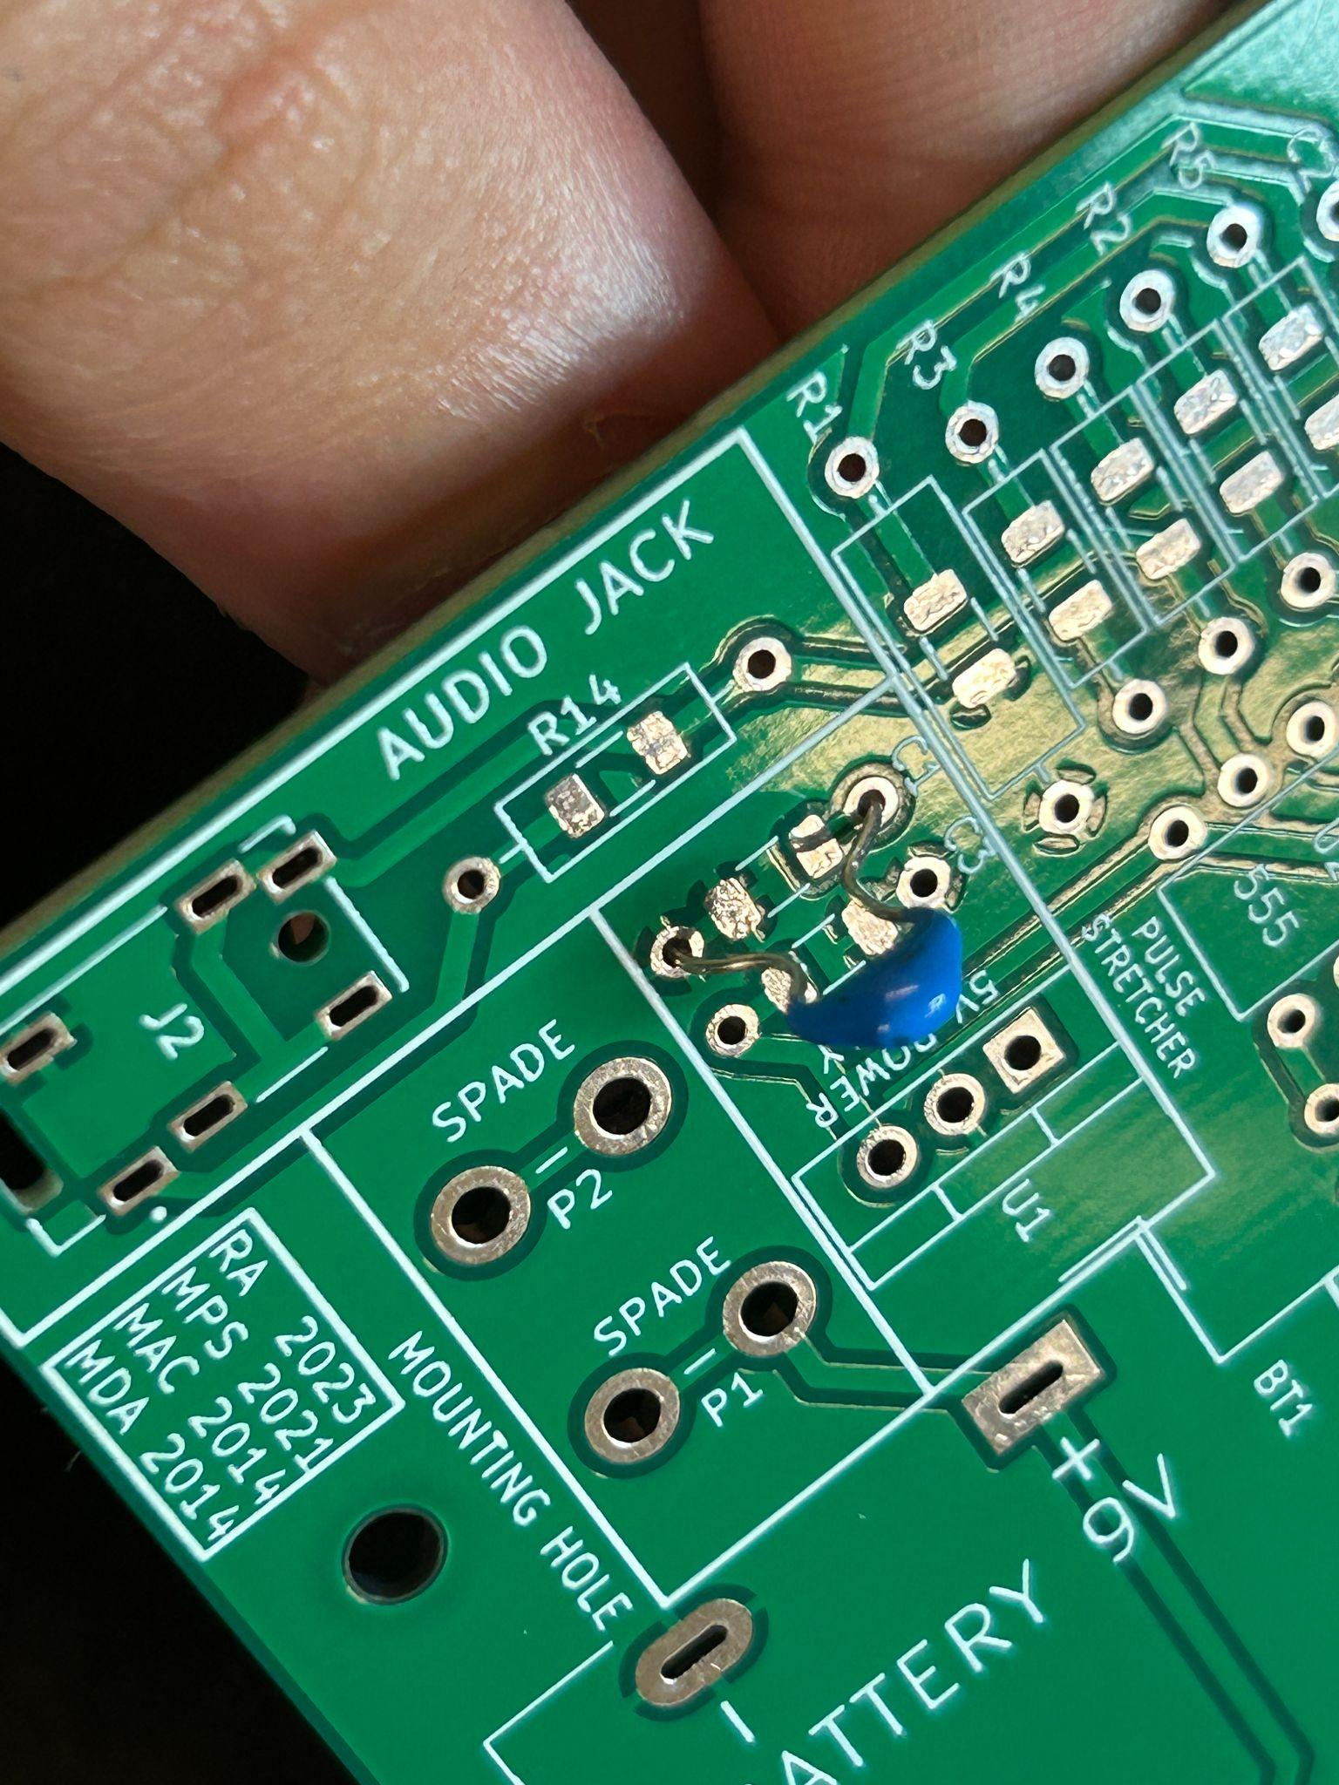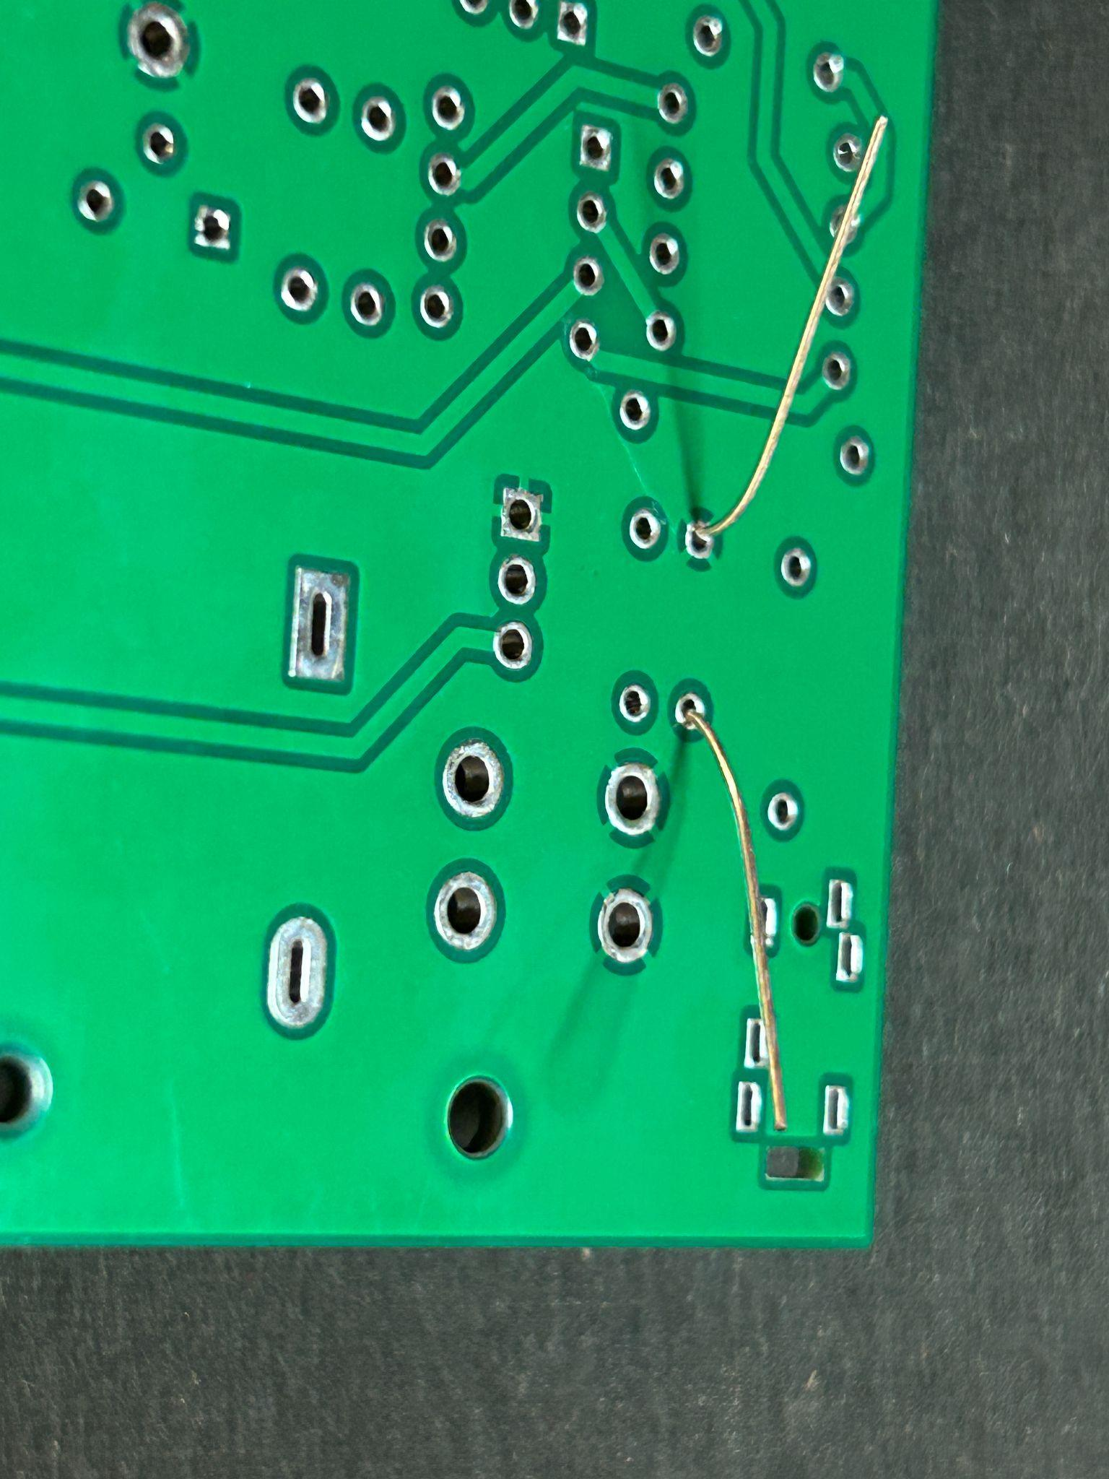

(Fig 8) (Fig 9)

Put the capacitor in so it sits close to the board and then flare out the ends, solder it in, and snip the ends. (Sidenote) The silvery looking pads between each one of the resistor holes makes it possible to use surface mount resistors and capacitors and/or through hole resistors and capacitors (the kind we’re using right now)

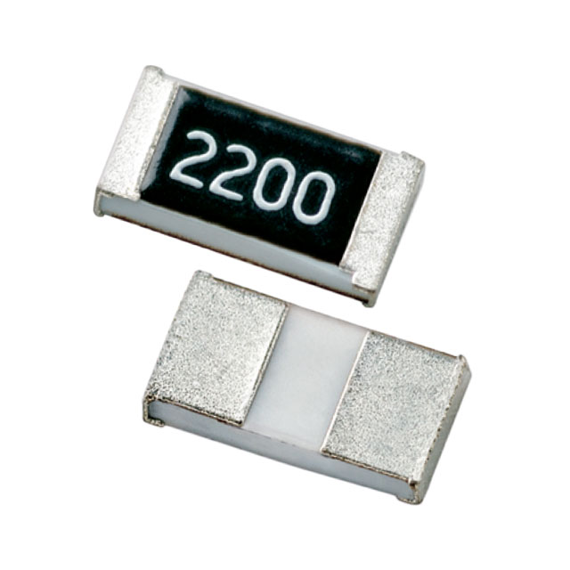

(Fig 10)

Here’s an example of a surface mount resistor for reference

(Source: Digikey HRG3216Q-15R0-D-T1)

**Section 3: The Diode**

The diode is like a one way valve but for electricity. This means it’s polarized and must **only go in one direction**. Our diode’s spot on the board is labeled **D2**. Make sure the silver line on the diode overlaps the line on the board’s outline of the diode

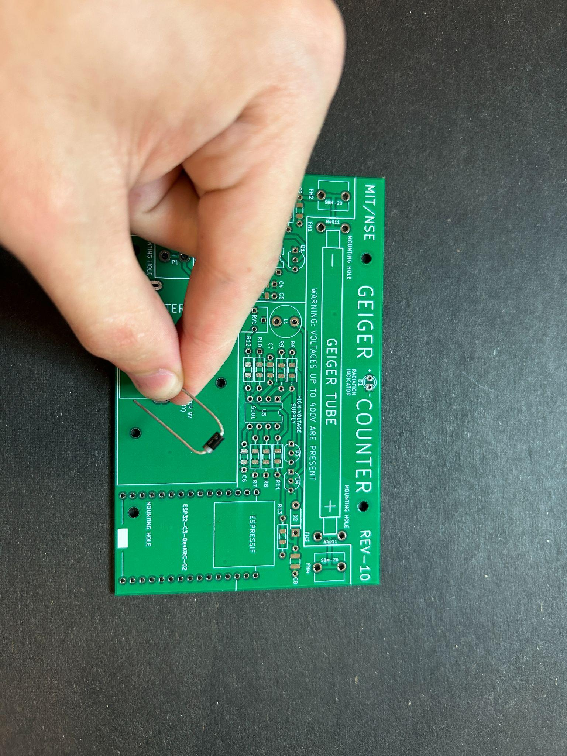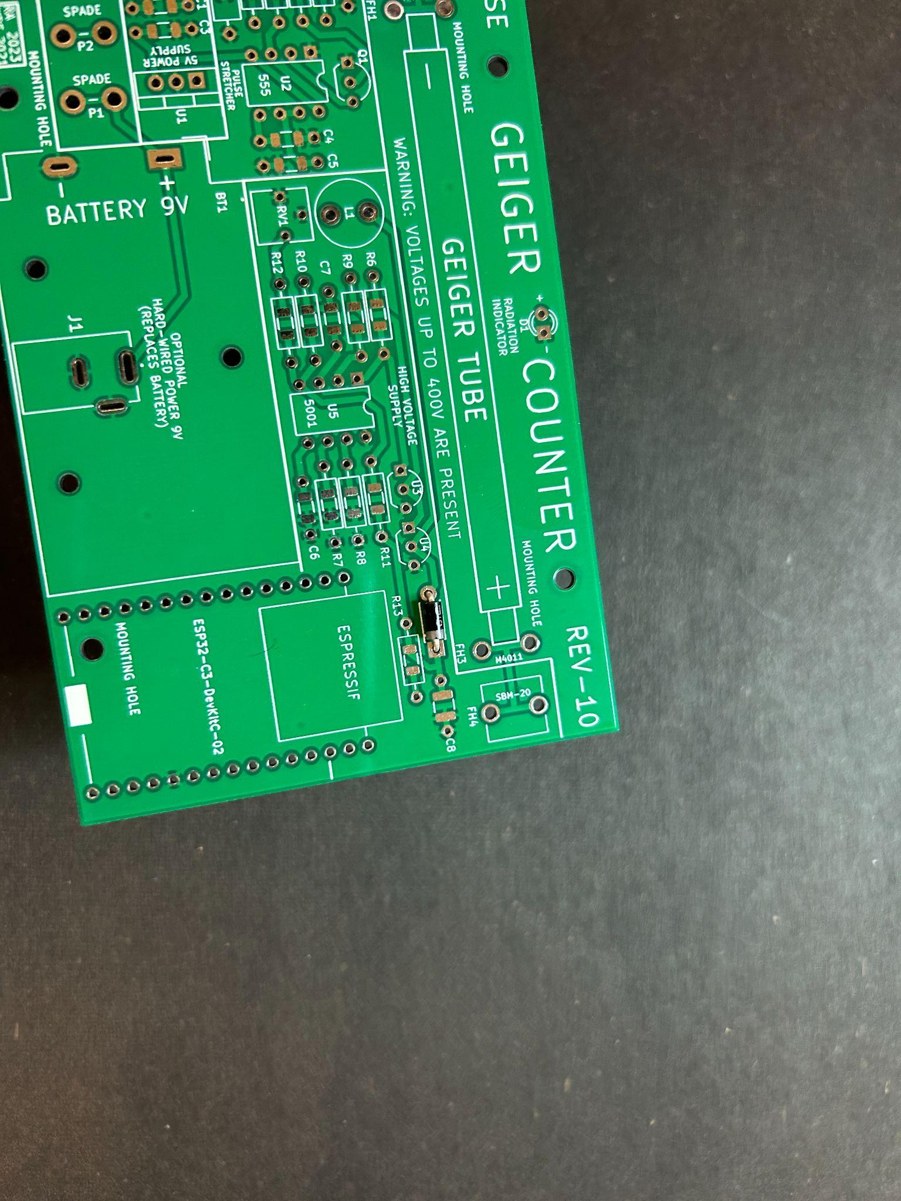

(Fig 11) (Fig 12)

From now on, if it’s not said, it’s implied that you will take the three steps to complete the installation of each component.

1. Bend Leads outward from the bottom to keep component attached to the board
2. Solder the component in to achieve sound electrical connection
3. Snip the excess leads from the bottom of the board

**Section 4: The LED**

The LED emits light which will be our main use, however it is also a diode (Light Emitting Diode), and therefore may **only go in one direction**.

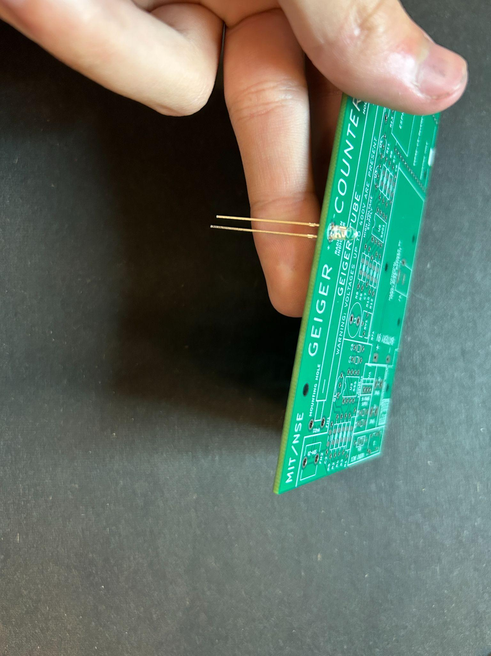

(Fig 13)

Notice how one lead of the LED is a bit longer. Now notice that there's an + and - sign next to the led hole labeled **D1**. The Longer lead goes into the hole labeled +.

**Section 5: The Potentiometer**

This is a potentiometer, it has three leads, and in our circuit it will allow us to vary the output high voltage that will bias our geiger tube. This is done by turning the dial on the top with a screwdriver. It’s labeled **RV1** on the board

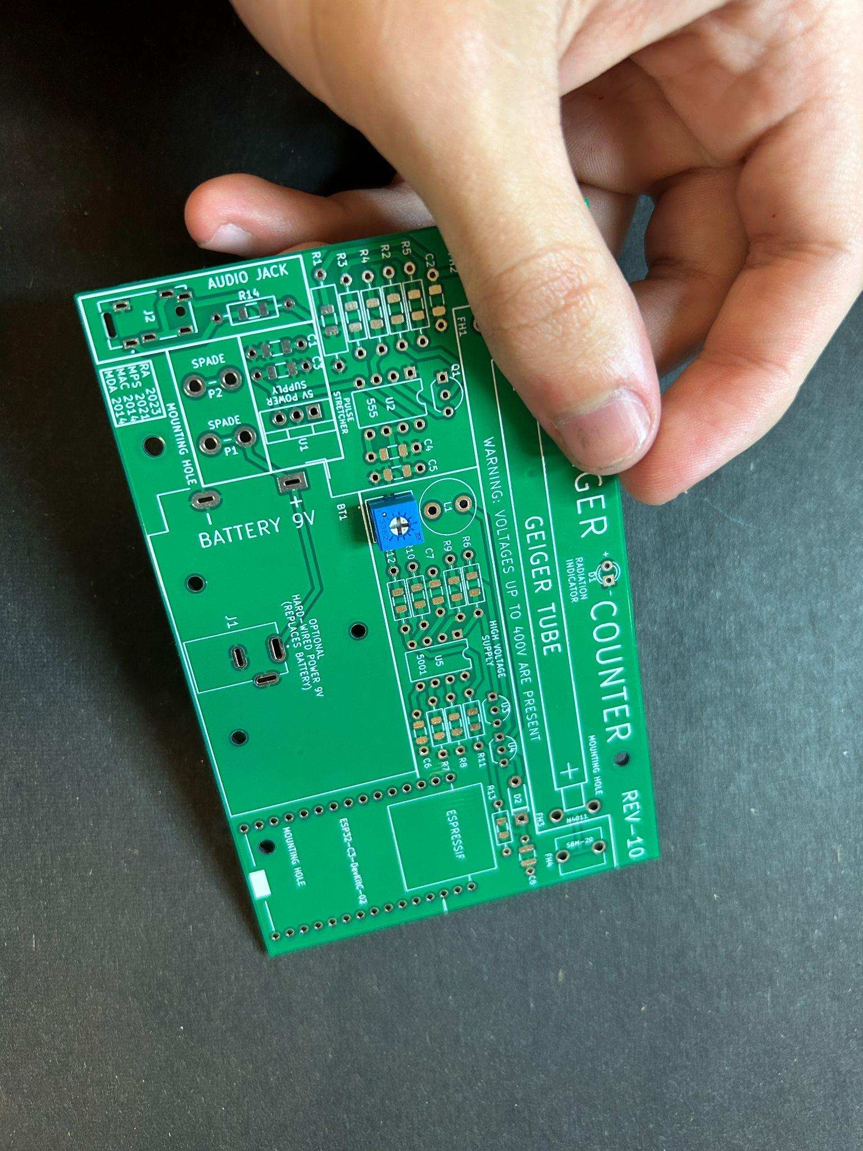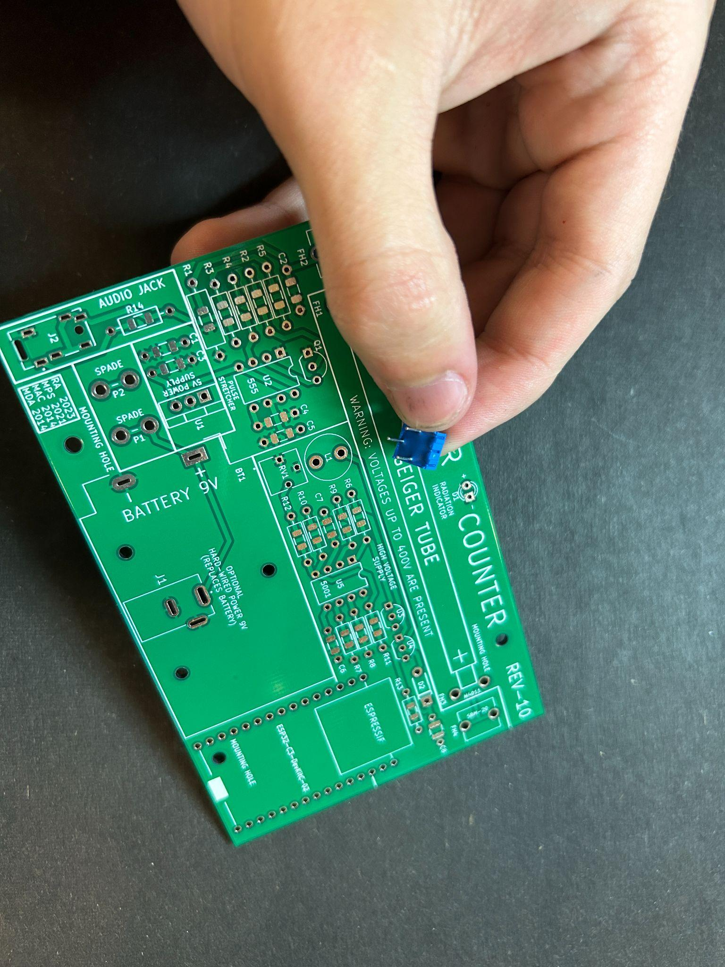

(Fig 14) (Fig 15)

**Section 6: The Inductor**

This is an inductor. It works to store energy in the form of a magnetic field. We use this property to generate our high voltage when switched on/off quickly. It’s labeled **L1** on the board. While one of the leads may be longer, the inductor **can go in either orientation**

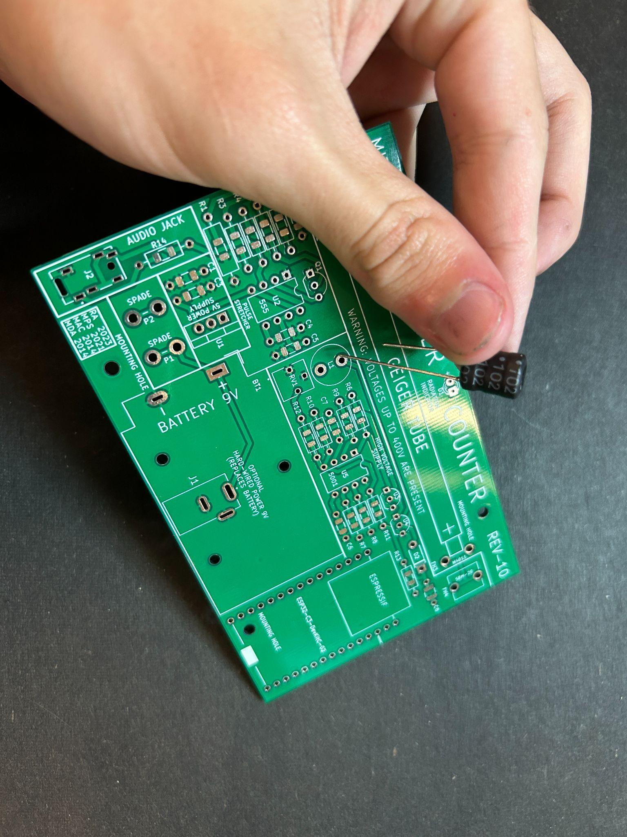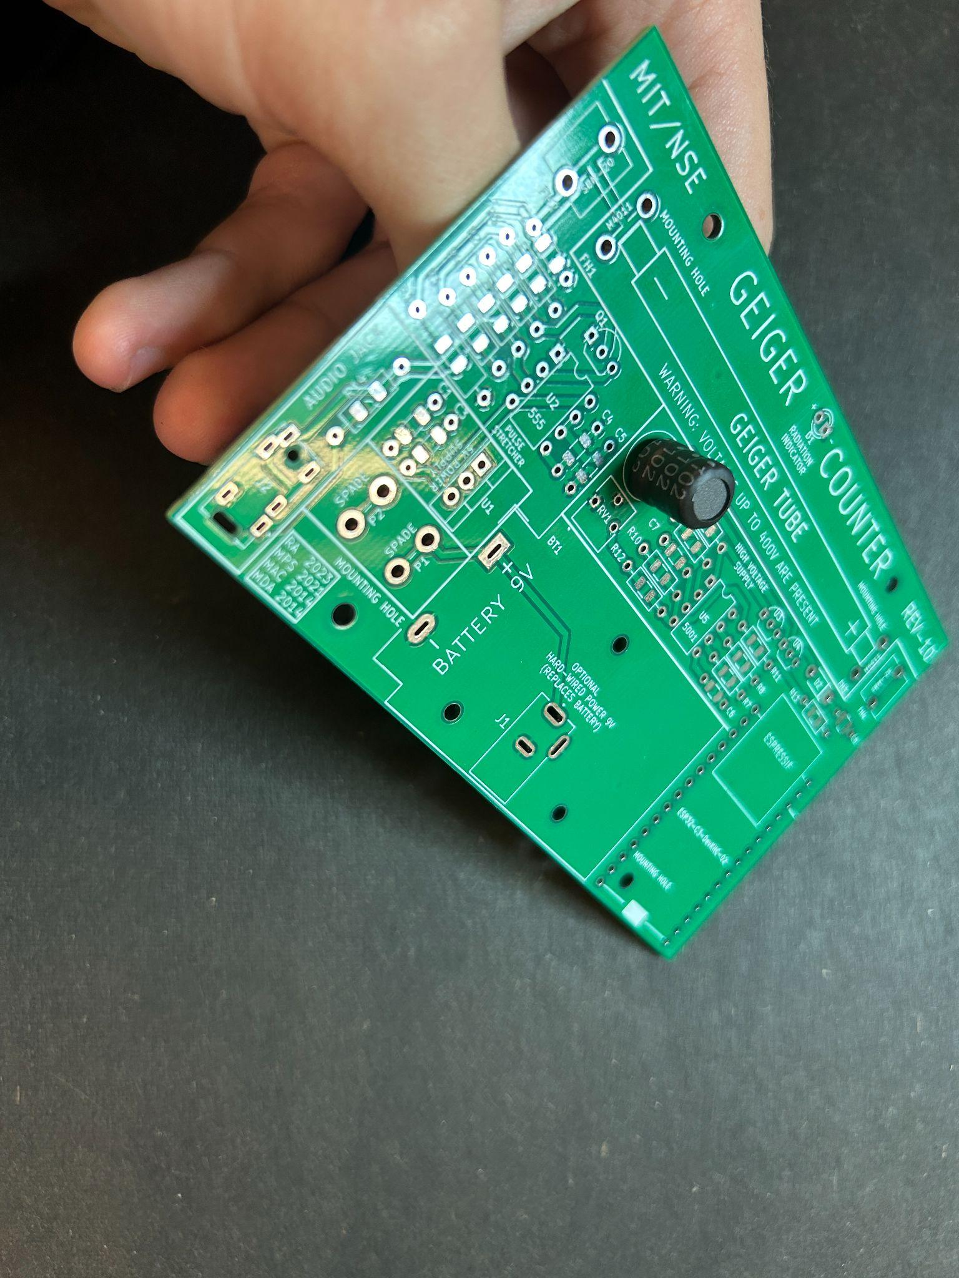

(Fig 16) (Fig 17)

**Section 7: The 2N3904 NPN Transistor**

The transistor is a pretty simple invention. At the most basic level, a transistor is to electricity as a ball valve is to water. When the top is turned water can flow.

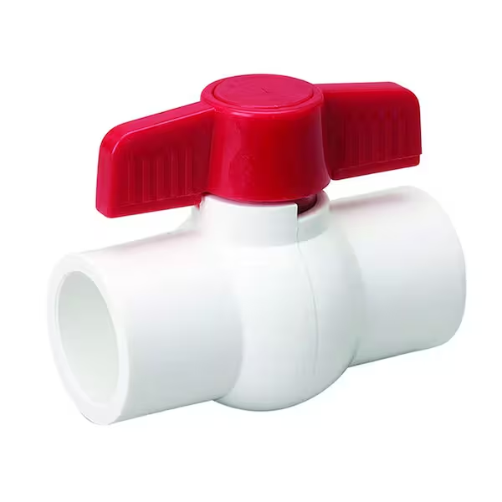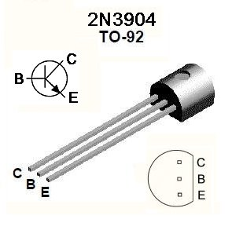

(Fig 18) (Fig 19)

(Src: Home Depot 1-1/4 in. PVC S x S Ball Valve) (Src: Wikimedia File:2n3904.jpg)

The base (labeled **B**) of the transistor is like the red part of the valve that you twist. When positive voltage is applied to the base of the 2N3904, current is allowed to freely pass from the collector (labeled **C**) to the emitter (labeled **E**). Otherwise, current is not allowed to pass.

There are many types and variants, but they all operate on that same basic principle.

We have one 2N3904 in our geiger counter to help with the pulse detection. The transistor must **only go in one direction**. The circuit board has a white outline of the top of the transistor, line it up. Our 2N3904 is labeled **Q1** on the board. You may want to bend the leads out a bit before inserting it.

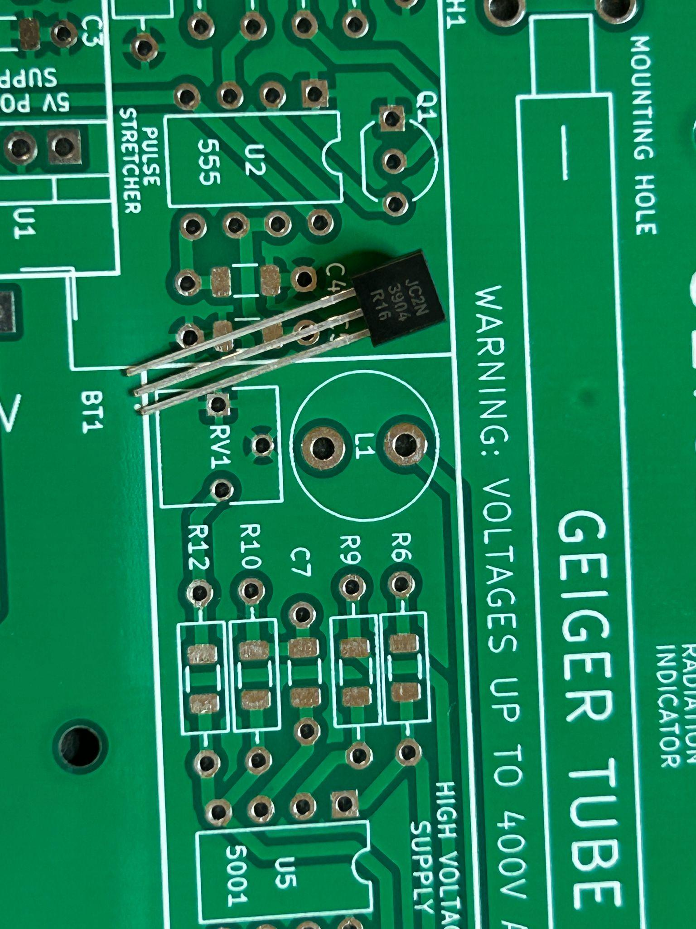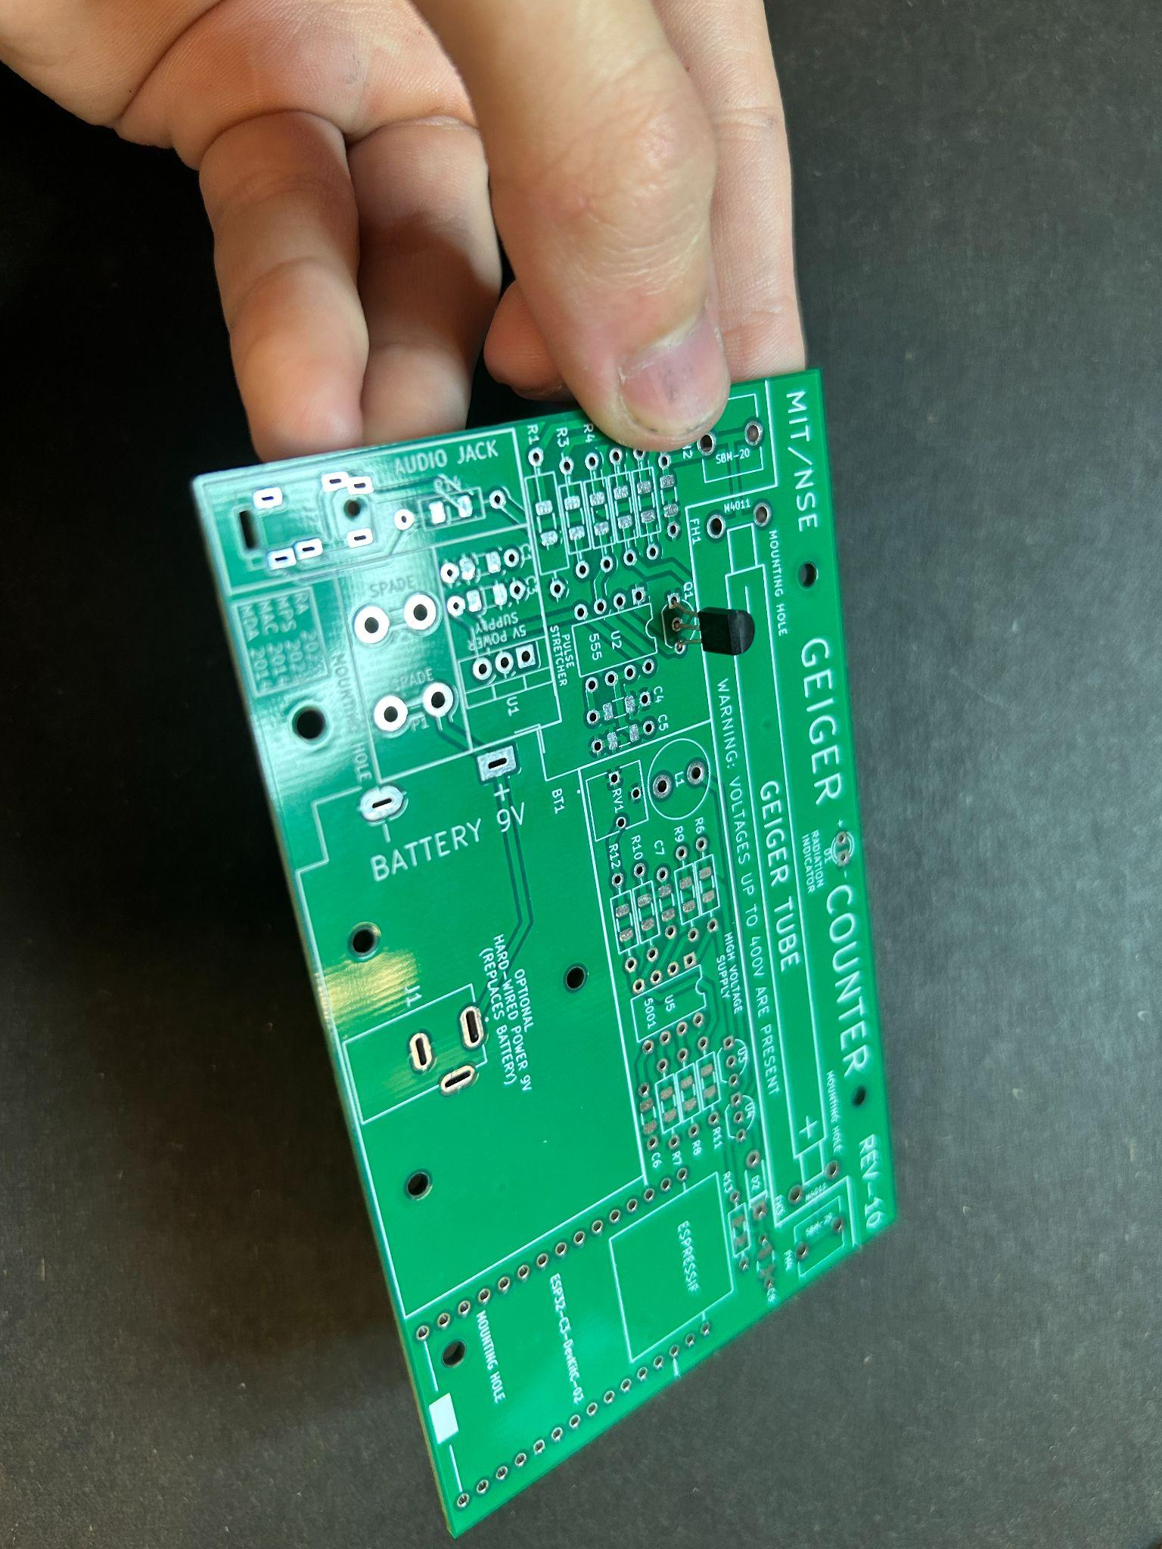

(Fig 20) (Fig 21)

**Section 8: The N-Channel MOSFET**

A N-Channel MOSFET (metal-oxide-semiconductor field-effect transistor) really does about the same thing as the classic NPN transistor we just talked about. It’s just better at switching on and off quickly and uses less energy.

We have two in our circuit that are responsible for connecting and disconnecting a piece of the circuit that bridges across the output side of the inductor and ground. If you do this really quickly high voltage at the output is generated. That idea is the basis of the boost converter.

They are **U3** and **U4**, and again may **only go in one direction**. Align their tops with the white silkscreen on the board.

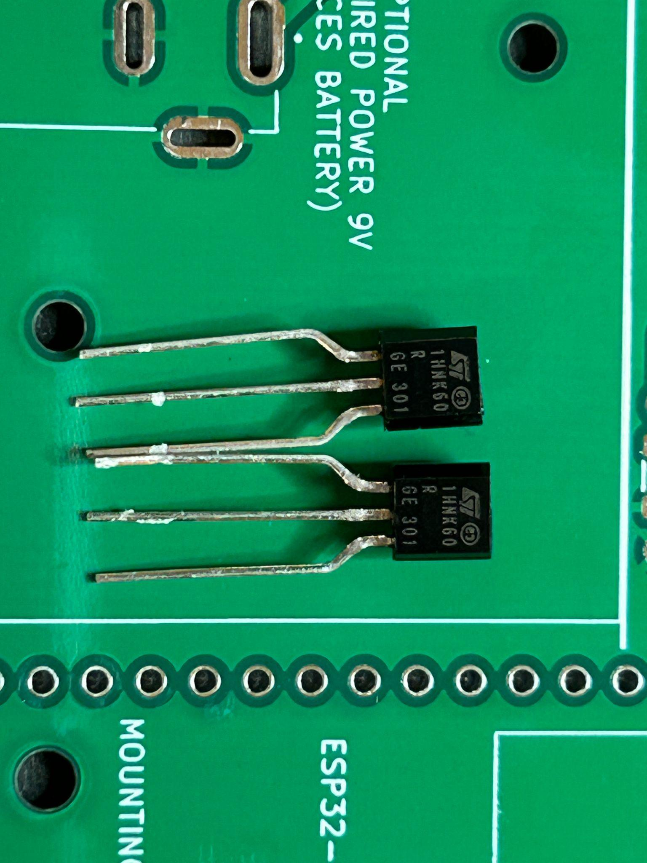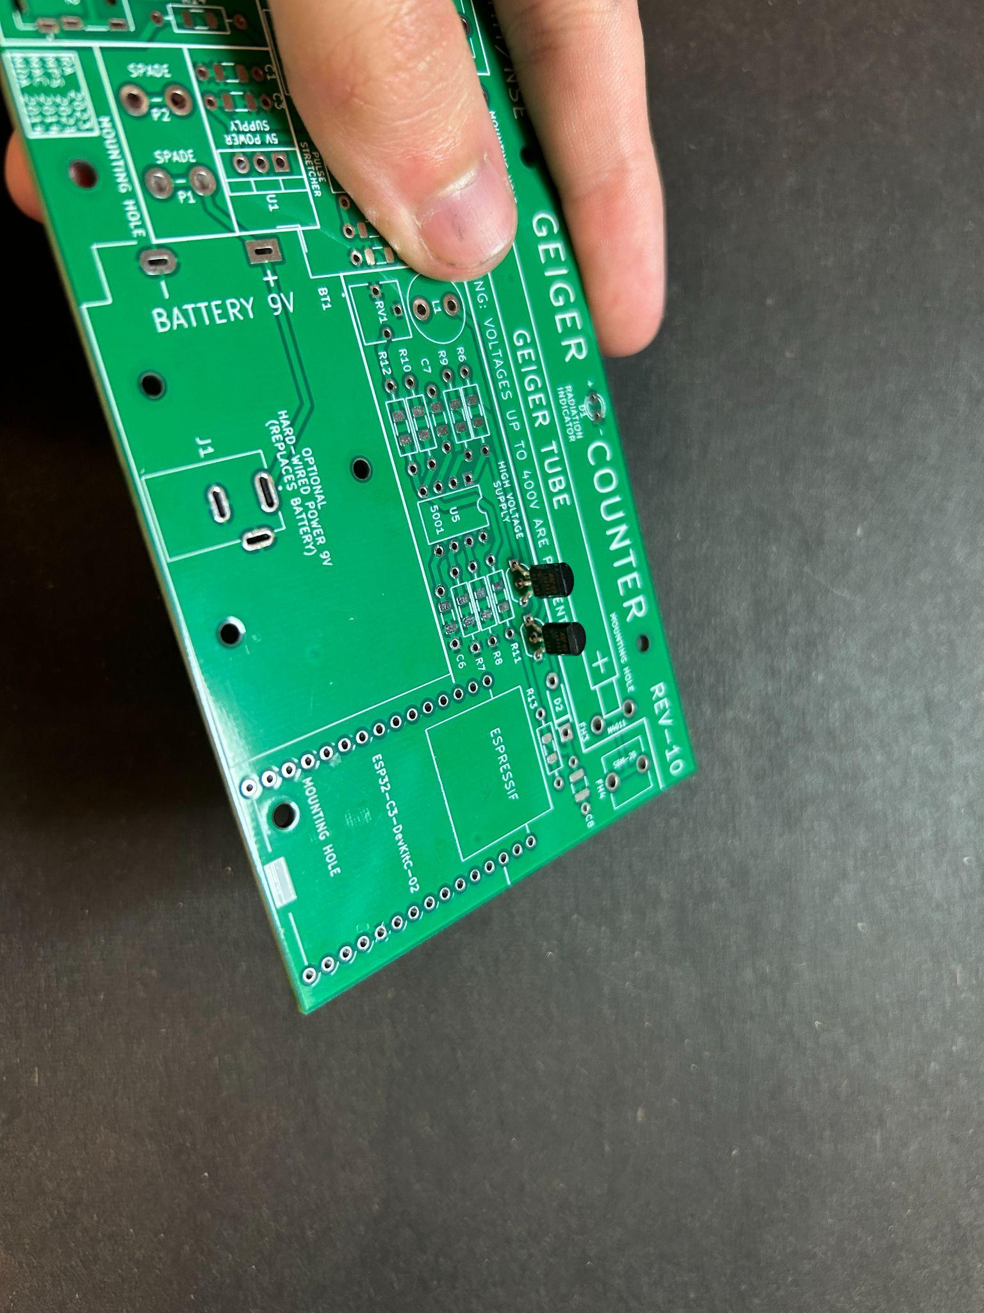

(Fig 22) (Fig 23)

**Section 9: The Header pins**

To make it easy to connect and disconnect the ESP32-C3-DEVKITC-02 to the circuit board we use header pins 15 long. It’s important that these are soldered onto the board directly up and down so everything fits nicely.

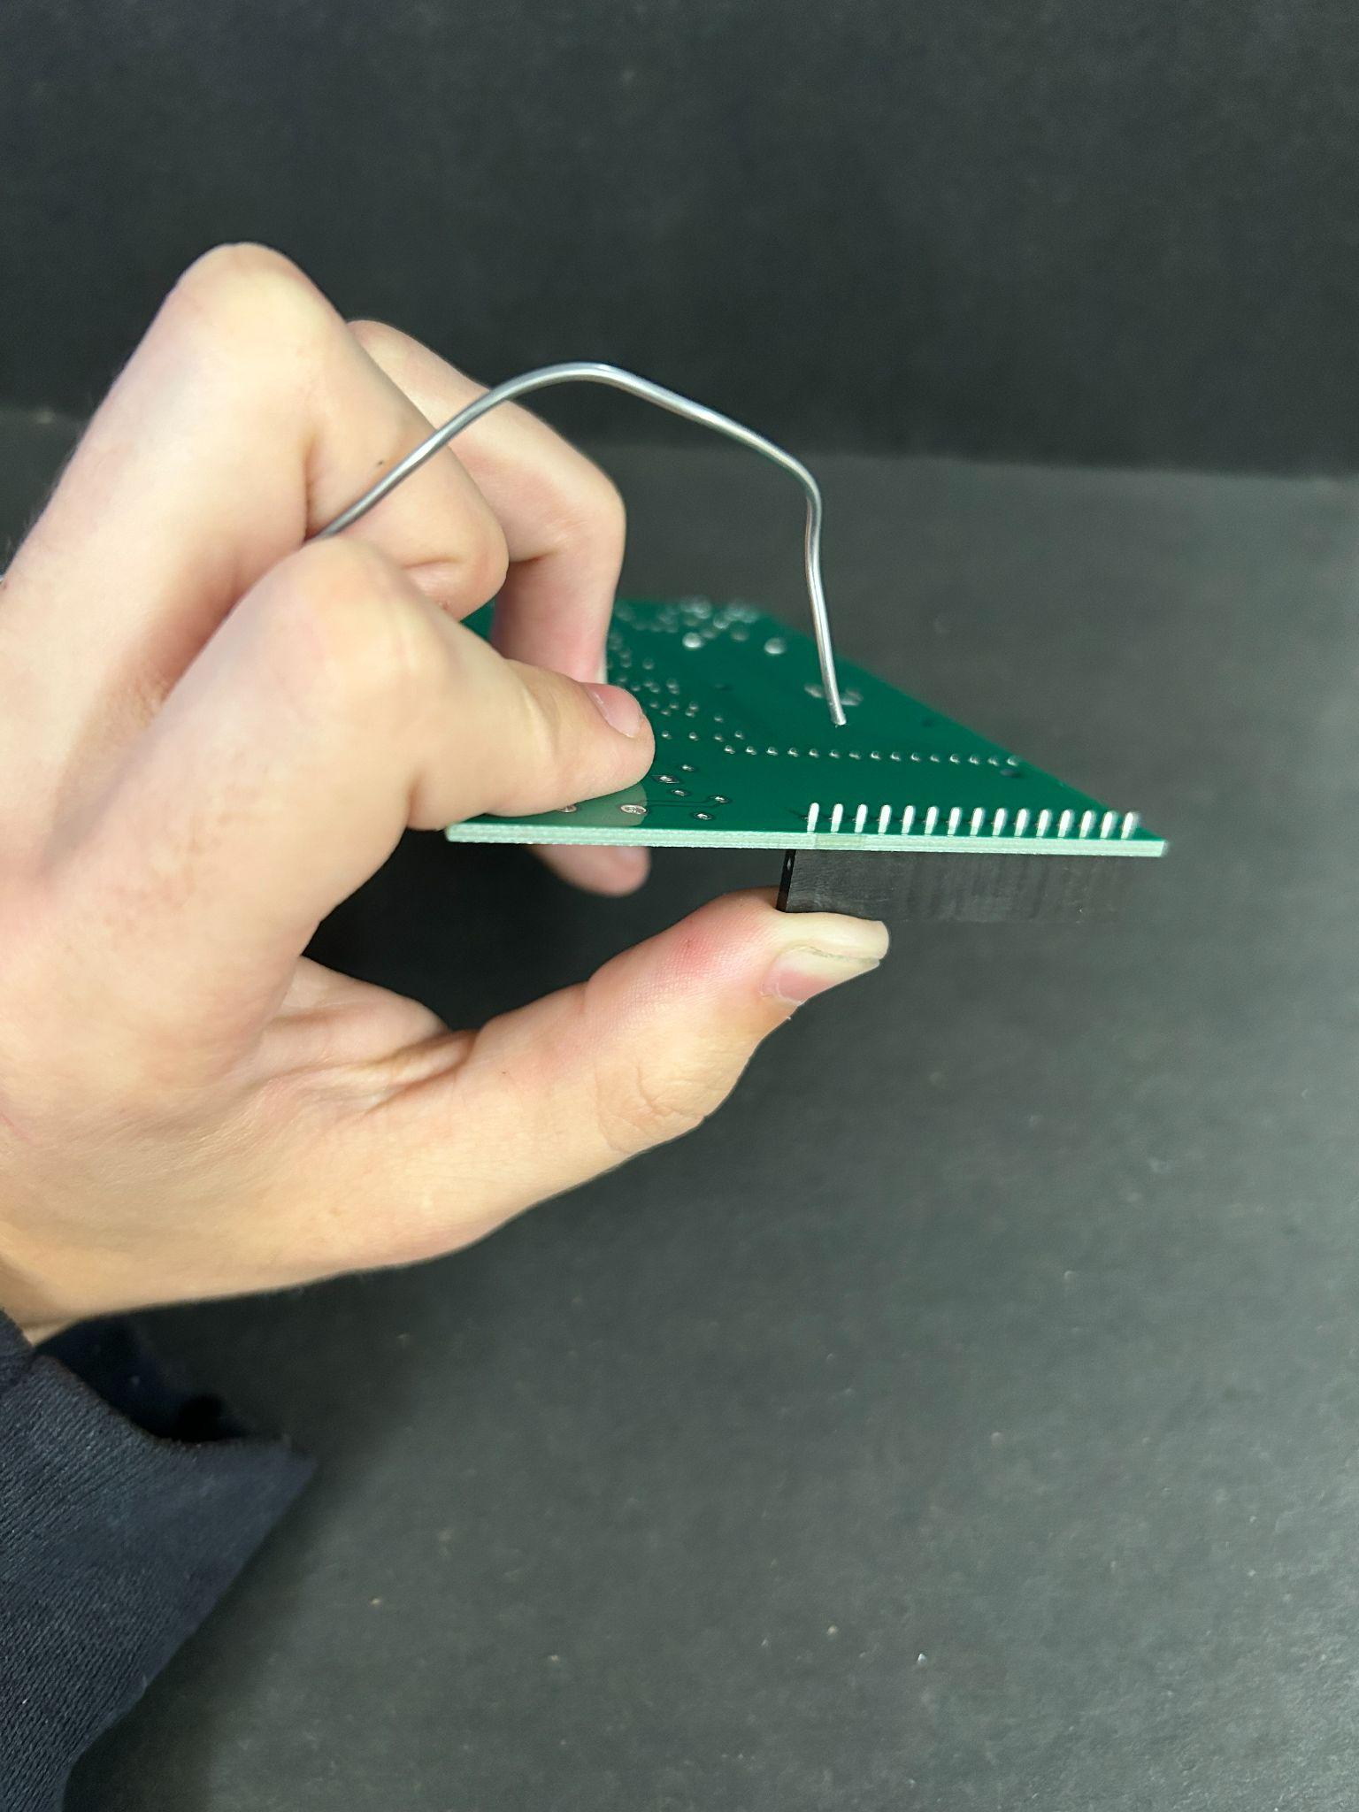

(Fig 24)

This is not easy, the best way to do this if you don't have helping hands is to hold the header to the board while also holding solder in the same hand. Use your other hand to hold the soldering iron and get two quick soldiers on the first and last pin of the header. Then once stable, solder the pins between the first and last, plus re-doing the ones between to ensure good connection. Do this twice

**Section 10: The DIP-8 Sockets**

DIP stands for, Dual Inline Package, and 8 signifies how many pins it has in total. We have two DIP-8 sockets. One is for the LMC555 **U2** we use, and another is for the TL5001 **U5**

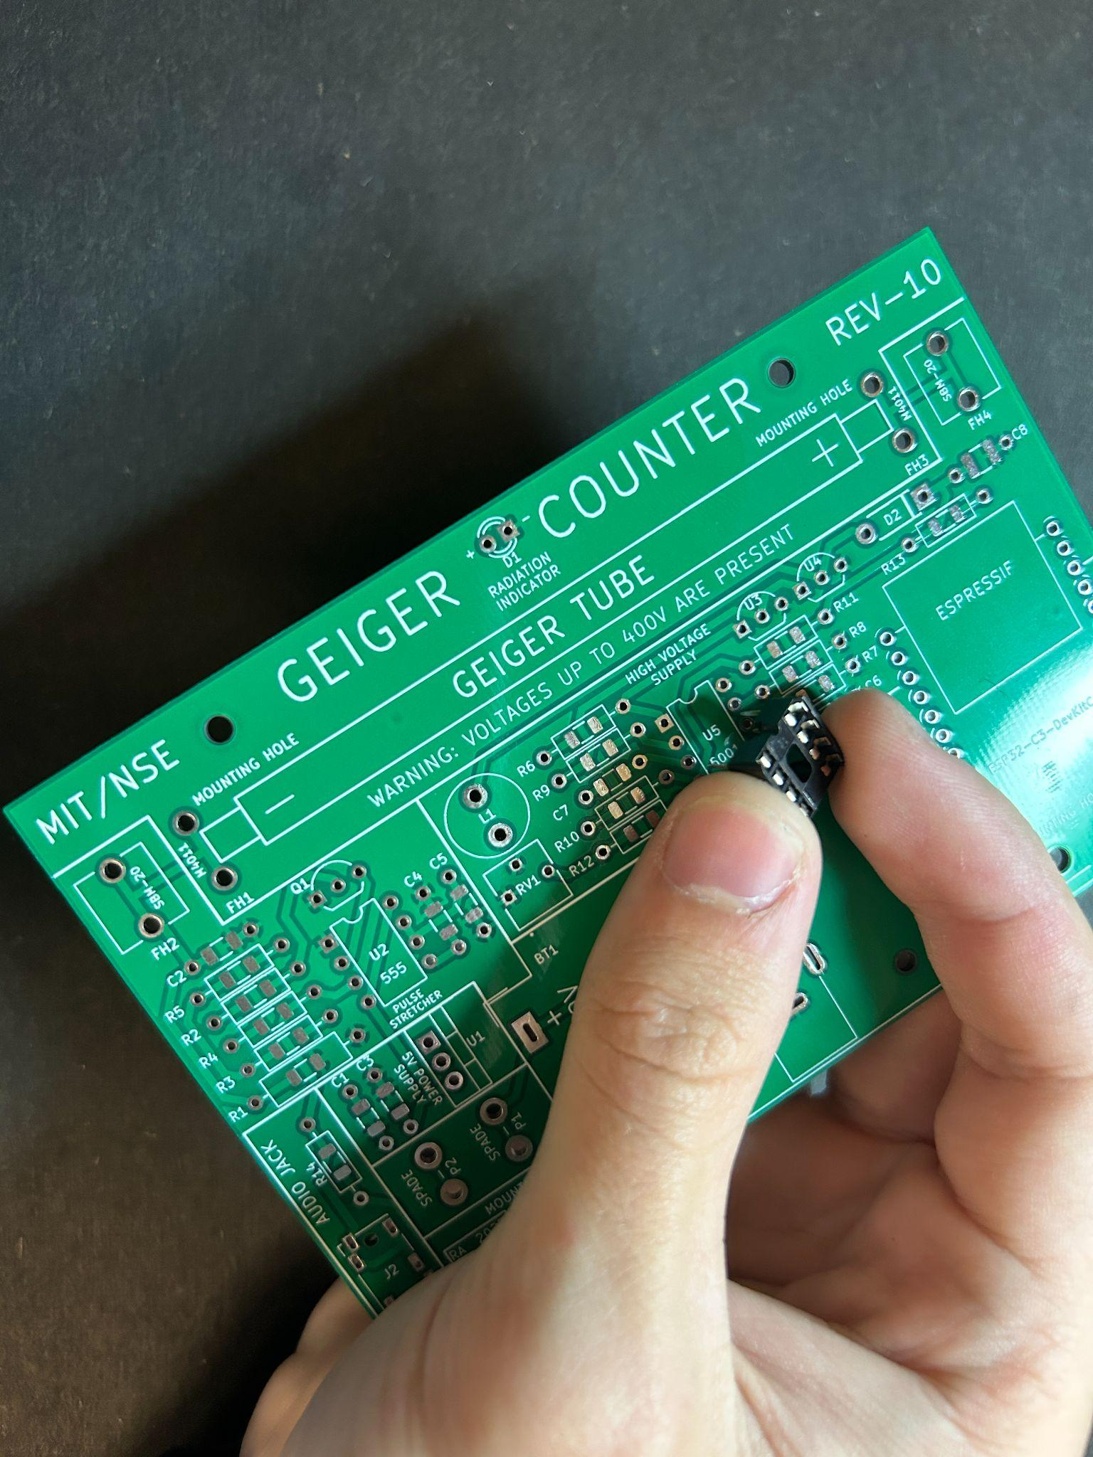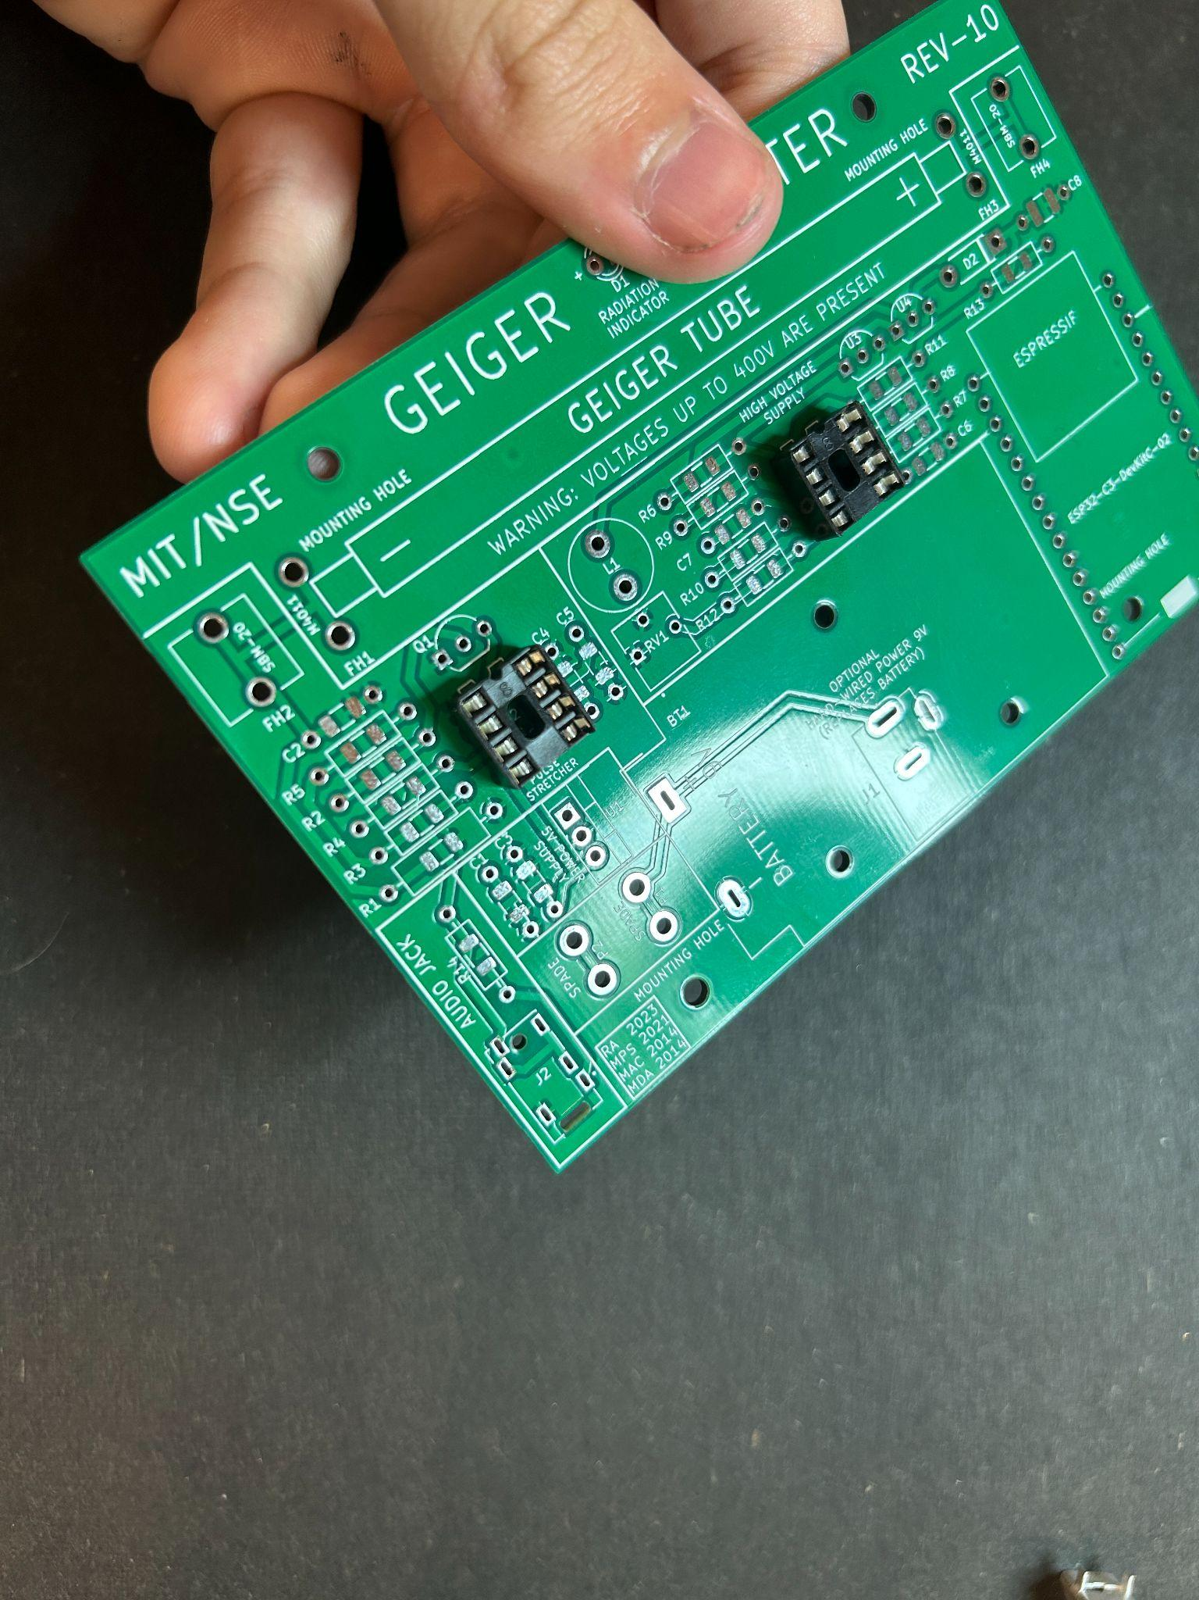

(Fig 25) (Fig 26)

Make sure the notch on the top of the DIP-8 socket lines up with the notch on the board for both the 555 and 5001.

Solder the sockets one by one. If you don't have helping hands to make it easier hold use a similar technique to that discussed in the previous section on the headers.

Please refrain from putting in the 555 or 5001 chip till later so they don't get damaged.

**Section 11: The Spades**

In this build we use spades to connect the board to a switch. This lets you remove the top case easily to adjust things as you see fit while being able to have a nice case mounted switch. Spades are also tricky to solder in place correctly upright. Find the spades included in your kit, and the set of holes labeled **spade** .

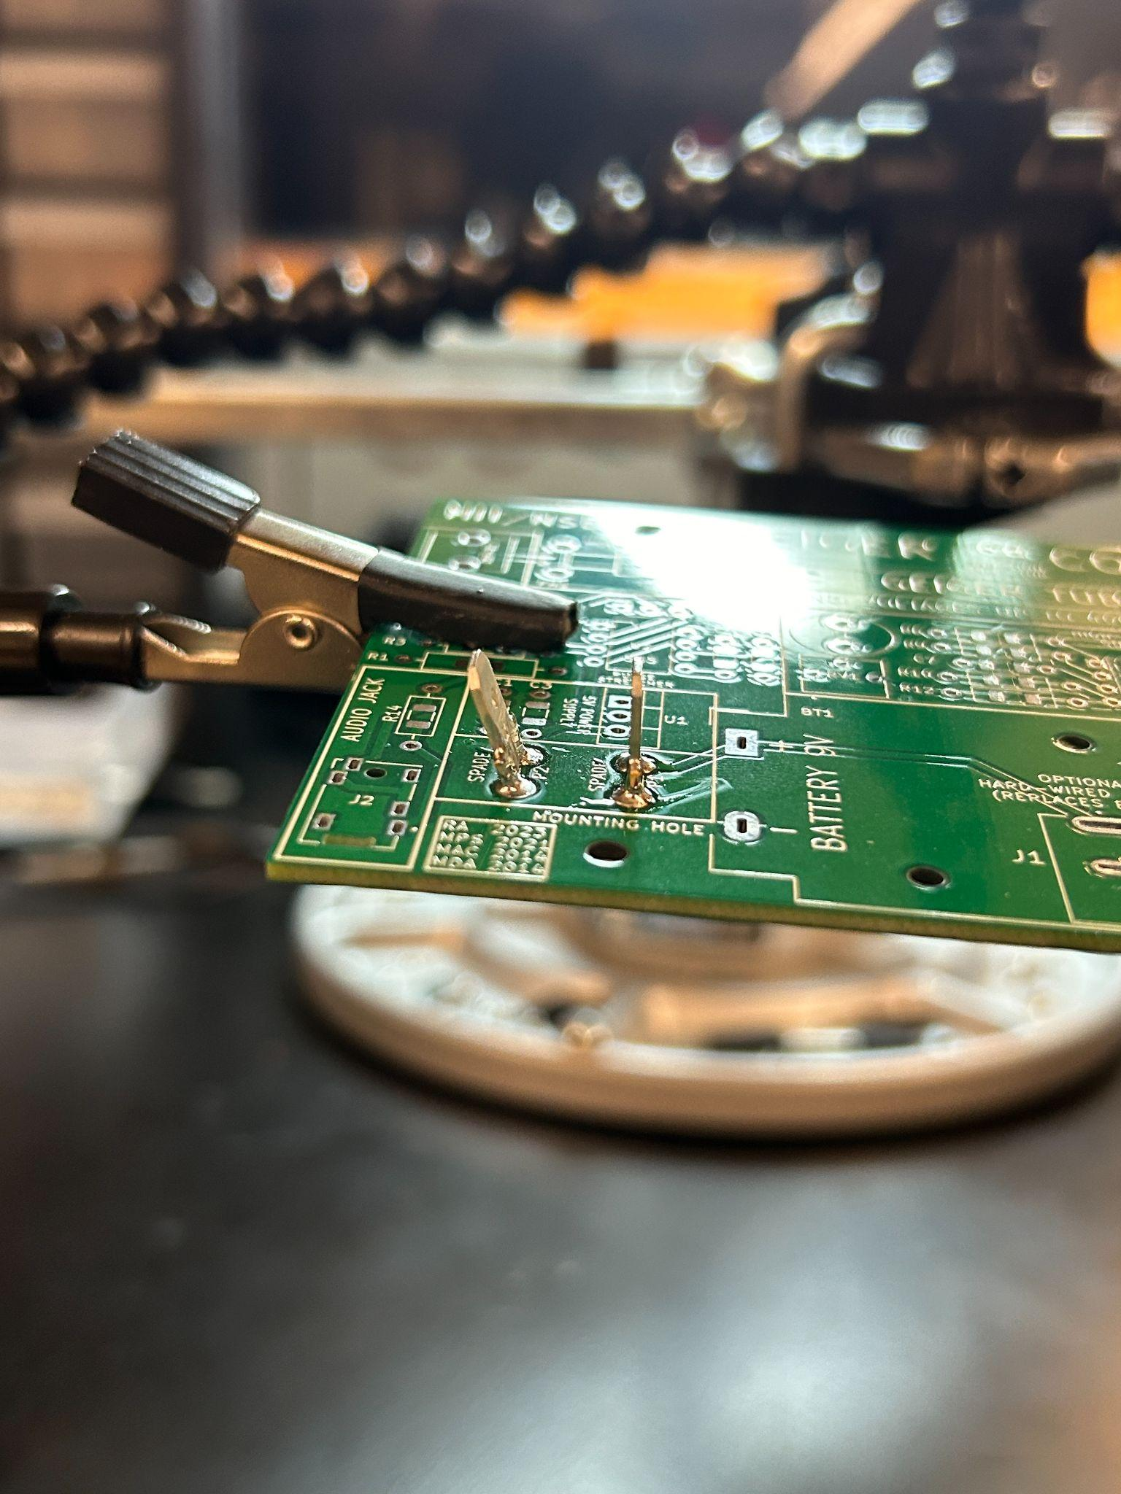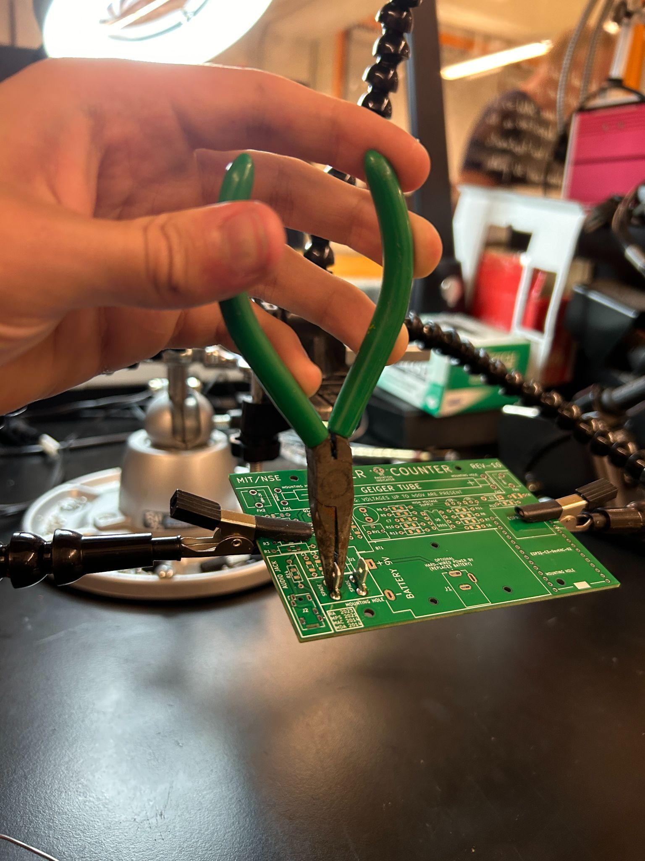

(Fig 27) (Fig 28)

I would recommend first soldering in the spades just lying in the holes without any help and then going back and re melting both all the solder at the same time while holding the spade with pliers. After the solder is liquid orient the spade up and wait for it to solidify before letting go of the spade. Feel free to try other methods if you would like.

**Section 12: The Headphone Jack**

If you want to hear geiger pulses through headphones you can! We’ll be soldering on an audio jack to let us do this. The holes are quite small, however not impossible by any means. Find the audio jack and corresponding board position (**J2**) and solder it from the bottom.

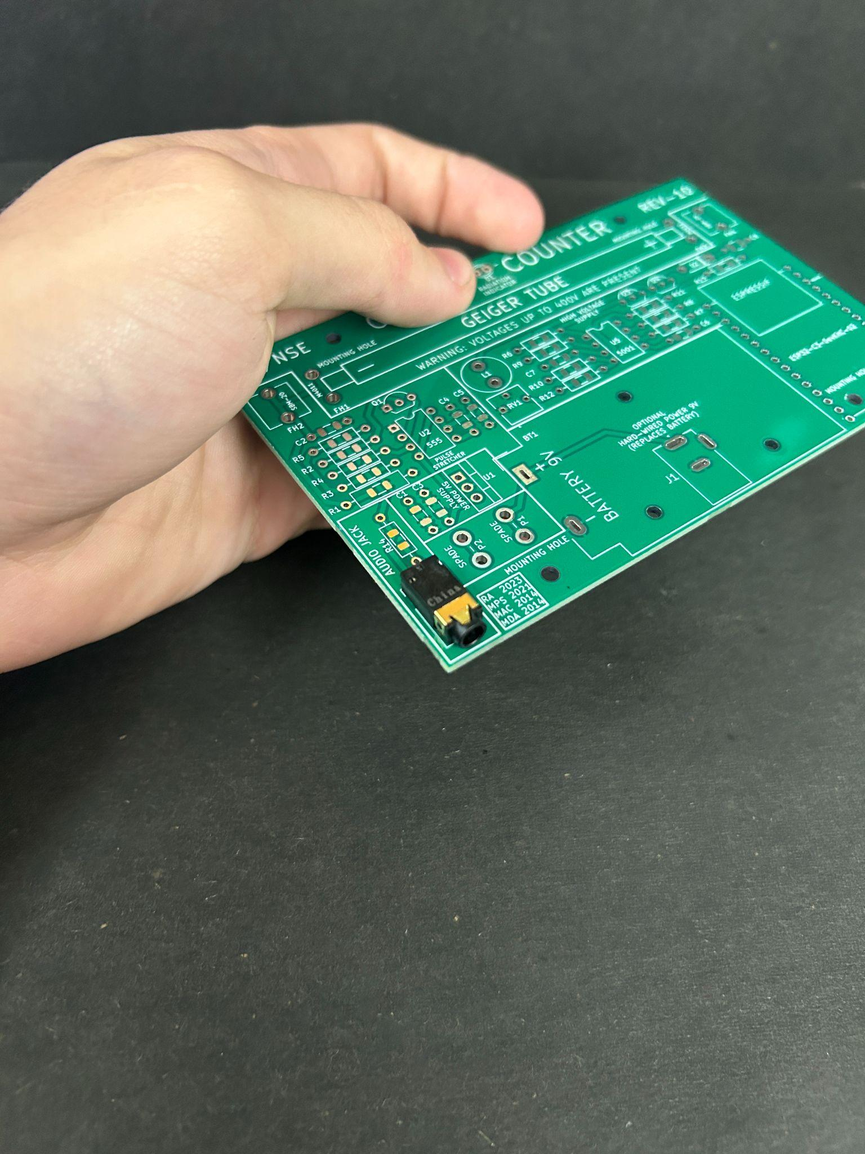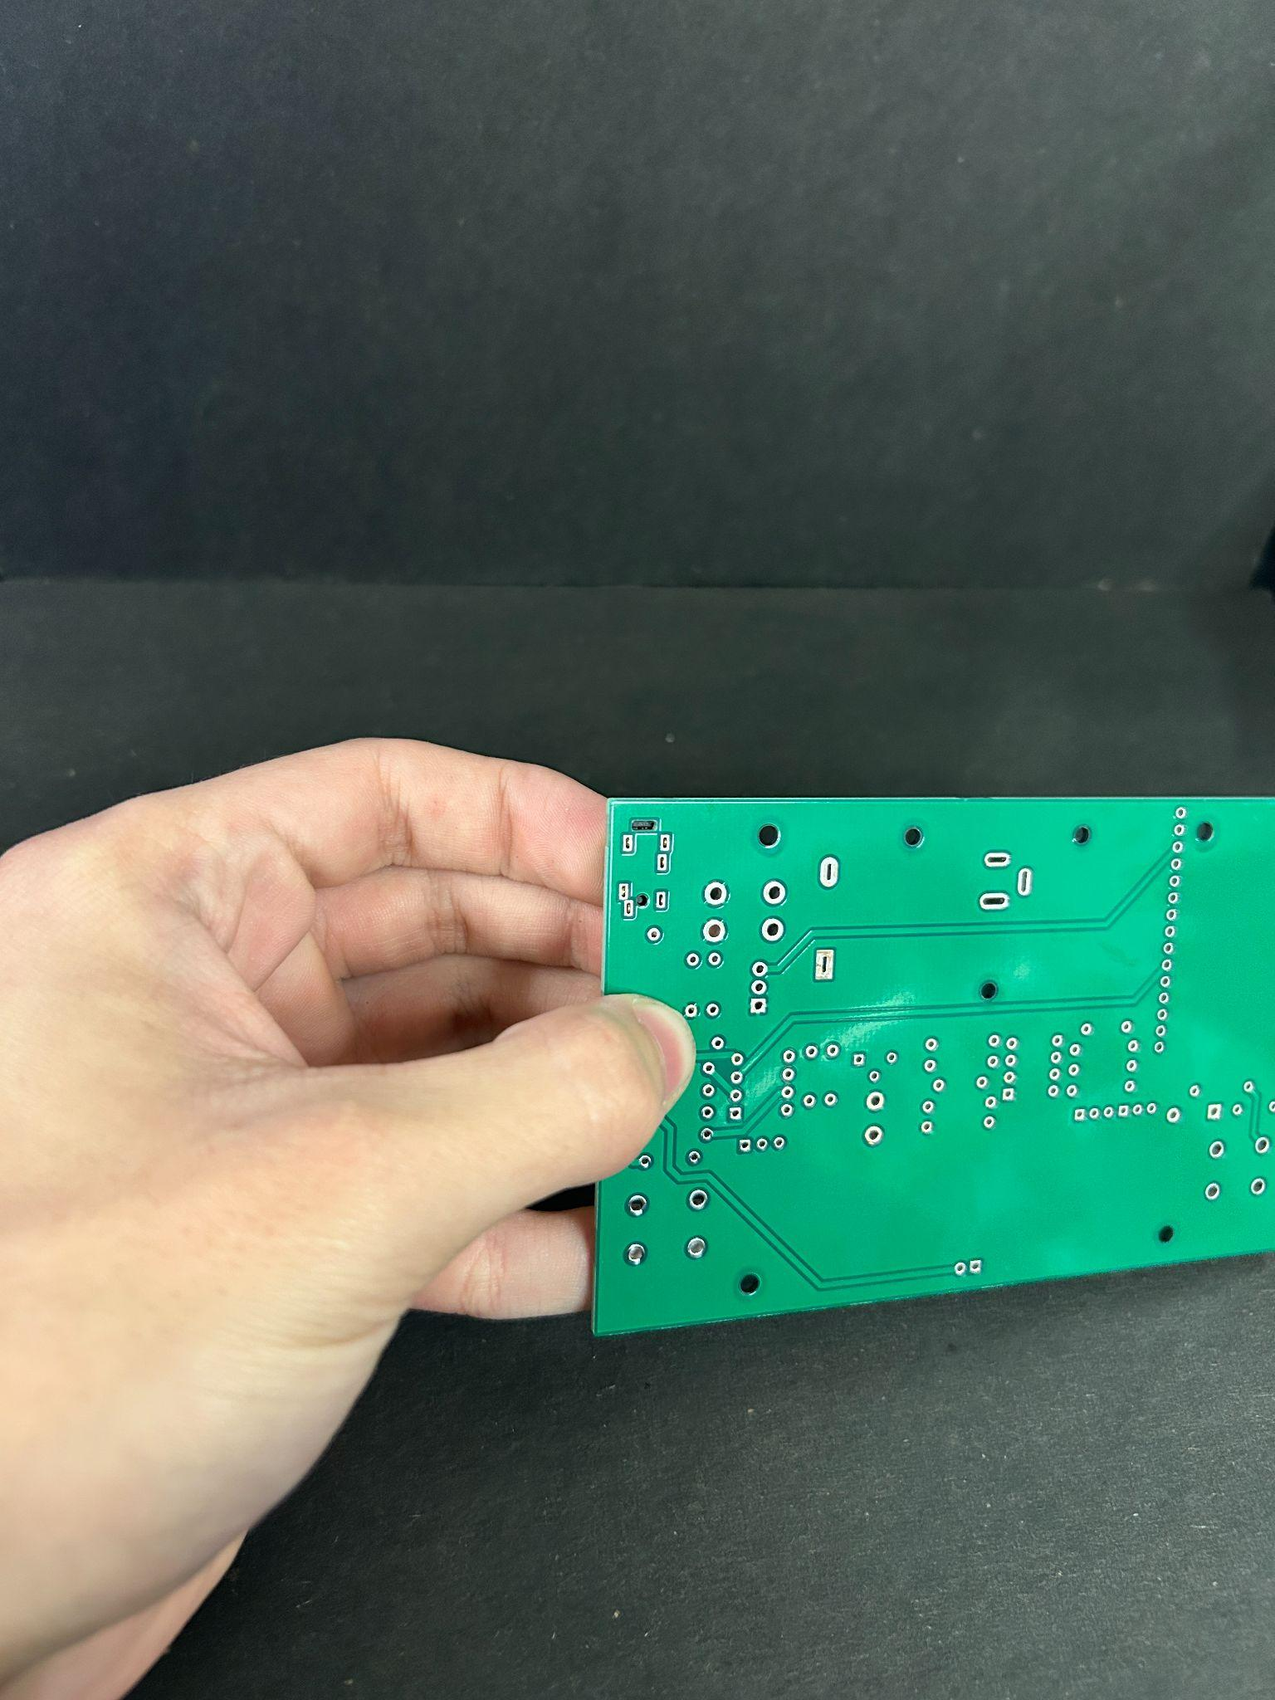

(Fig 29) (Fig 30)

**Section 13: The Voltage Regulator**

To run the 555 chip and the ESP32-C3-DEVKITC-02 we use a 5v 500mA linear voltage regulator to turn the 9v into 5v. The only thing tricky here is orientation. The linear voltage regulator must **only go in one direction**. The regulator has the denotation of **U1** on the board

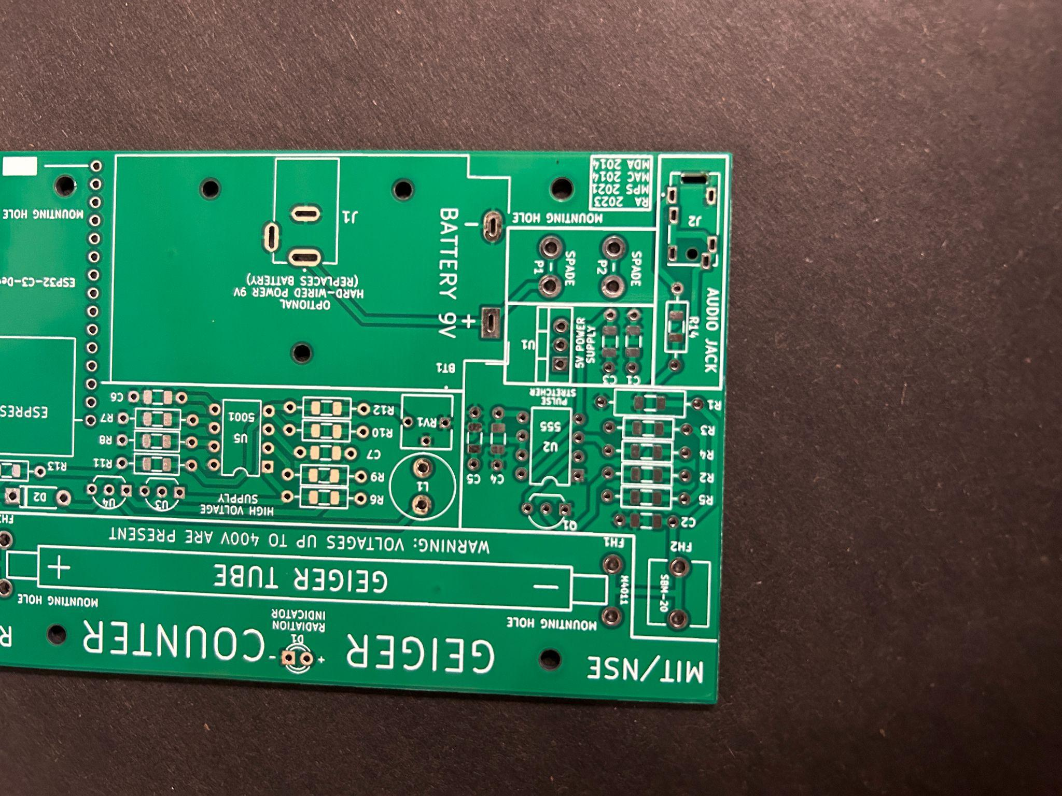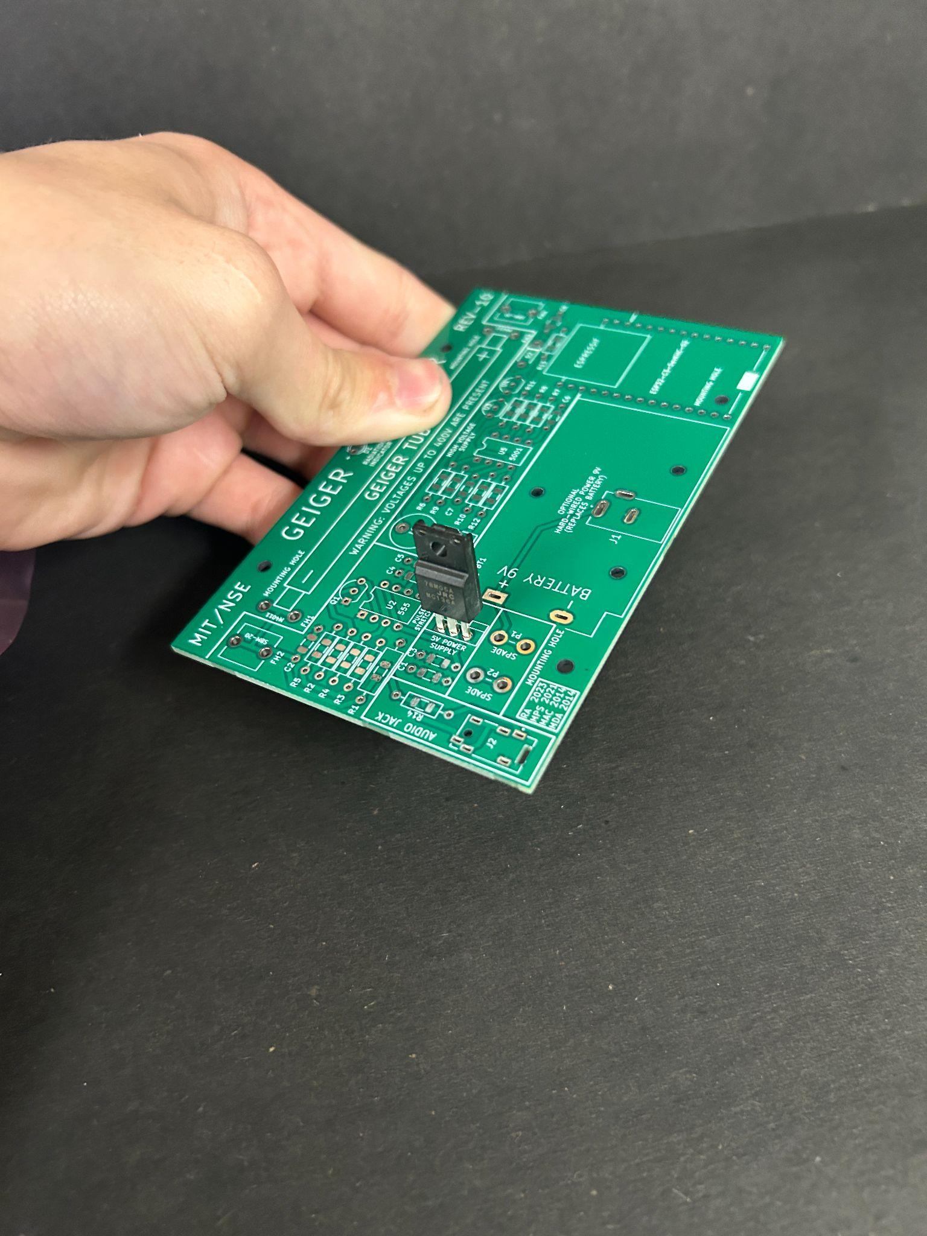

(Fig 31) (Fig 32)

As shown in Fig 32 the regulator needs to have its flat side facing the part of the white silkscreen that has three rectangles next to each other.

**Section 14: Picking a Geiger tube**

You may be thinking “I only have the tube that came with the kit” which is true, however if you would like to learn about the tubes you are able to run with this counter, read this section. There are two main choices that this board was designed for. Those being the classic SBM-20 soviet era geiger tube (top), and the modern M4011 geiger tube (bottom).

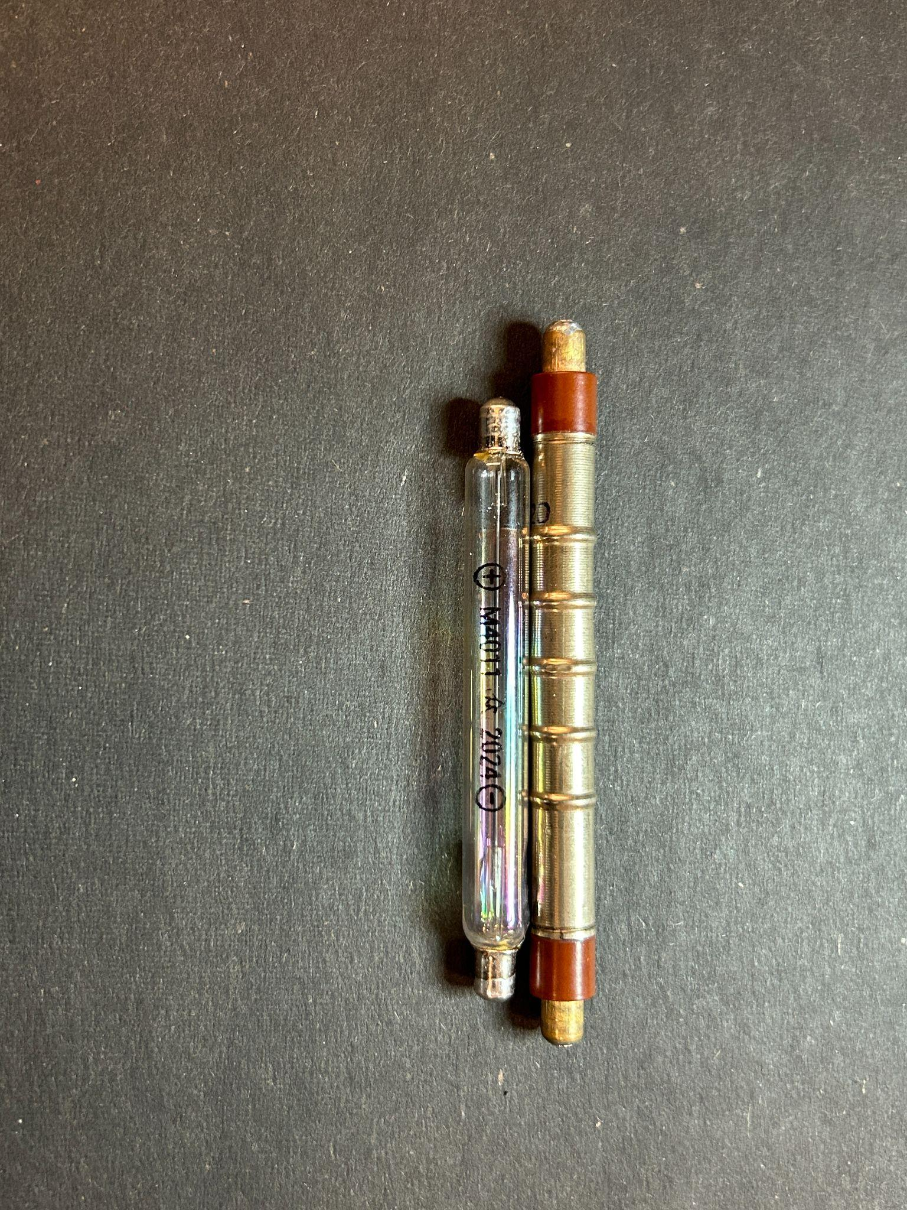

(Fig 33)

The M4011 was chosen because of its wide availability and the fact that it’s being actively manufactured.

(sidenote) the M4011 may also be sold as the J321 or other variants. The most important thing is that the tube is around 88-90mm long, 10mm diameter, and has similar working voltage.

Both tubes work quite well however if you decide to choose the M4011 there are some additional considerations

**Section 15: Additional M4011 Considerations**

One of the main reported disadvantages to the M4011 is that it **may or may not** be light sensitive. It has therefore been advised to cover the tube in heat shrink to block the majority of the light that comes in contact with the tube. Be sure to mark the + and - sides so you don't forget

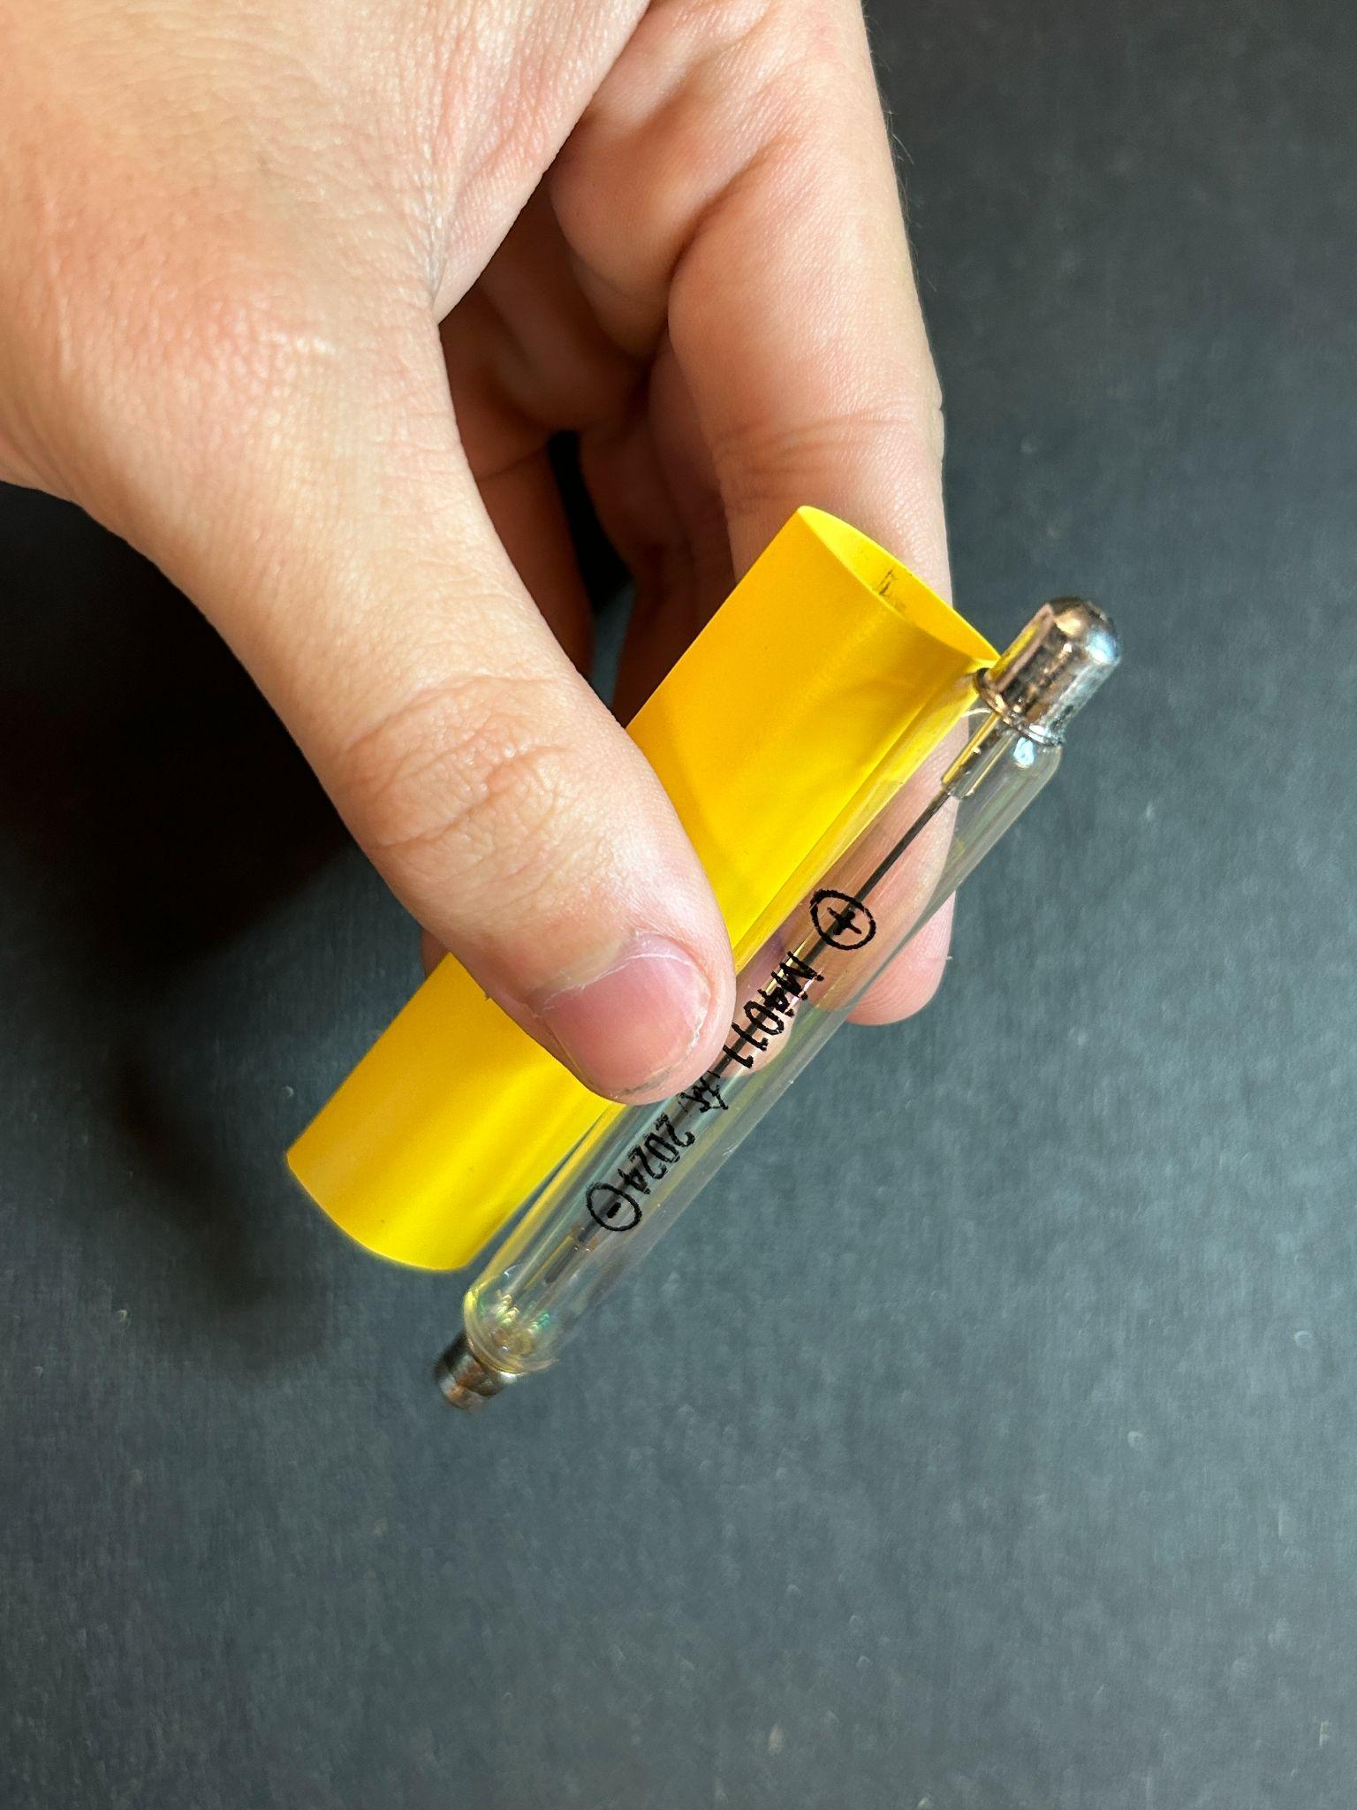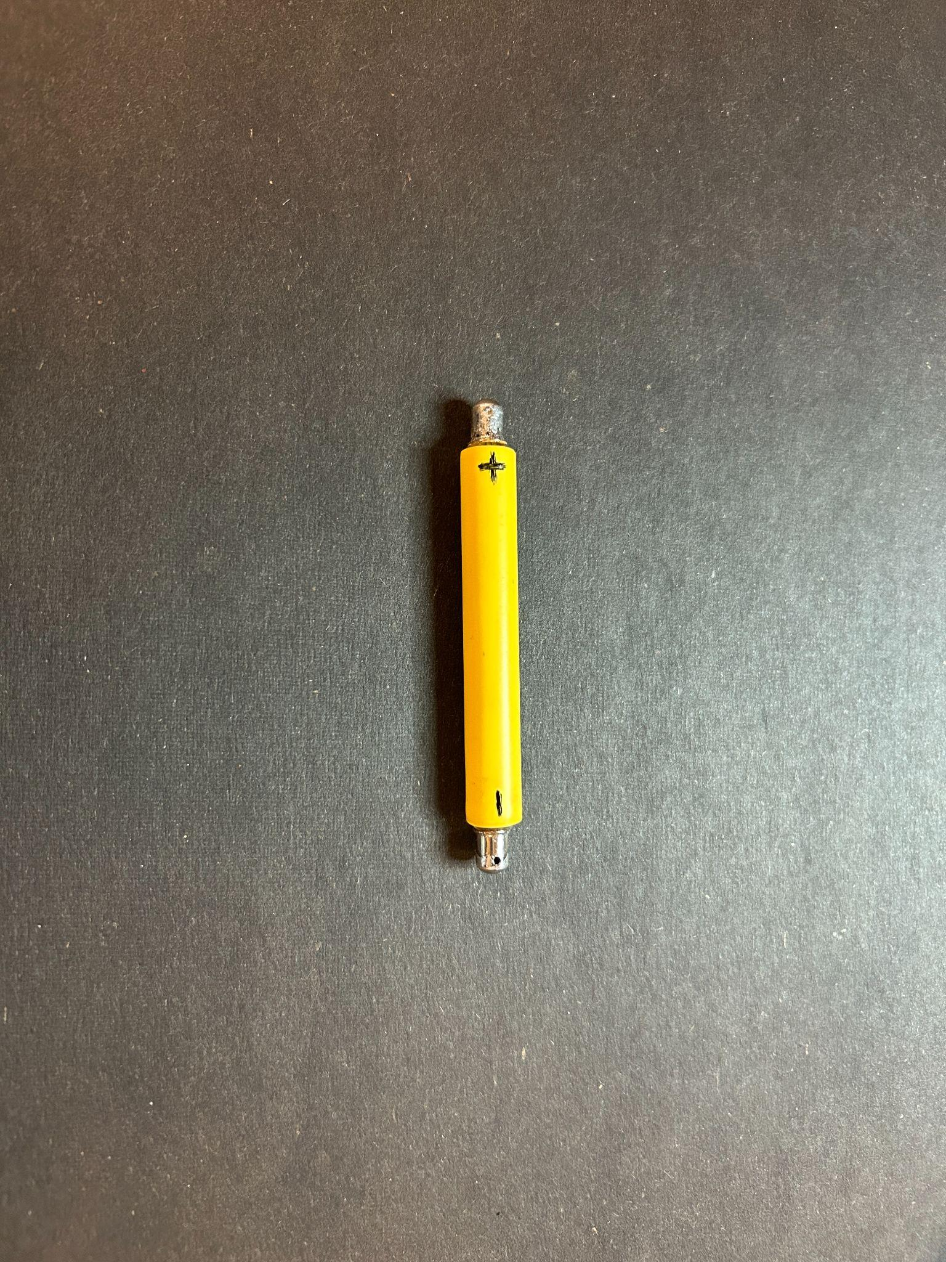

(Fig 34) (Fig 35)

**Section 16: The Tube Clips**

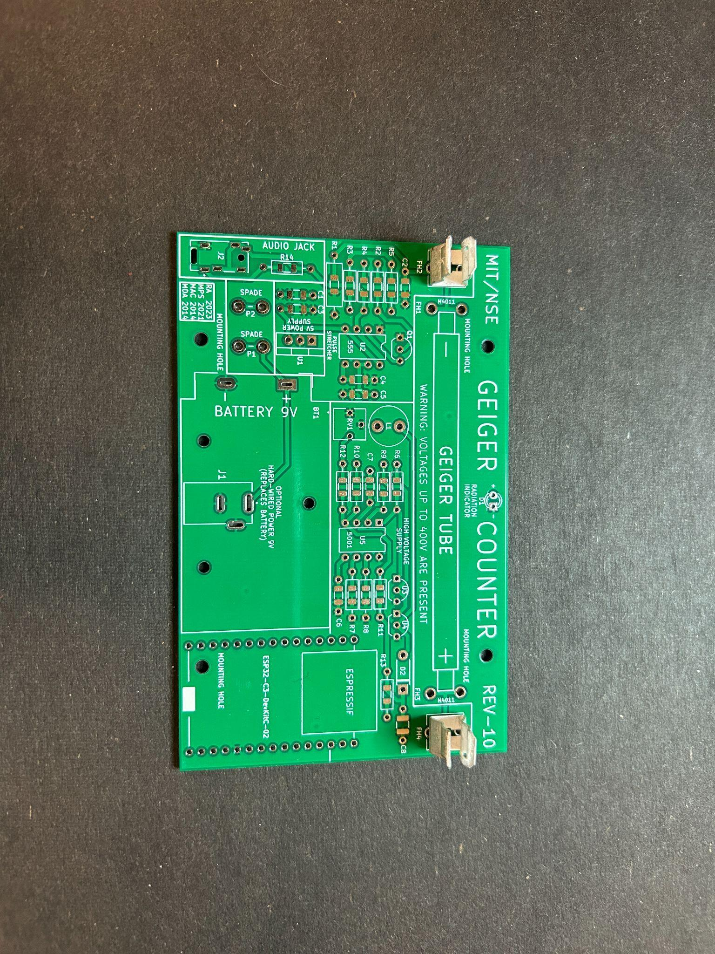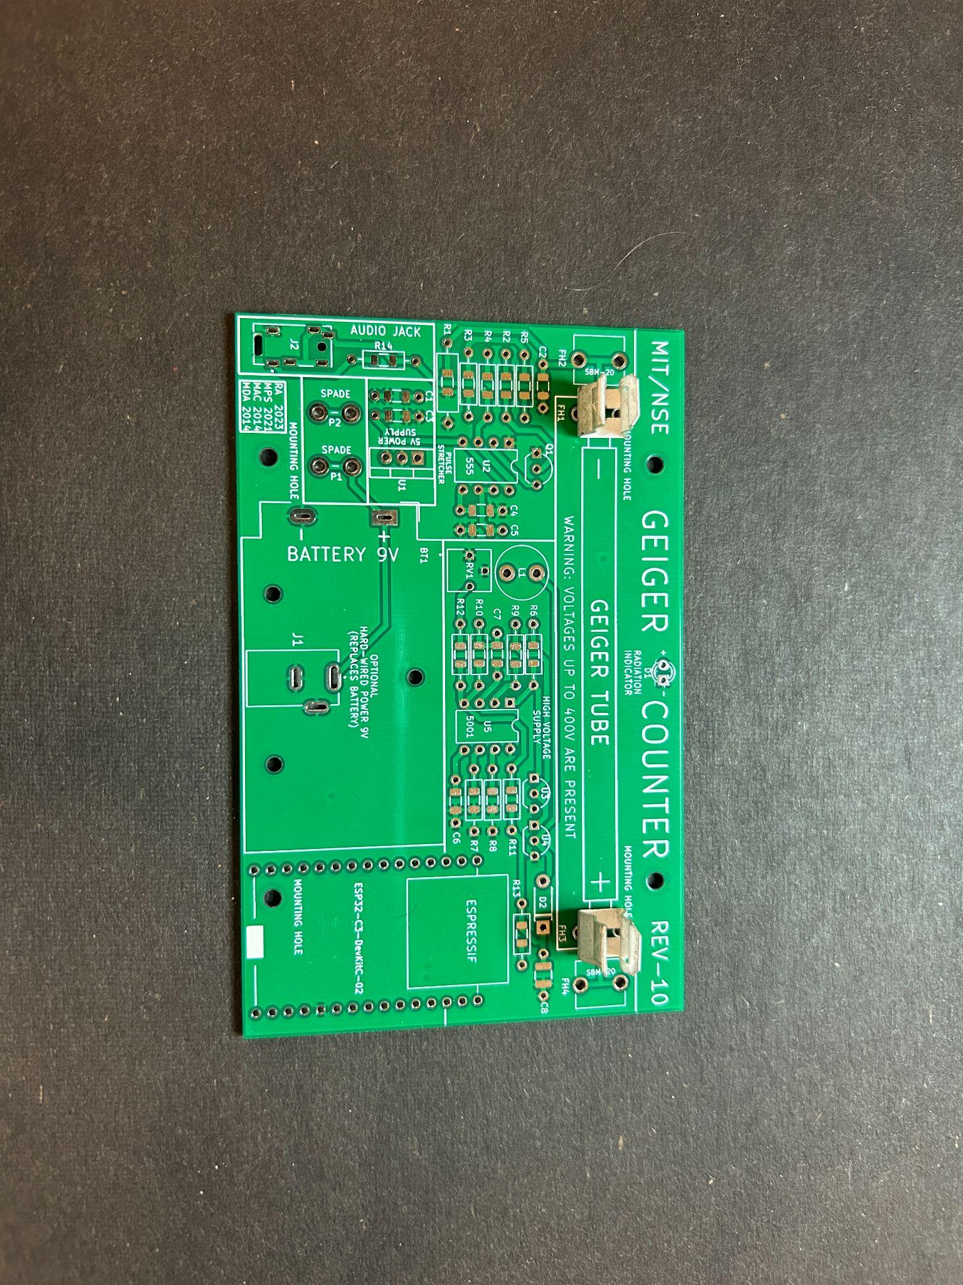

(Fig 36)(**SBM-20**) (Fig 37)(**M4011**)

Fig 36 displays the conventional SBM-20 configuration and Fig 37 shows how they should be put in for the M4011. The Tube clips must **only go in one direction** or else they will not be able to accept the tube

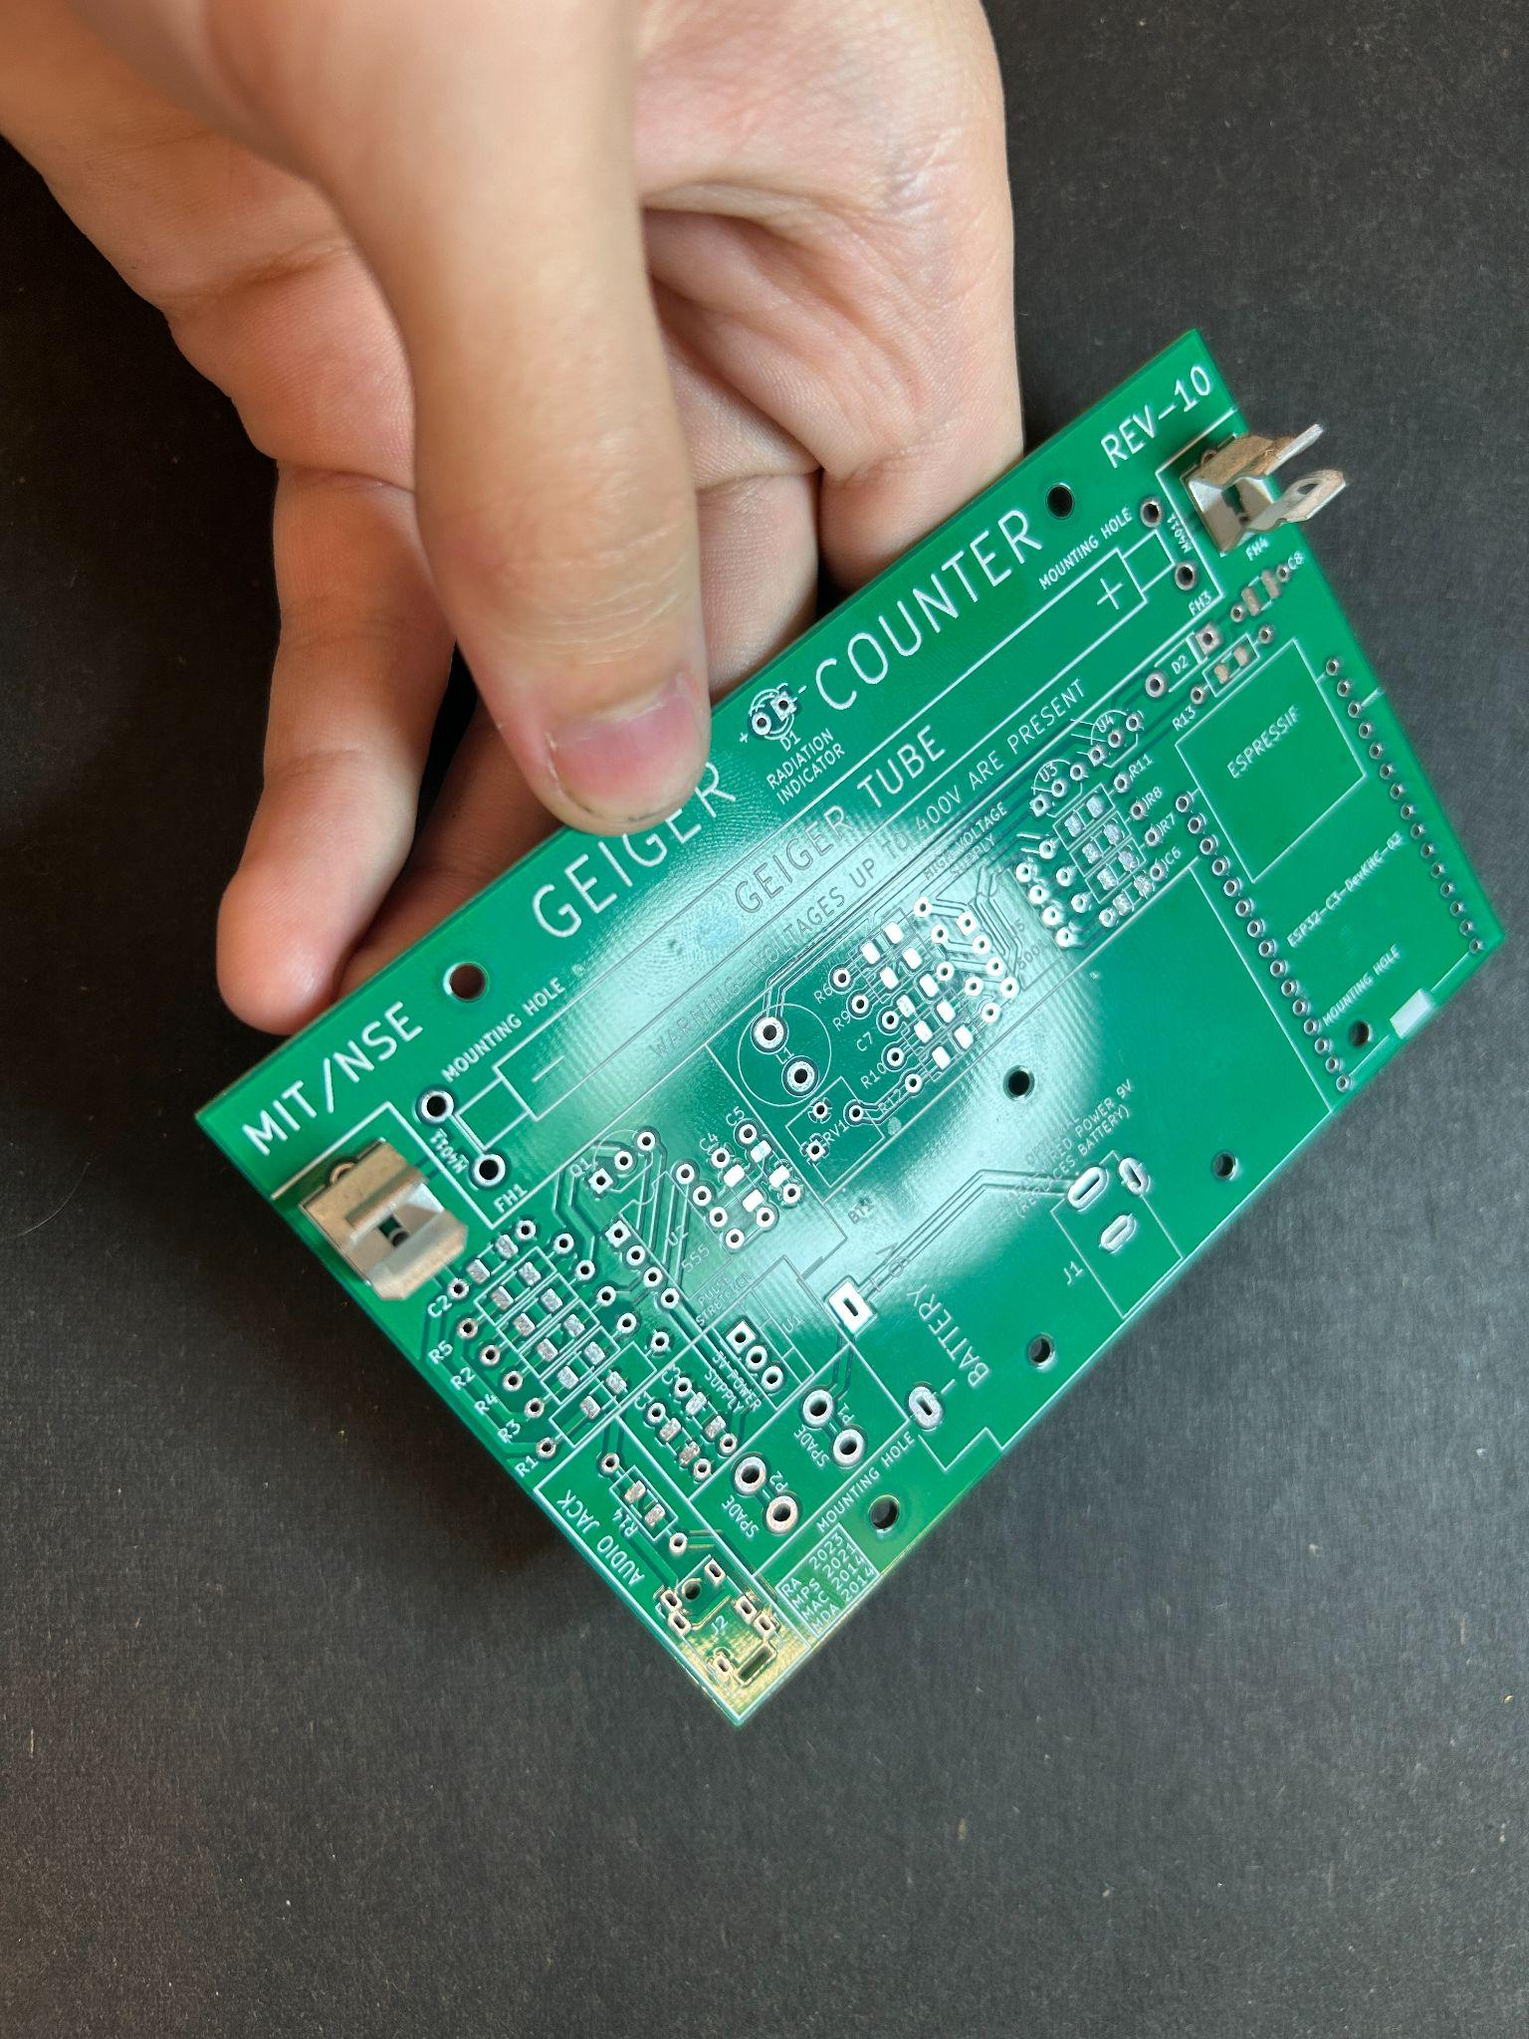

(Fig 38)

Here’s a close up of the correct orientation of the fuse clips. Flip the other fuse clip 180 degrees so both can accept the tube.

**Section 17: Picking a Power Source**

This geiger counter is designed to be able to run off battery power or wall power if the user so-chooses. However, you can only pick one so choose wisely. If you choose wall power you must use a power brick rated at **9V 500mA**. If you try to use a 5V brick it will not work at all. Running the geiger counter fully transmitting data from the ESP32-C3-DEVKITC-02 you will get around 4 hrs 45 mins of battery life, removing the ESP will increase this drastically.

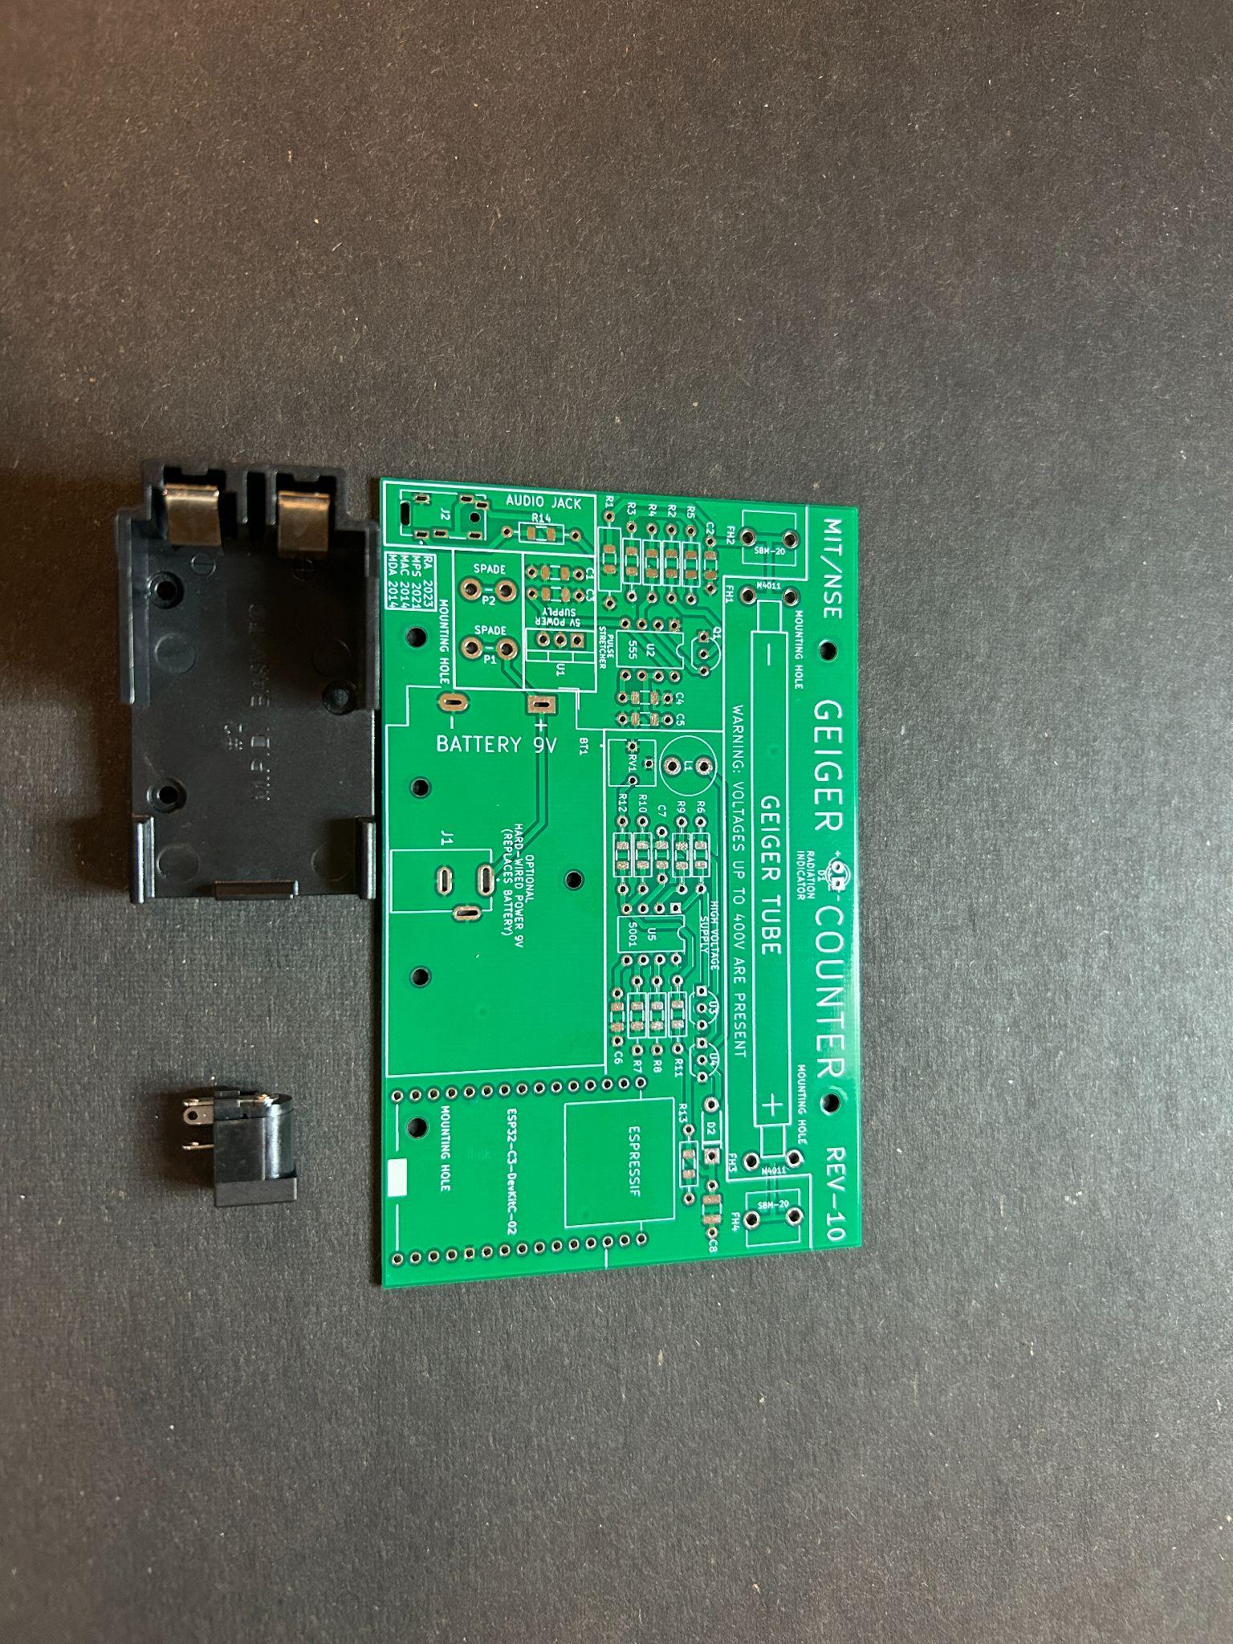

(Fig 39)

The Battery holder is shown on the left, and the 9V barrel jack option is shown on the right.

**Section 18: Power Source Installation**

After you've chosen if you’d like to run the geiger counter with the battery or the 9V barrel connector it’s time to install and solder it in

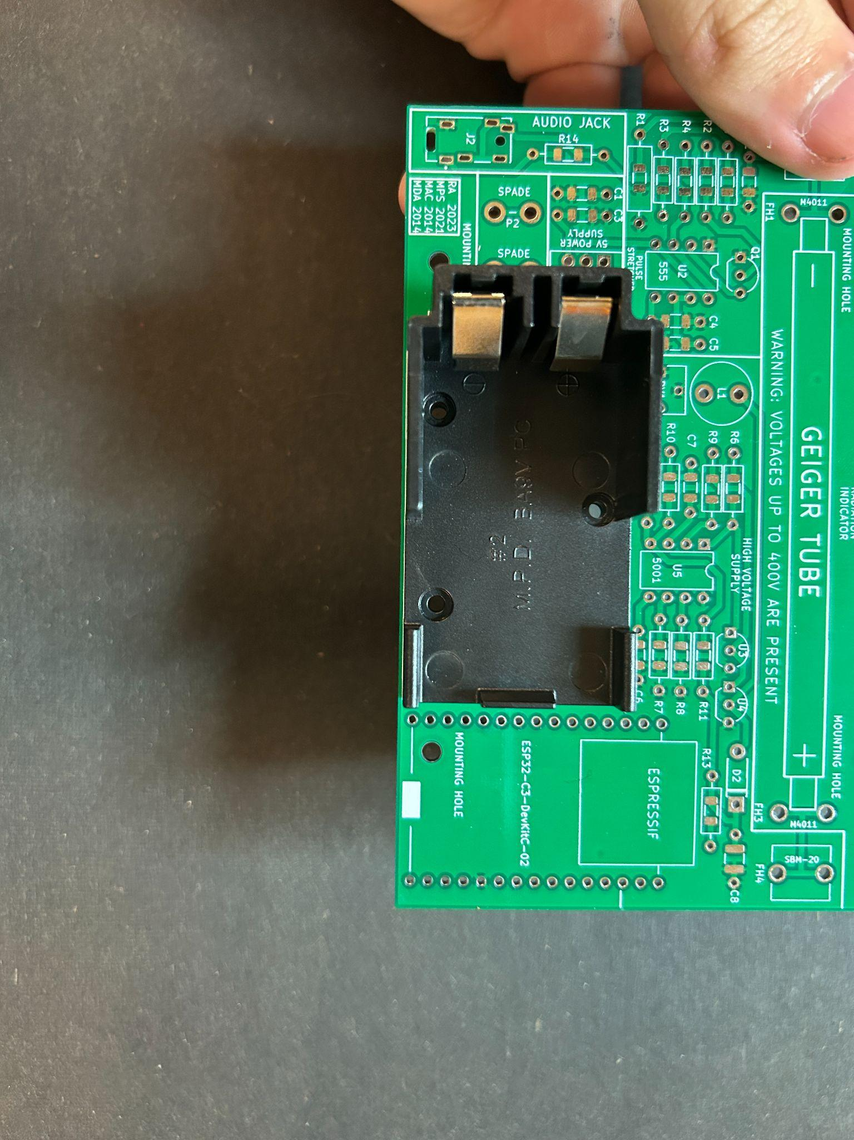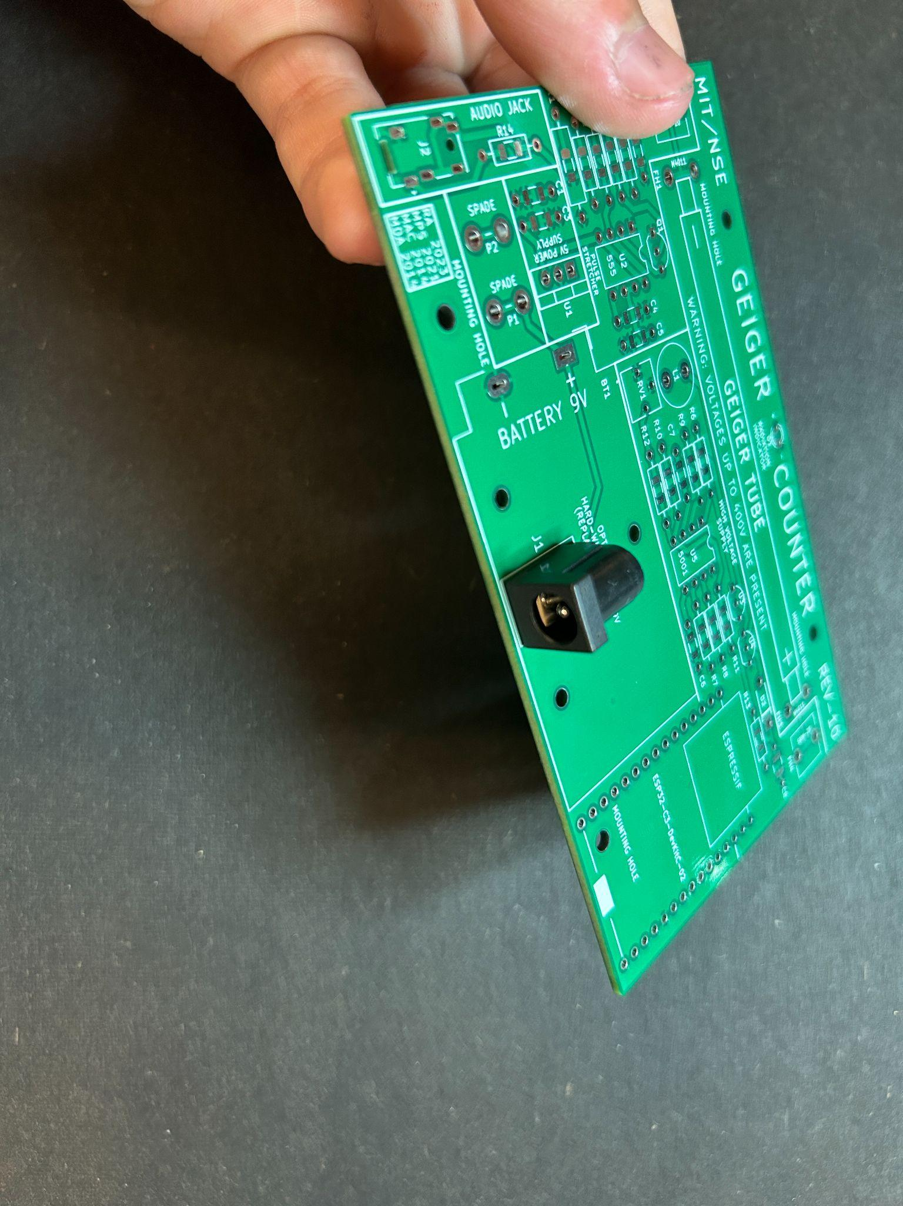

(Fig 40) (Fig 41)

If choosing the battery holder make sure to snip off the leads on the bottom to make sure it can fit nicely on the case’s base plate.

**Section 19: Putting in Chips**

Both the LMC555 and TL5001 go in the same way which I will explain now

First the **LMC555 (Left)**

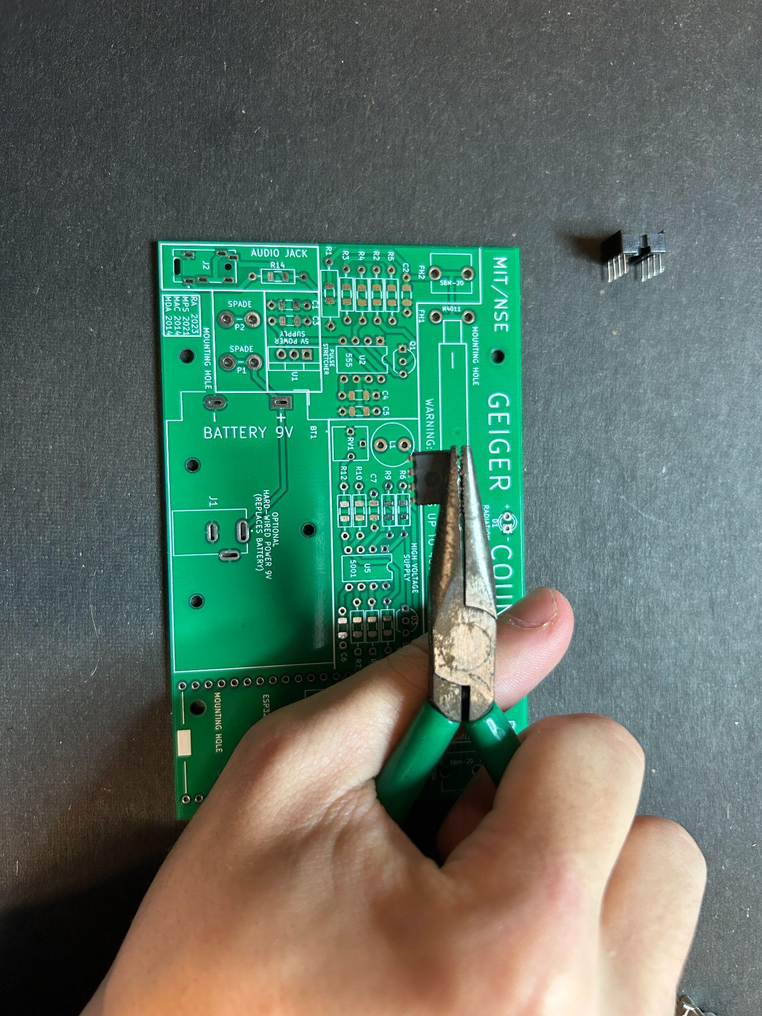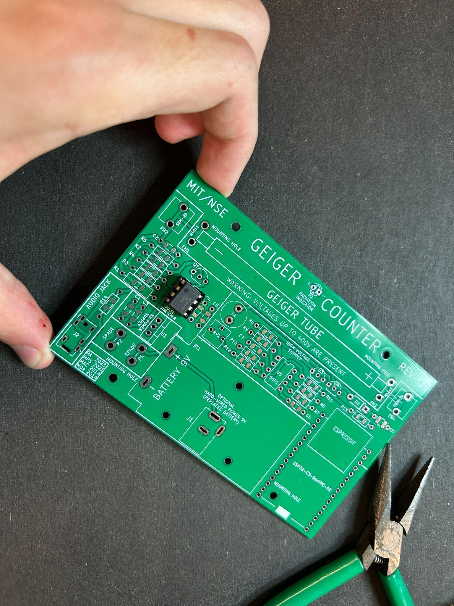

(Fig 42) (Fig 43)

Bend the chip’s legs ever so slightly inward so that they fit into the DIP-8 socket better, then align the circle on the top of the chip with the **circle in the top left**, then press in carefully making sure to not bend the legs of the chip.

Next with the **TL5001 (Right)**

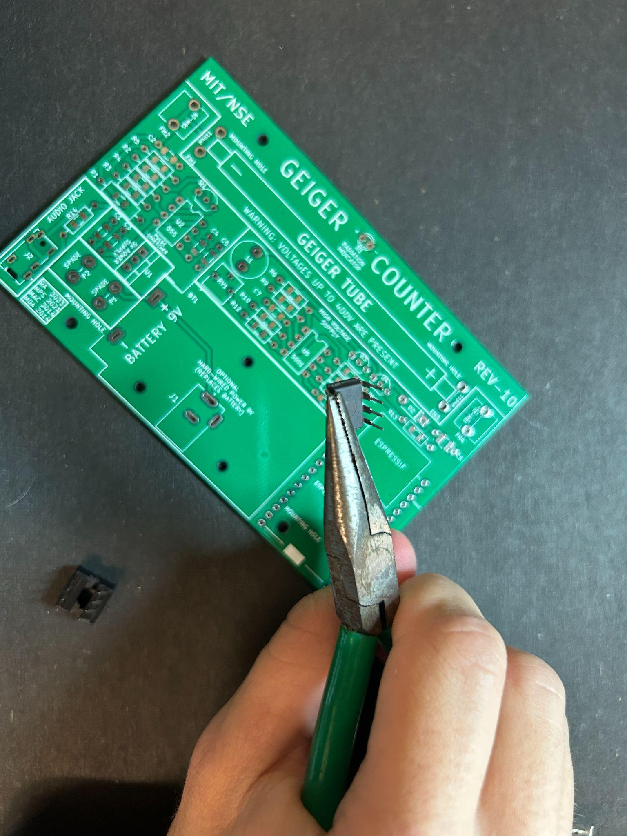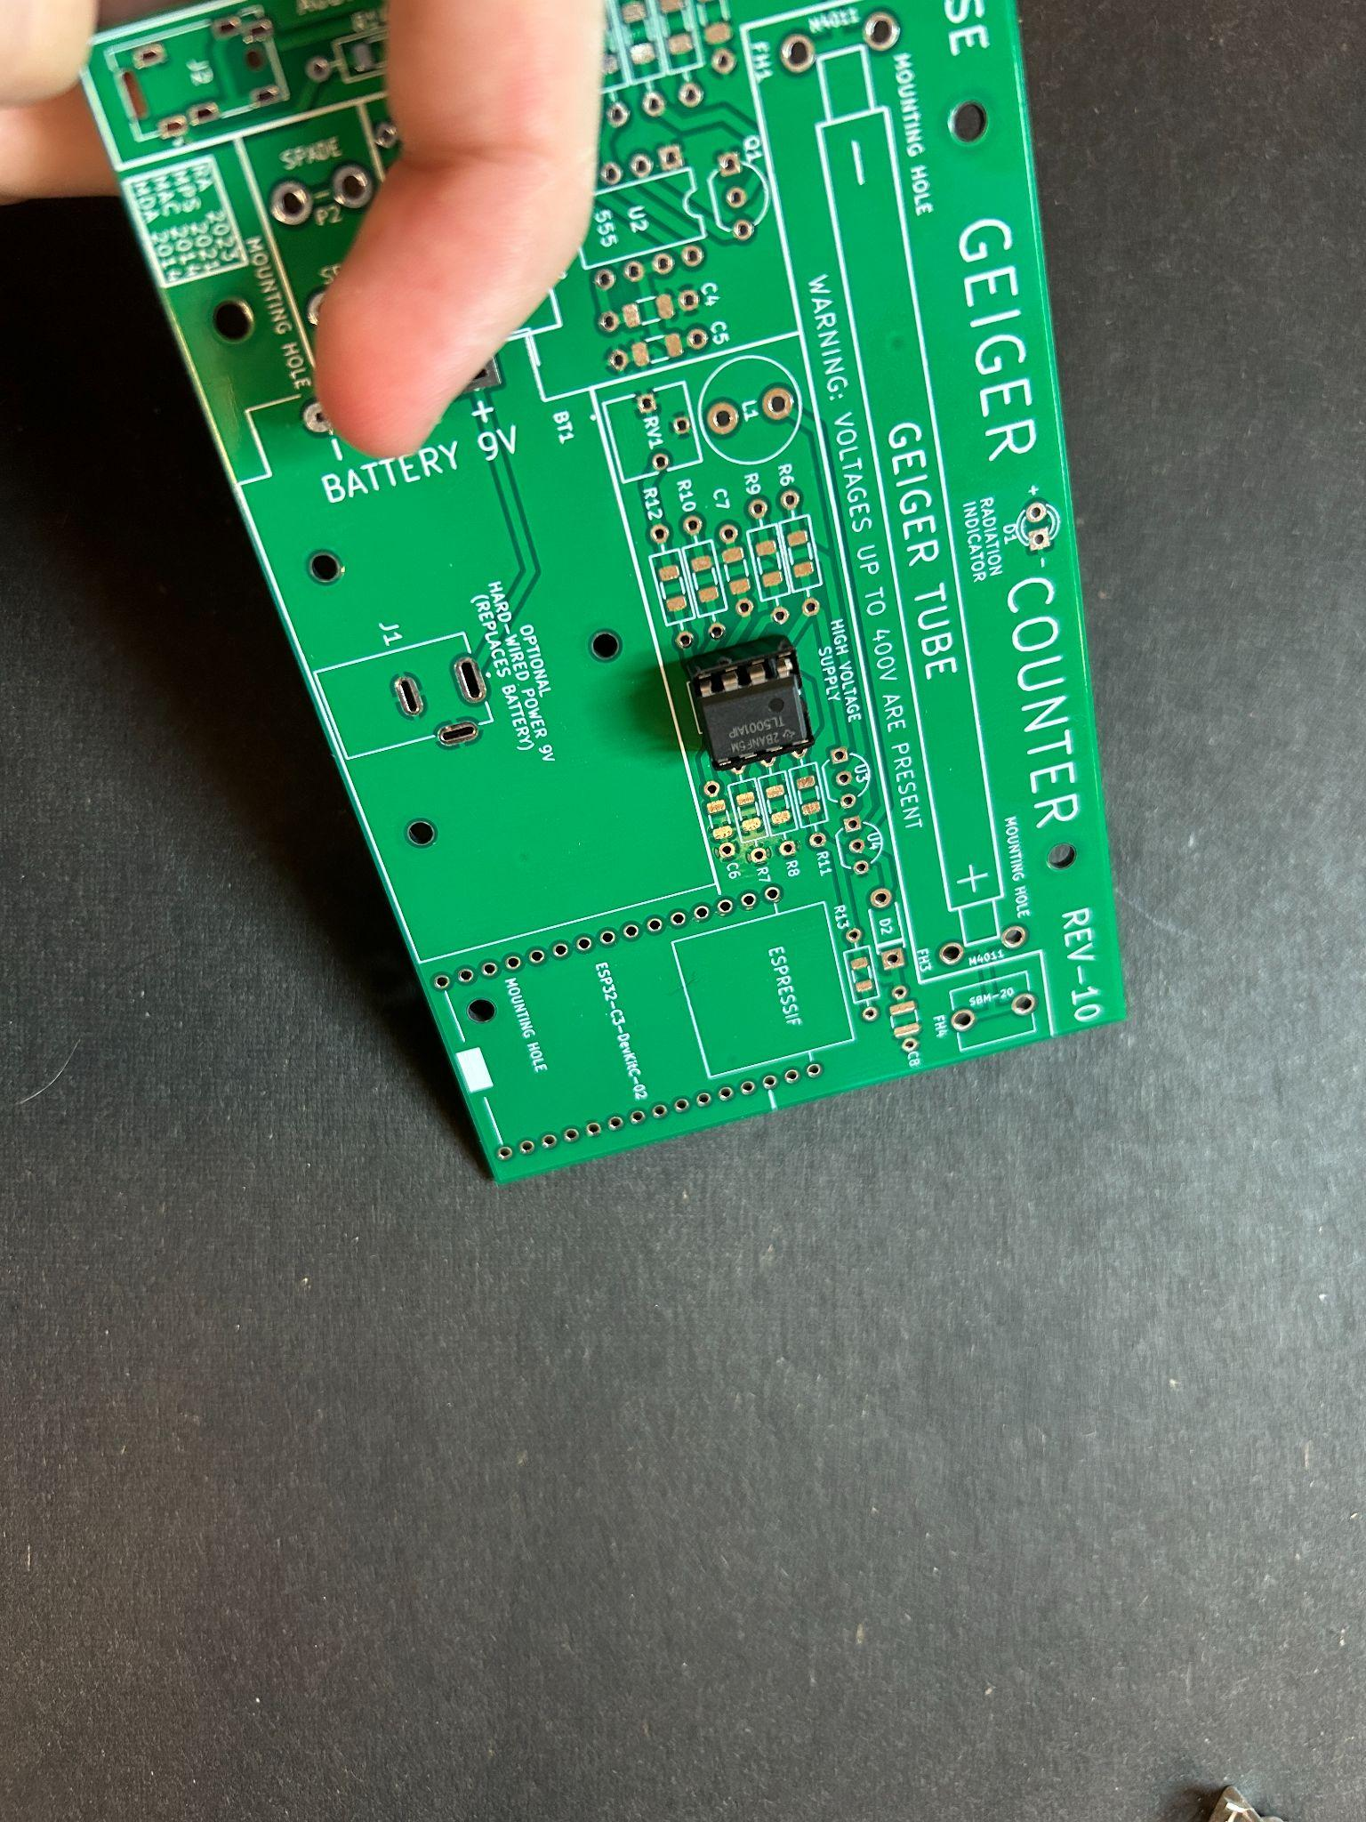

(Fig 44) (Fig 45)

Same thing, Bend the chip’s legs in ever so slightly so that they fit into the DIP-8 socket better, then align the circle on the top of the chip to the top left **circle in the top left**.

The LMC555 is a really cool chip and has three operating modes (monostable, bistable, and astable). We’re using it in monostable mode, which means when we send in a pulse it sends out a pulse, but the pulse it sends out is longer.

The geiger tube makes the pulse which we need the 555 to stretch for us to send it to our LED, ESP, and Audio Jack.

The TL5001 is a Pulse Width Modulator chip (PWM). This means that it sends a high signal then a low signal in a consistent pattern again and again. This high and low turns on and off our MOSFETs from earlier to create a changing current in our inductor which in turn leads to our high voltage output via a boost converter topology.

**Section 20: Mounting The Board to Case**

It’s finally time to mount the board to the case! Find the four small mounting screws included with the kit and get the bottom base plate and line up the holes

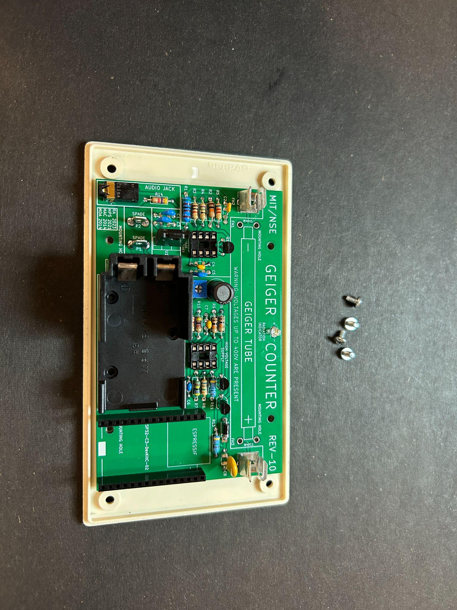

(Fig 46)

It doesn’t matter which way around the board is, they will both work.

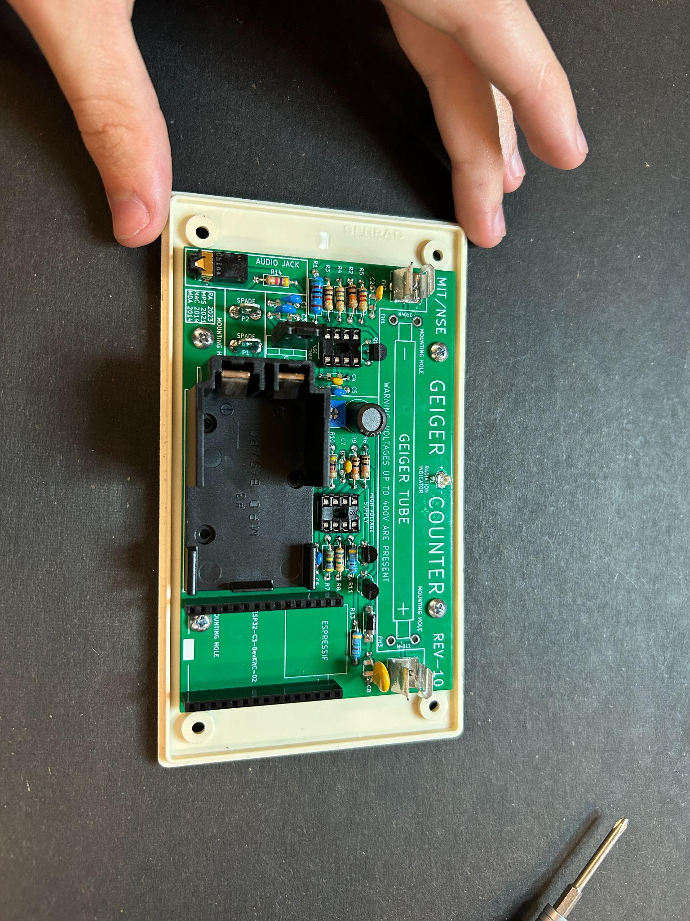

(Fig 47)

Screw each screw in incrementally to make sure everything lines up good and **do not over tighten the screws**. When they’re flush with the circuit board, stop tightening.

**Section 21: Installing The Tube, ESP, and Battery**

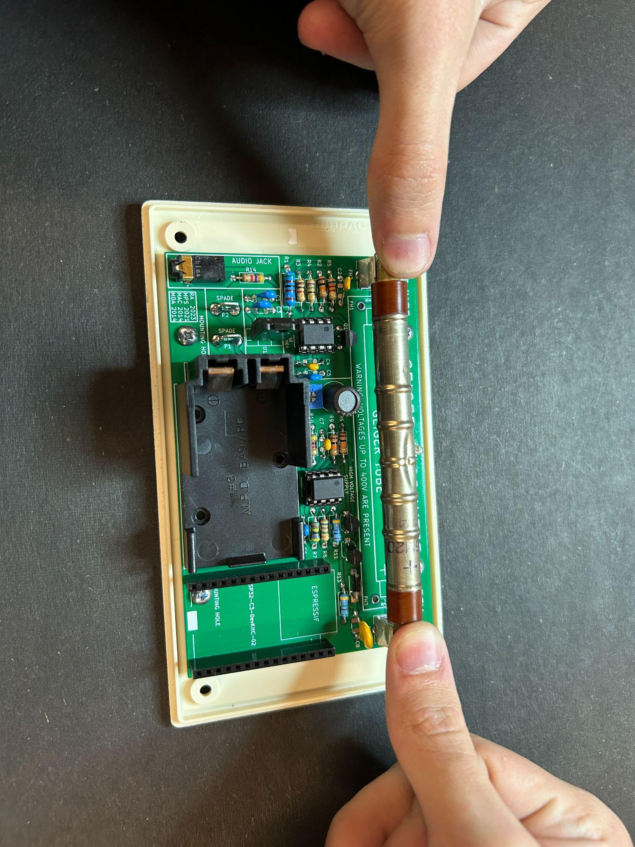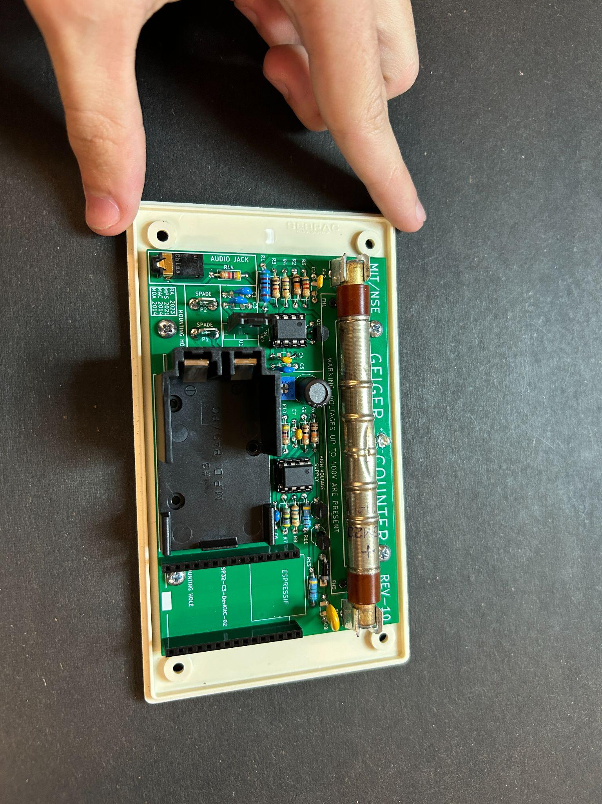

(Fig 48) (Fig 49)

It’s now time to pop in the tube and the ESP! Line the + side of the tube up with the + on the circuit board and use both thumbs to firmly press the geiger tube into the clips. Tube must **only go in one direction**

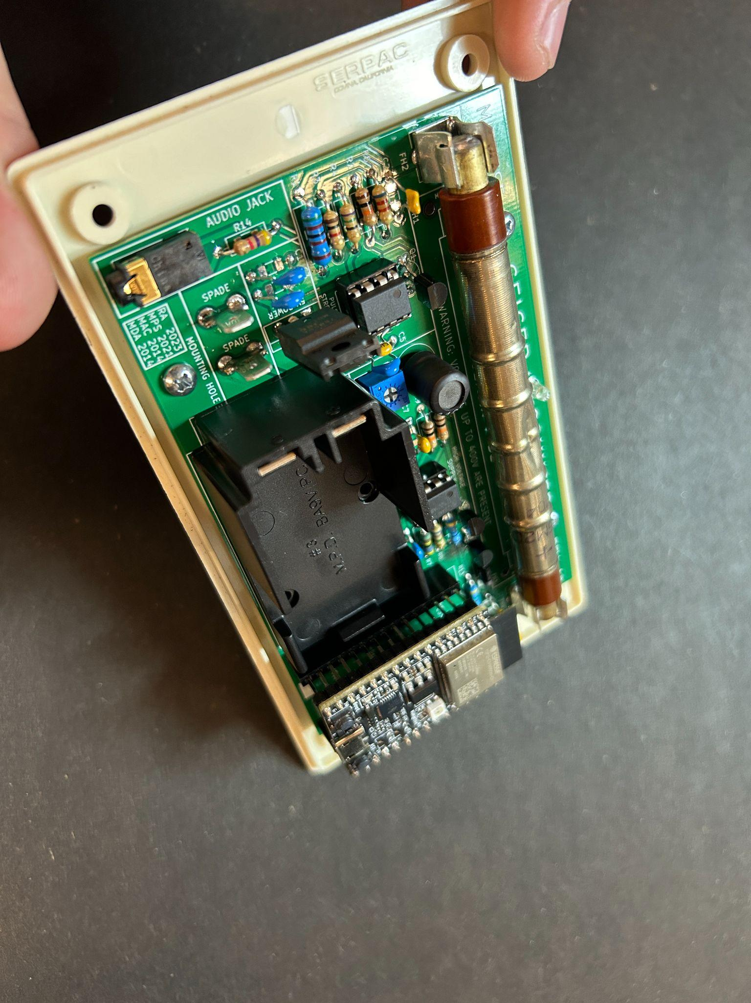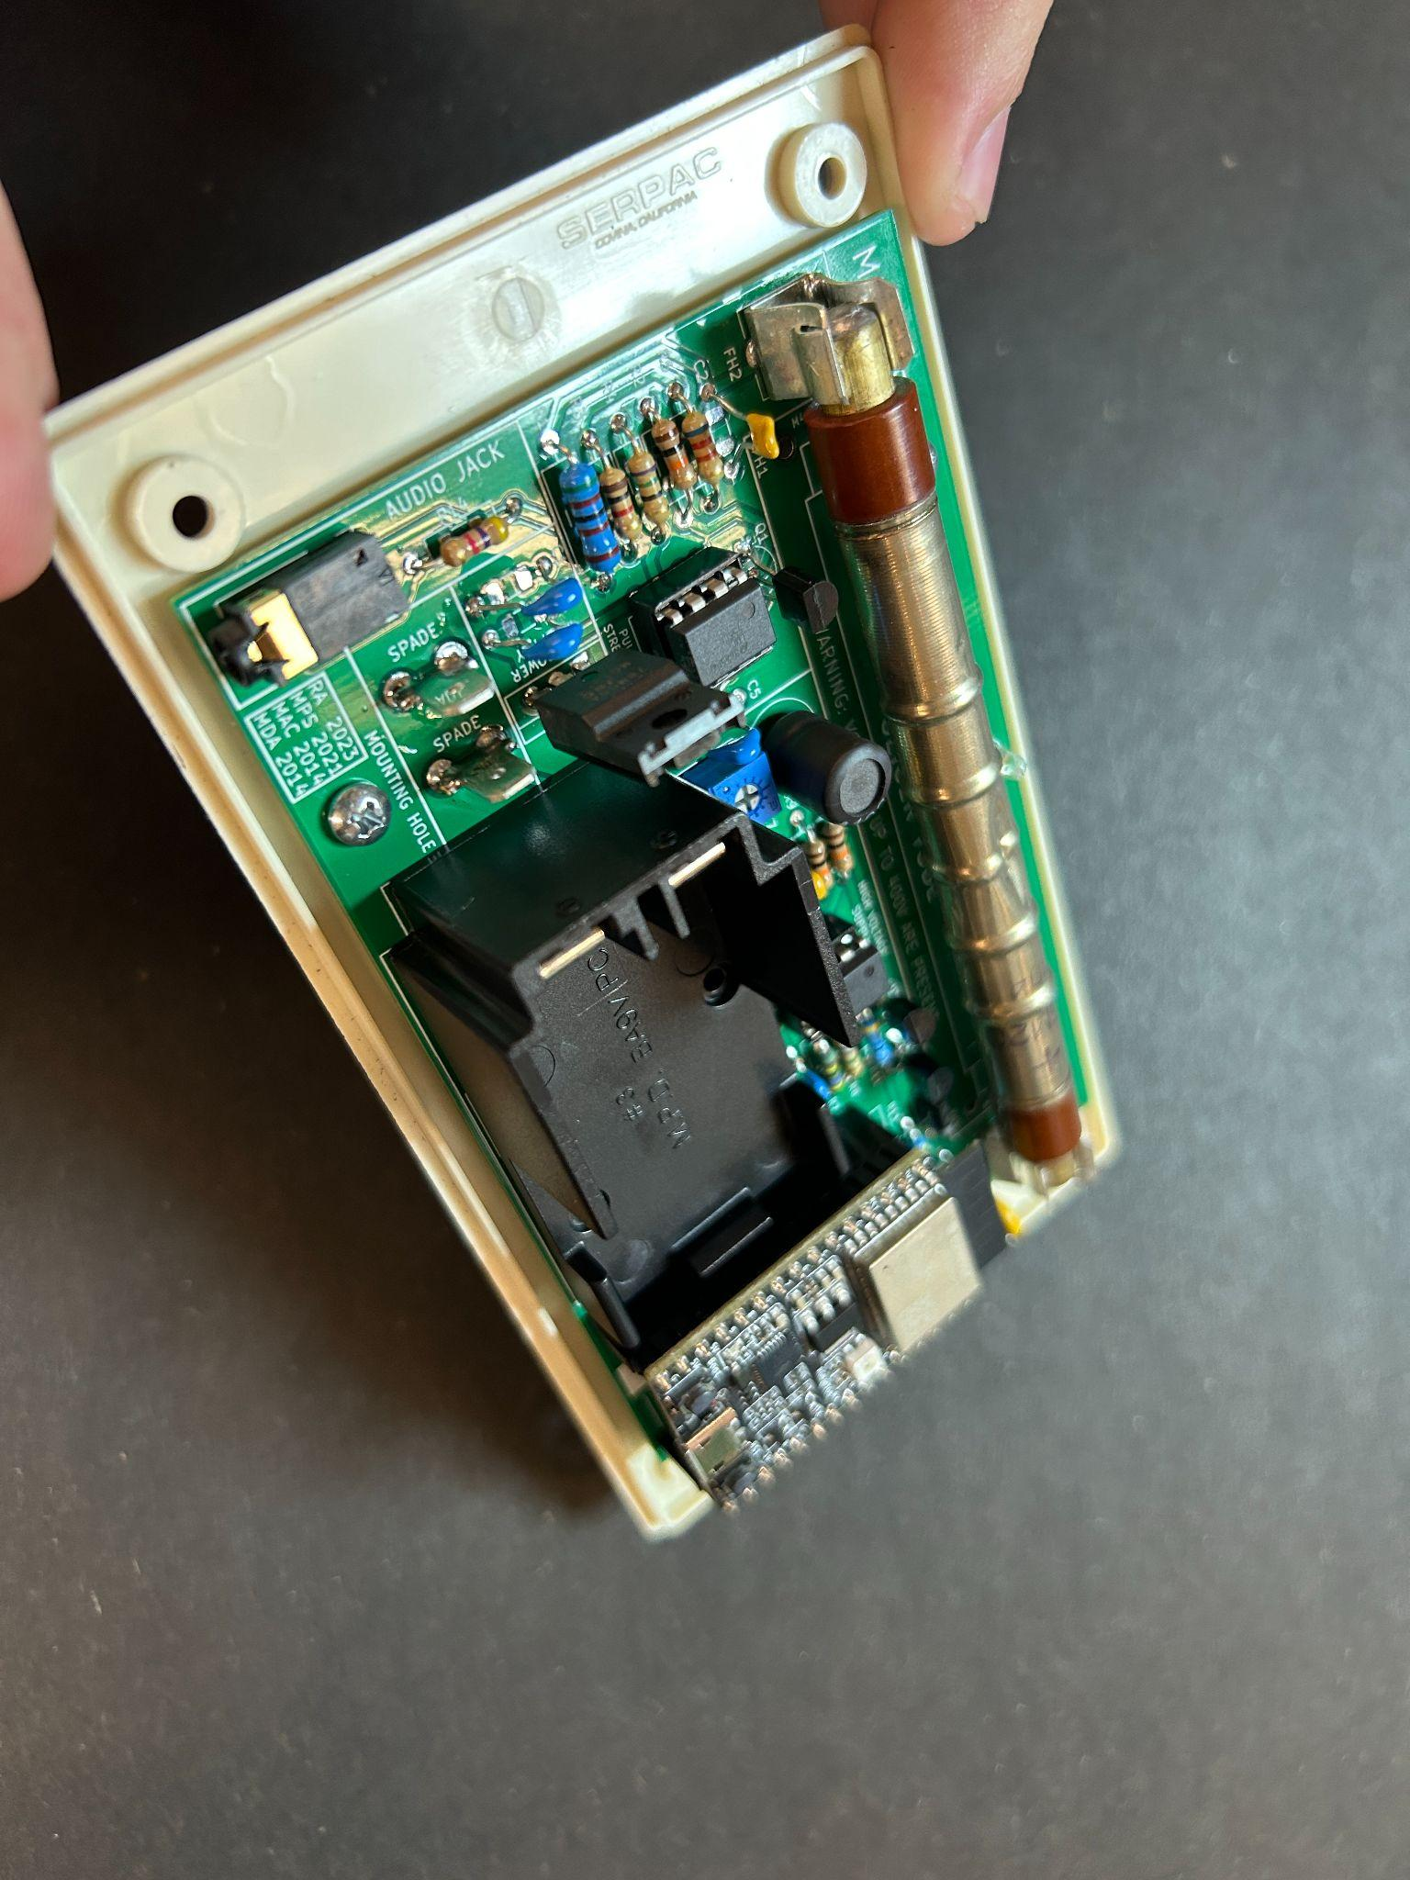

(Fig 50) (Fig 51)

Line up the esp making sure all the pins slide in nicely then press down firmly. ESP may **only go in one direction**

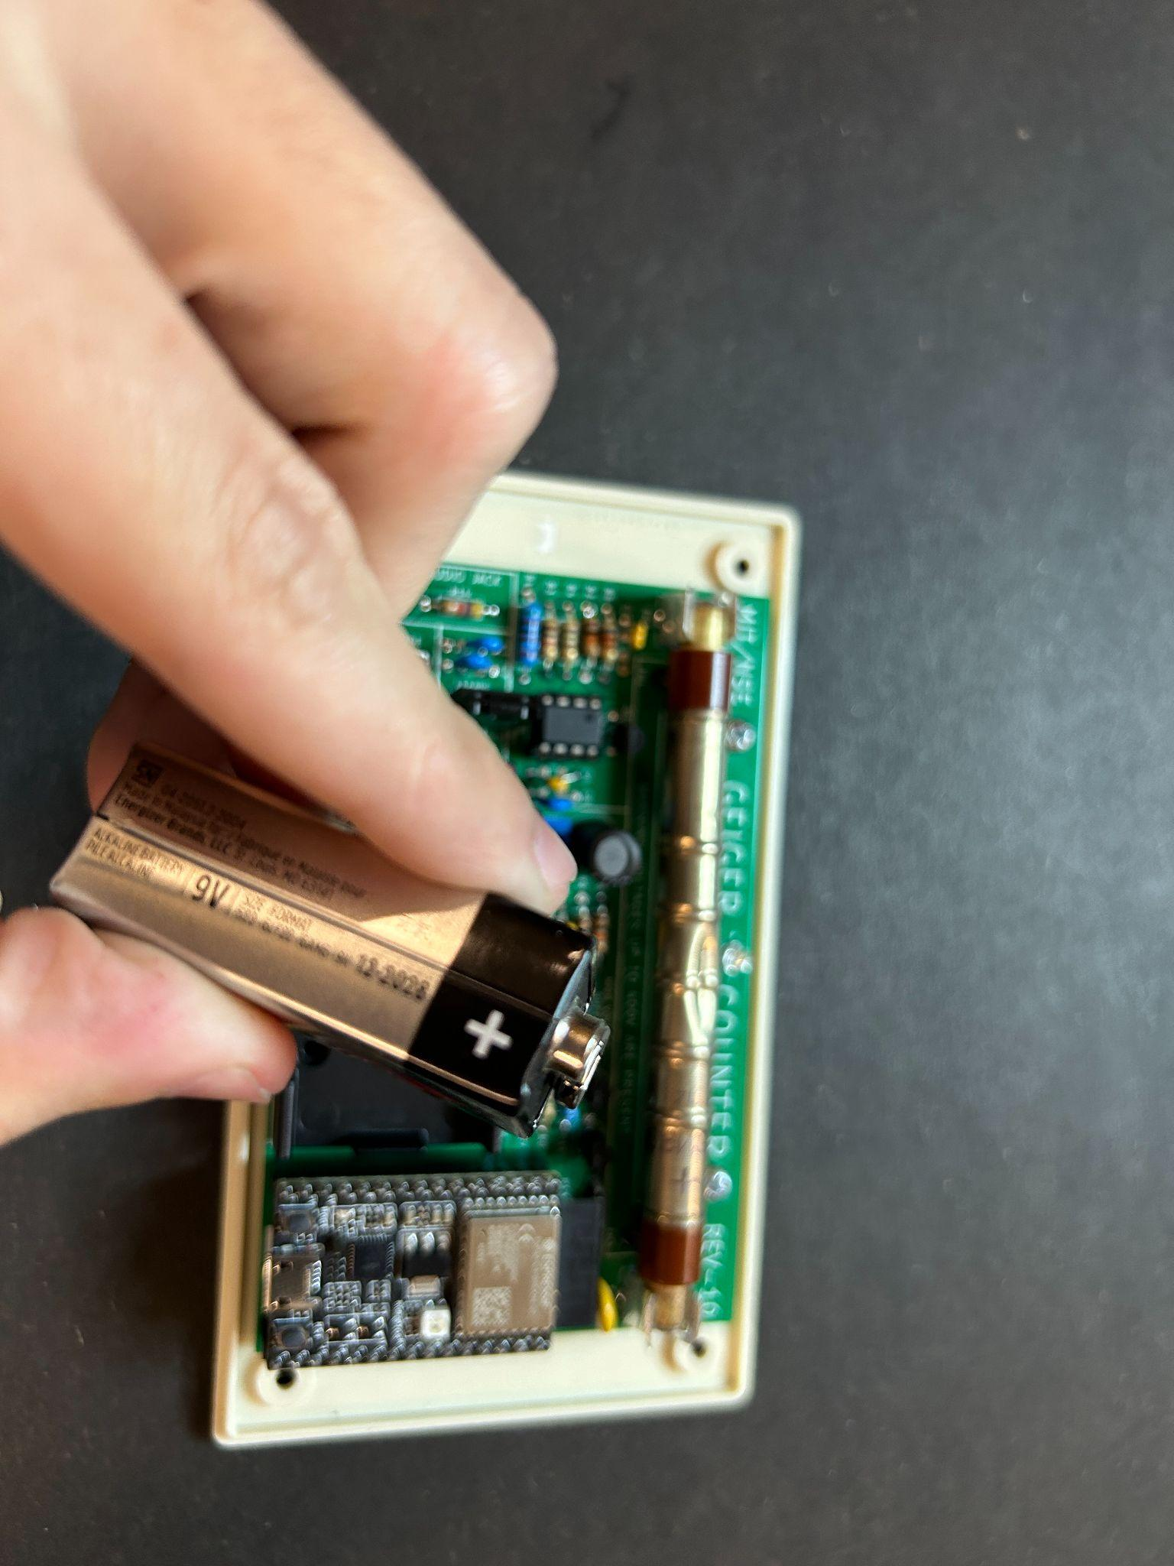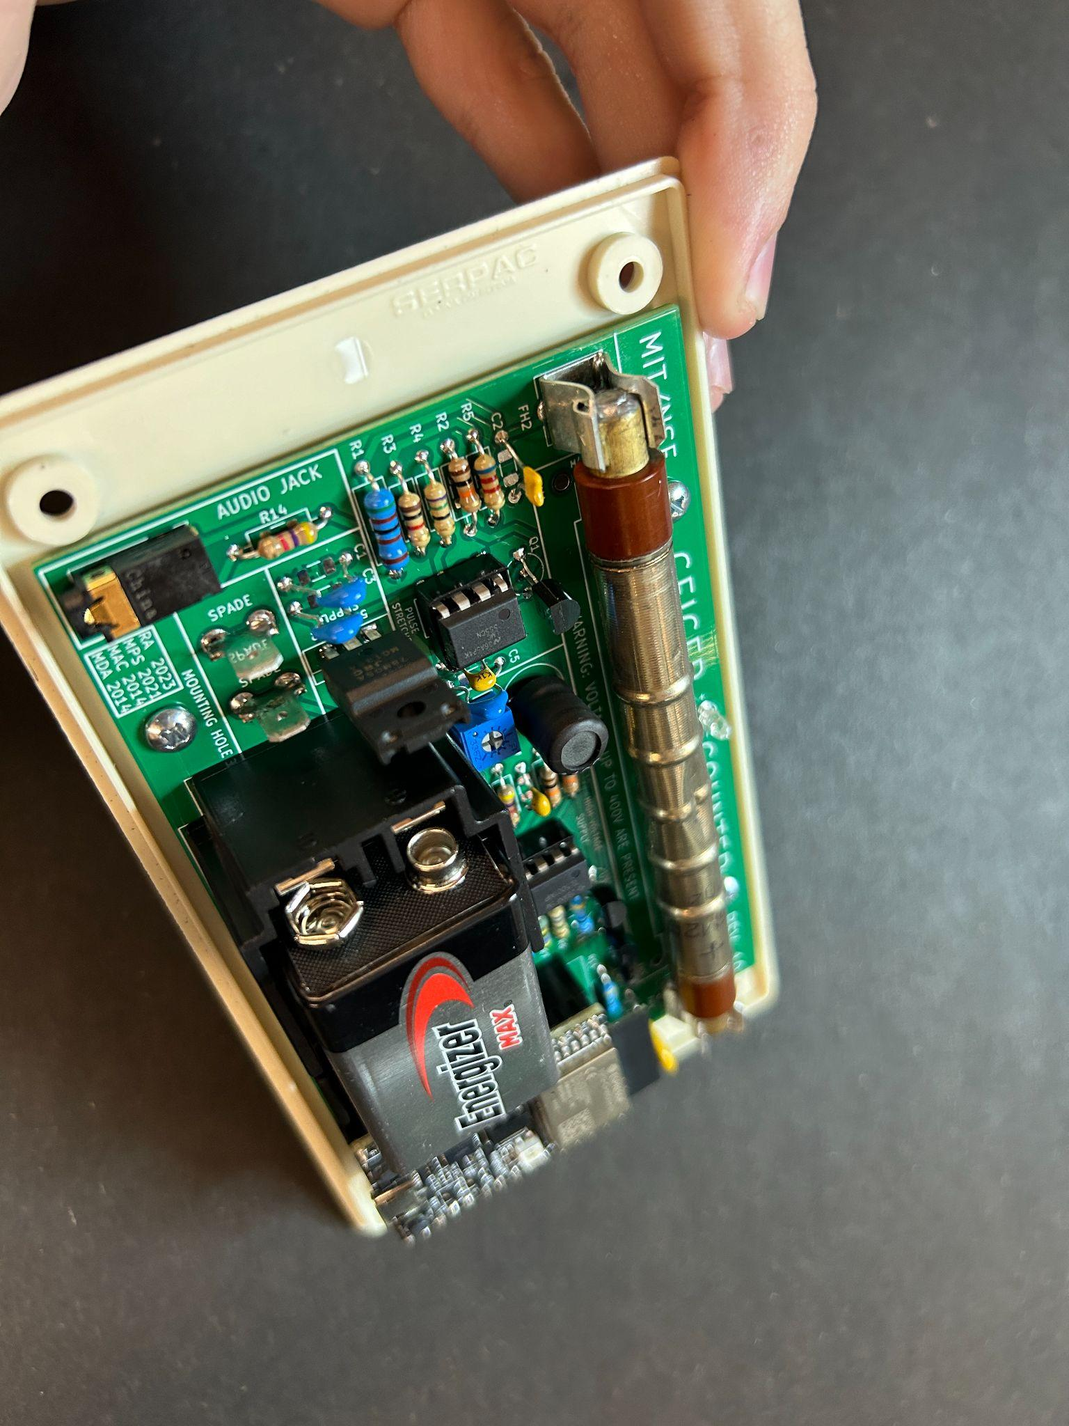

(Fig 52) (Fig 53)

Make sure if using the battery it is installed like is shown in the Fig 53 with the leed + closer to the top and the - closer to the bottom. Battery may **only go in one direction**

**Section 22: Final Assembly**

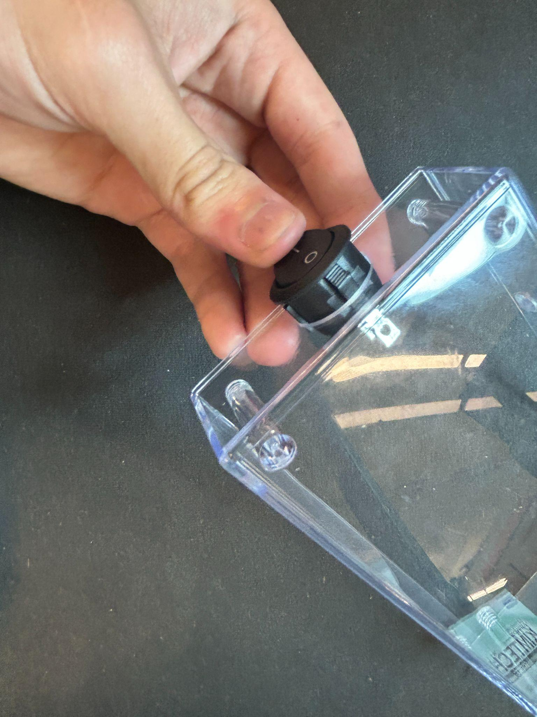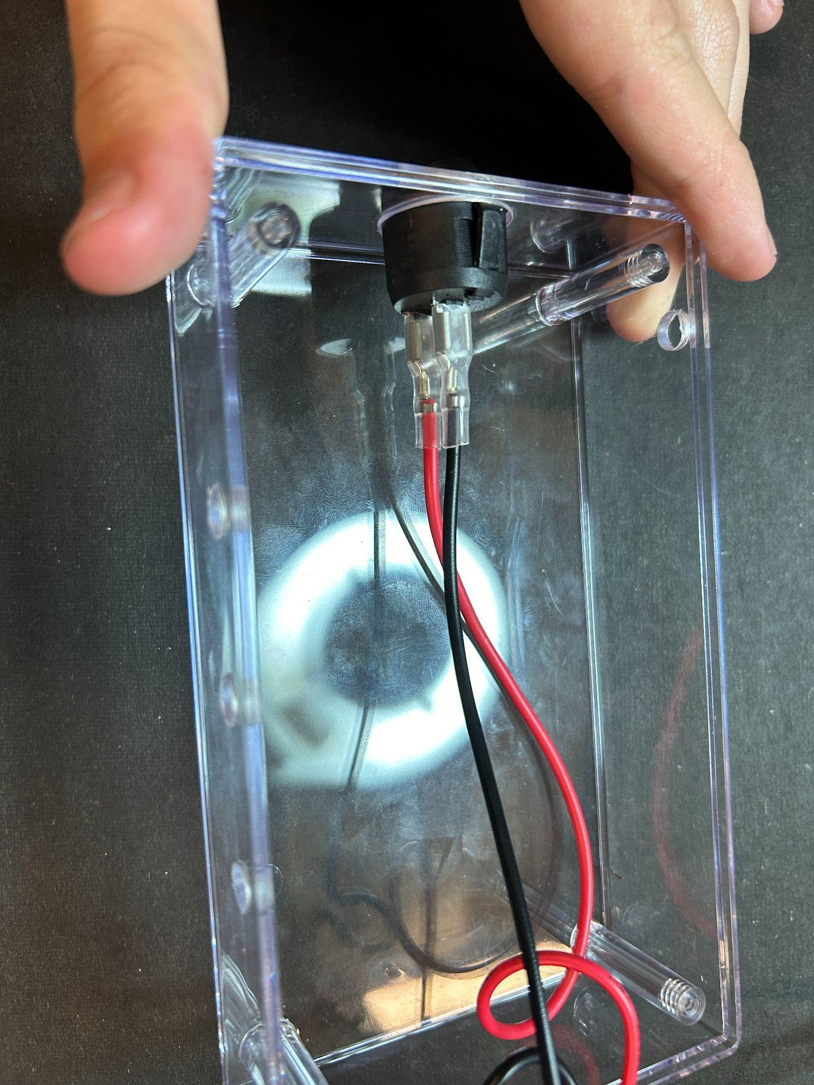

(Fig 54) (Fig 55)

Push the switch into the large hole at the end of the clear part of the case. Make sure the “0” on the switch is facing towards the closed face, and the “1” is towards the open face (like is shown in Fig 54). Then attach the wires to the on/off switch (with the red on the bottom).

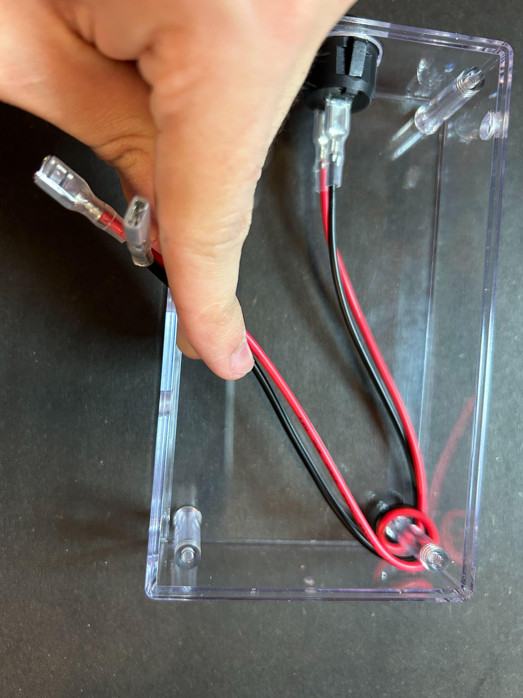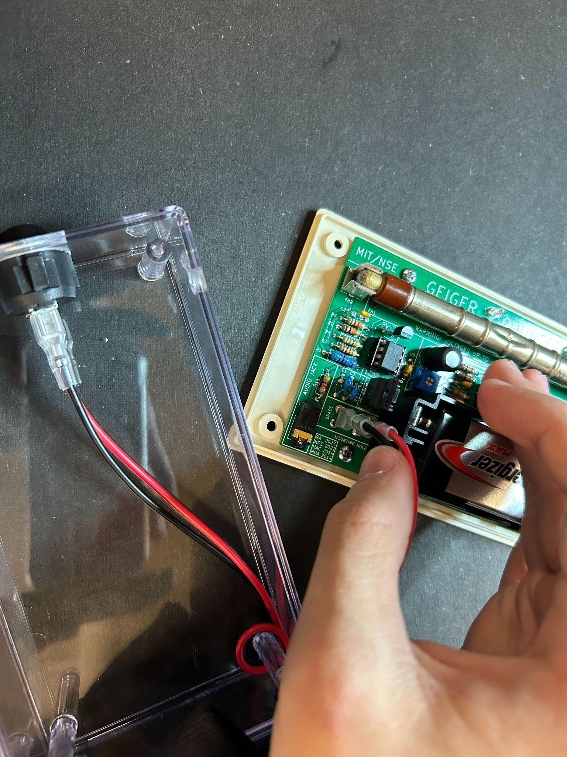

(Fig 56) (Fig 57)

Wrap the wires tightly around the top right post and connect the ends of the wires to the spades on the board (with the red wire on the right).

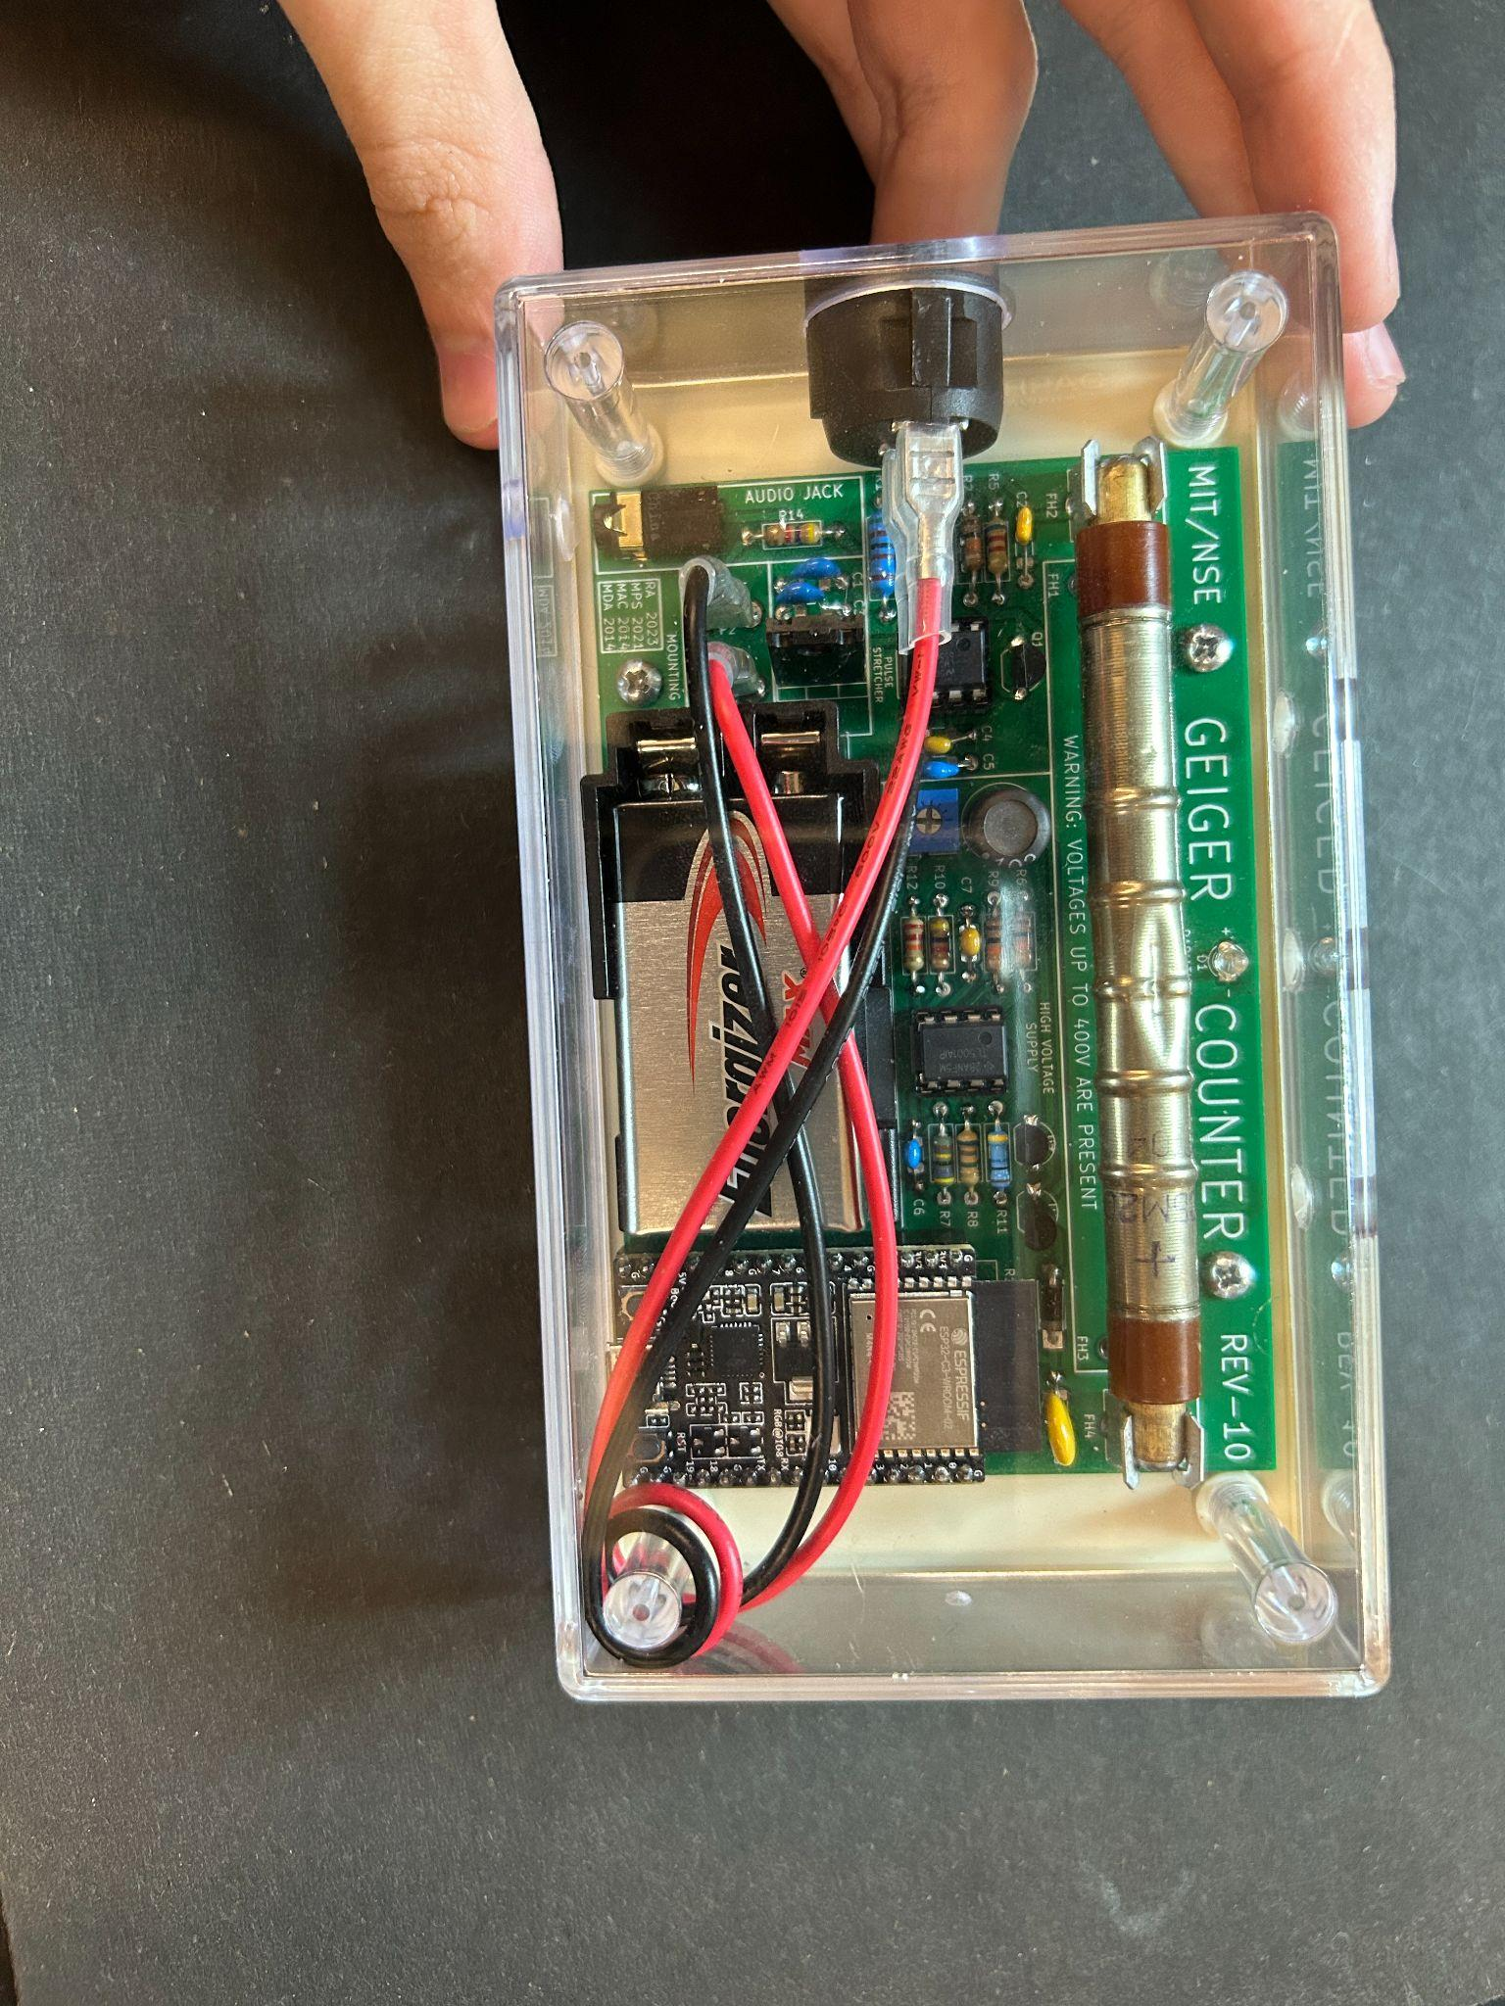

(Fig 58)

Flip the top part of the case over the board and line the pillars up with the holes on the bottom of the board as shown in (Fig 58)

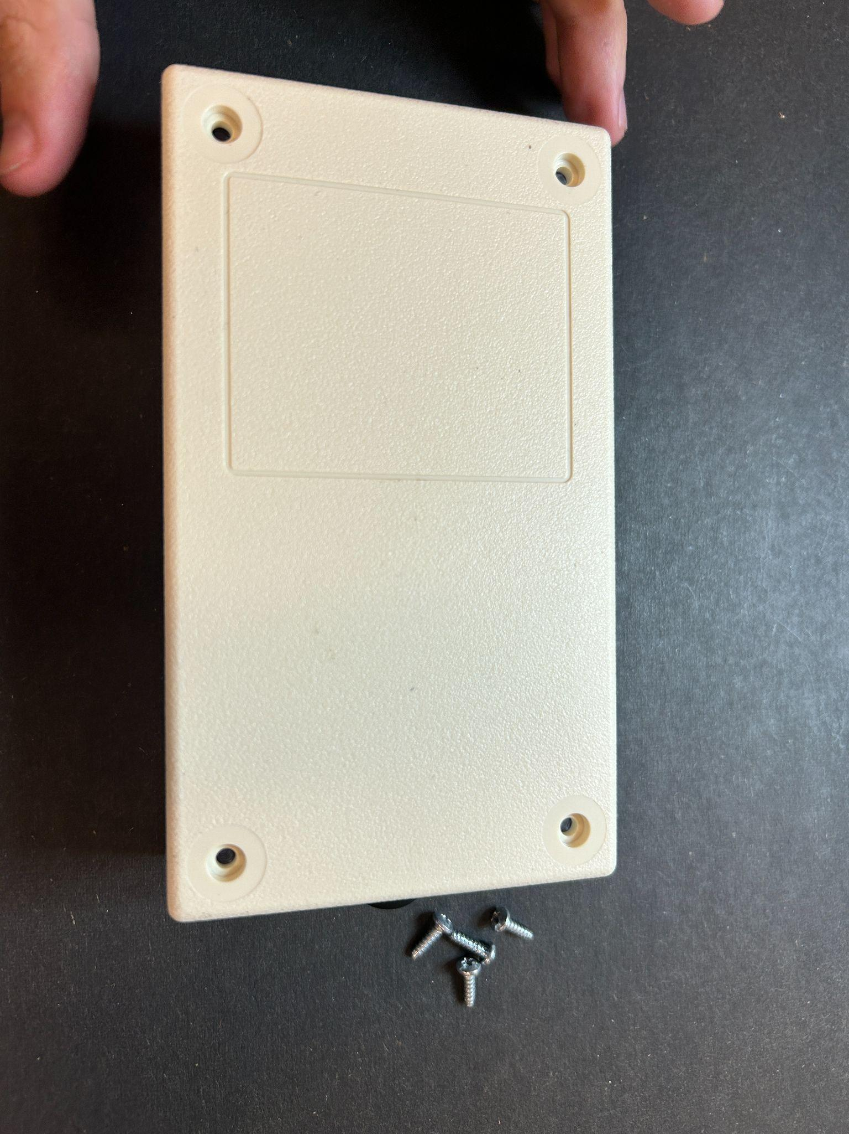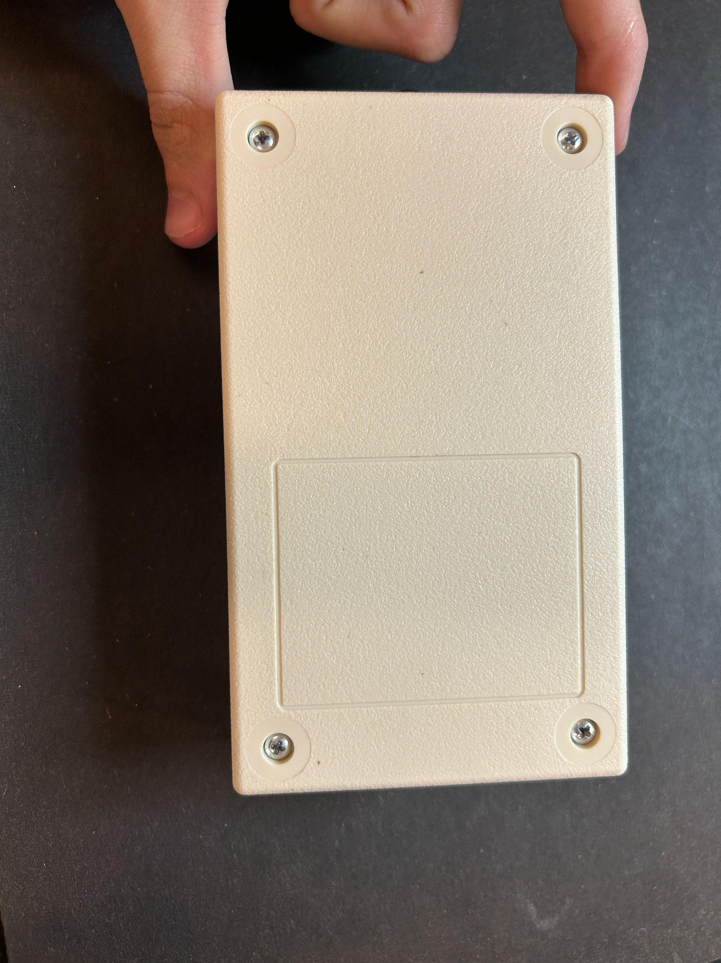

(Fig 59) (Fig 60)

Flip the case over, and find your longer screws. Be sure to screw them in directly up and down to avoid difficulty.

**Section 23 CIRCUIT REFERENCES**

| (Fig 61) | |
| --- | --- |
|  |  |

(Fig 62 and Fig 63)

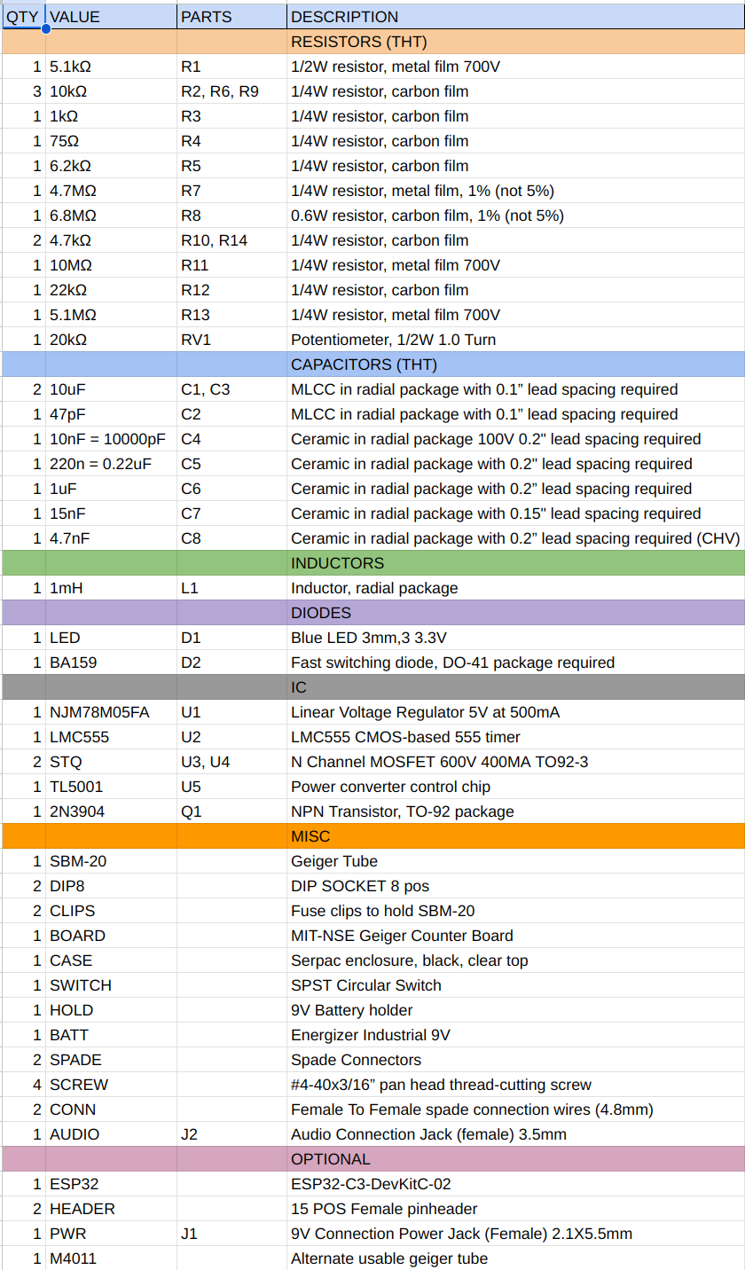

(Fig 64)